2015 August Southeast Alaska Coastal Monitoring (SECM) survey report
"The contents of this report are mine personally and do not necessarily reflect any position of NOAA."
Joe Orsi

All scheduled stations were successfully completed during the 7-d August Southeast Alaska Coastal Monitoring (SECM) project survey from 26 August to 03 September 2015. This was the final of four scheduled SECM surveys for 2015. Participating researchers onboard the chartered Northwest Explorer included: Emily Fergusson (NOAA), Joe Orsi (NOAA), Sarah Ballard (NOAA Contractor), Nathaniel Mertz, (NOAA Contractor), Michelle Morris (NOAA Contractor), and Elizabeth Tobin (University of Alaska, Volunteer).

Twenty-nine sampling events were accomplished in the marine waters of Southeast Alaska (SEAK). Surface trawling and oceanography (CTD & Bongo DO 333/505) was conducted along a four station transect line 65 km offshore of Icy Point, and sampling was also conducted repetitively along two transects situated 3-6 km offshore in Icy and Upper Chatham Strait which are major SEAK seaward migration corridors. An additional sampling event occurred for oceanography at the Auke Bay Monitoring station (ABM). Some SECM survey objectives included: 1) the use of a modified Marine Mammal Exclusion Device (MMED) inside the trawl (with a GoPro camera) along the offshore transect, 2) the collection of live zooplankton taxa to identify lipid content of salmon prey as an annual ecosystem metric, 3) the examination of stomach contents of larger fish that could be potential predators of juvenile salmon, 4) the examination all Chinook and coho salmon for adipose fin clips to later be examined for the presence of coded-wire tags revealing origin and ocean-age information, and 5) conduct a surface trolling operation with jigs at 5 knots beyond the 65 km offshore station to check for the possibility of northward migrating scombrids.

Overall, seawater temperatures (both upper 20-m integrated and 3-m) were <1ºC above the 19-yr SECM average at both strait and coastal sampling localities. Of the total salmon catch, there were 1,100 juveniles sampled (all five species), 71 adults (63 pink, 2 chum, 1 sockeye, and 3 coho), and 2 immature Chinook. The salmon abundance trend from June to August indicated numbers of juveniles declined by about an order of magnitude. As with the prior survey months, the juvenile salmon sampled were ~20% larger than average sizes in the 19-yr SECM time series, suggesting juveniles entered the ocean early in 2015 and were met with favorable growing conditions and rapidly migrated seaward. No evidence of predation on juvenile salmon was found during stomach analysis of the 67 fish examined. Of the Chinook and coho salmon sampled for adipose fin clips, four Chinook and ten juvenile coho salmon were retained.

Icy Point--Total catch along the four stations of the Icy Point transect were: 16 juvenile salmon (2 pink, 4 chum, 1 sockeye, and 9 coho), 8 adult salmon (6 pink, 1 sockeye, and 1 chum), 30 Pacific saury (Cololabis saira), and 10 squid. After the transect was completed, a surface trolling operation with conducted with four 25-30 fathom long tuna lines fished at 5 knots from 65-85 km offshore over a period of about five hours. No Scombrids were sampled (see photos of gear and sampling with the Fairweather Range in the background).

Icy Strait--Fish catches in 24 surface trawl hauls along the Icy Strait and Upper Chatham Strait transects were: 1,084 juvenile salmon (459 coho, 306 pink, 269 chum, 46 sockeye, and 4 Chinook), 63 adult salmon (57 pink, 1 chum, 3 coho), 386 age-2 walleye pollock, and 2 crested sculpin. Live zooplankton taxa were sorted and retained to identify lipid content of salmon prey.

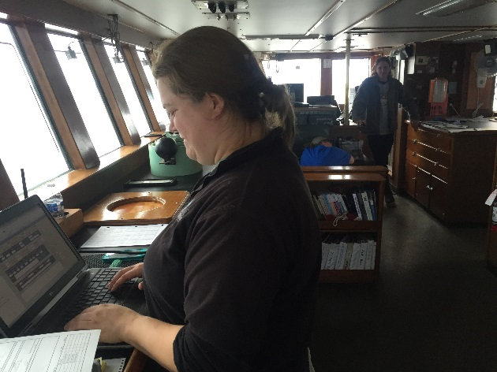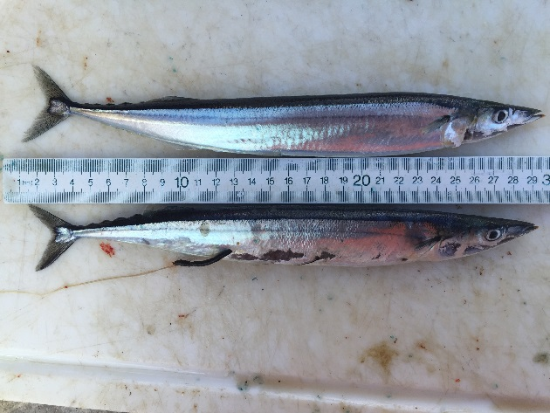
Sarah entering data, Emily & Nat on mammal watch Pacific Saury offshore

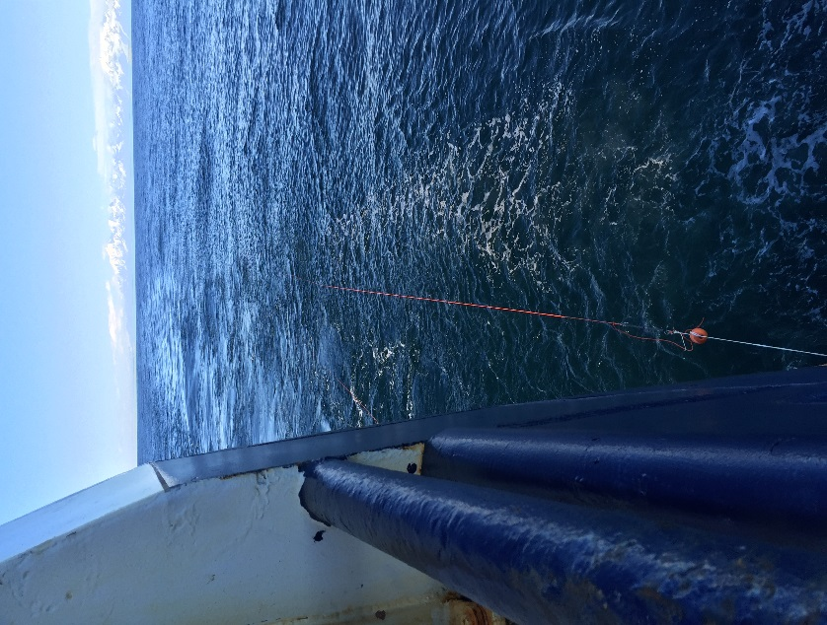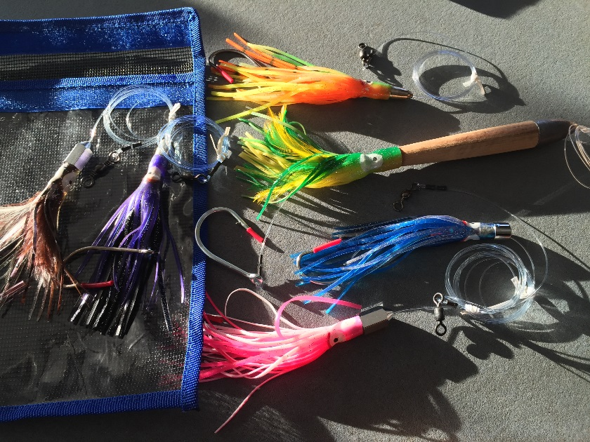
One of four tuna lines fished 20-25 fa aft Four tuna rigs (top) fished

