GOA-IERP & Seward Line CRUISE REPORT
April 26-May 9 2011

Funding Source: NPRB (plus AOOS, UAF)

Chief Scientist: Russ Hopcroft, Zooplankton, hopcroft@ims.uaf.edu
Institute of Marine Science
University of Alaska
Fairbanks, AK 99775-1080
Phone: 907-474-7842
hopcroft@ims.uaf.edu

Co-Chief Scientist: Ken Coyle, Zooplankton, IMS-UAF (coyle@ims.uaf.edu)

Scientific Personnel: Leg 1 - April 26 – May 1 (Homer to Kodiak)
Bill Floering Physics PMEL
Scott McKeever Physics PMEL
Jennifer Questel Zoo- and Ichthyoplankton (days) UAF
Imme Rutzen Zoo- and Ichthyoplankton (days) UAF
John Hogue Zoo- and Ichthyoplankton (nights) UAF
Amelia Kolb Nutrients/Chlorophyll, WWU
Dan Nabor Nutrients/Chlorophyll, UAF
Amy Tippery Floater, UAF
Toby Burke Seabirds/Mammals, FWS

Scientific Personnel: Leg 2 – May 1 – May 11 (Kodiak to Seward)
Jonathan Whitefield Physics, IMS-UAF
Jennifer Questel Zoo- and Ichthyoplankton (days) UAF
Heather Oleson Zoo- and Ichthyoplankton (days) UAF
Lisa Ershova Zoo- and Ichthyoplankton (days) UAF
John Hogue Zoo- and Ichthyoplankton (nights) UAF
Kerri Fredrickson Nutrients/Chlorophyll, WWU
Amelia Kolb Nutrients/Chlorophyll, WWU
Kristen Shake Chemistry, UAF
Amy Tippery Floater, UAF
Toby Burke Seabirds/Mammals, FWS

Scientific Purpose:
The scientific purpose of the core Seward Line project is to develop an understanding of the response of this marine ecosystem to climate variability which has been ongoing since 1998. In 2011 and 2013 the program has been expanded to survey a greater range of the shelf (Chatham Straight to Kodiak), attempting to understand how cross-shelf exchange influences primary and secondary productivity – and ultimately the survival of larval fish. Toward this end an expanded domain on the Gulf of Alaska shelf (Kodiak to PWS) determined the physical-chemical structure, primary production and the distribution and abundance of zooplankton and ichthyoplankton.
This cruise complements overlapping sampling activities by the R/V Thompson in Southeastern Alaska, and additional cruises to be conducted summer through fall over the entire domain. Some of the data will be compared with historical data sets whereas other data sets will be a product of the continuing systematic sampling effort on this shelf. This cruise marks the 15th consecutive spring cruise for the Seward Line long-term observation program (LTOP) sampling in the GOA.

Cruise Objectives
- Determine thermohaline, velocity, and nutrient structure of the Gulf of Alaska shelf, from Southern Kodiak through Prince William Sound.
- Determine phytoplankton biomass distribution.
- Determine the distribution and abundance of zoo- and ichthyoplankton.
- Determine Carbonate Chemistry (i.e. Ocean Acidification – funded through AOOS)
- Provide at-sea experience for graduate students within the UAF system

MOORINGS

- The primary purpose of the first leg was to deploy 6 moorings for the GOA-IERP in the region between Kenai Peninsula and Kodiak Island (Table 1).
- Conduct 3 lines of hydrographic stations to support these mooring (green stations).
- As time permited, we began sampling of the GOA-IERP grid.

SAMPLING

GOA-IERP GRID – 24 hrs operations, regardless of time-of-day
- Conduct tandem 20 cm (153 mesh size) and 60 cm (505 mesh size) Bongo net tows at all grid stations (Table 2) working from west to east. Deployments were made aft from the hydrographic winch, with a Seacat CTD mounted just above the nets to monitor their depth during deployment. Tows were to a maximum of 200 m or 5 – 10 m off bottom. 60 cm Net 1 (or side A) bongo sample was immediately preserved for ichthyoplankton. 60 cm Net 2 (or side B) bongo sample was sorted for fish larvae, quantitatively retaining all zooplankton, and then preserved for zooplankton. The sorted fish larvae were placed in 20 ml glass scintillation vials filled with genetic-grade ethanol.
- Conduct 505 µm mesh neuston net tows at all grid stations. Deployment was made starboard from the mid-ship crane.
- Conduct CTD casts, with bottles triggered for macro-nutrients, chlorophyll a and microzooplankton at a subset of stations. Chlorophyll size-fractionation (20 µm only) were be done at all stations – a replicate subset of macronutrients samples were prefiltered prior to freezing. Size-fractionated chlorophyll was extracted on fresh filters without freezing, while total chlorophyll was frozen for later analysis
- Primary production incubations and iron measurements originally planned for this cruise could not be conducted due to schedule overlap with the Thompson.

DAYTIME ACTIVITIES: Seward Line
- Occupy the various hydrographic transects and collect vertical CTD-chlorophyll-PAR profiles along the Seward Line and in Western PWS (see Table 3).
- Collect discrete bottle samples at these stations for nutrients, chlorophyll and microzooplankton. Chlorophyll size-fractionation (20 µm) was done at the whole numbered Seward Line and most PWS stations. Macronutrients samples were NOT prefiltered prior to freezing (although some cross-comparisons were made). Chlorophyll was BOTH extracted on fresh filters without freezing, and frozen for later analysis.
- Measure the dissolved carbonate chemistry along the Seward Line and within Prince William Sound from bottle casts.
- 1 Quad-net cast was be done (frame has 4 nets; 150 and 53 µm) after the CTD cast along the Seward Line and at PWS stations. (NO CALVETs at the “i” stations on the Seward Line).
- Measurement of Primary Productivity at Stations GAK 1, 4, 9, and 13 (and KIP2) was not completed.
- Zooplankton collections for incubation experiments were not undertaken.
- Comparisons between Bongo net, Quad-net & Multinets were not undertaken.
- Deep Multinet tows near the end of the Seward Line and at PWS2 were not possible.
NIGHTTIME ACTIVITIES: Seward Line
- Multinet discrete samples along the Seward Line, and at 3-5 PWS Stations were not possible at any stations.

Sampling Strategy
The expanded grid sampling grid involved 24 hrs operations without regard to time of day. Sampling will proceed from Southwestern Kodiak toward the Seward Line as a series of transects beginning in the southwestern grid corner during Leg 1. Station activities consisted of a CTD/bottle cast, a tandem Bongo net, and a Neuston net, with a typical station time of 1 hour. There are 53 stations on the grid at 20 nm spacing (i.e. 53 hrs of station time, 120 hrs transit time: ~ 7 days total) – we completed 47 of them, expecting to pickup the final 6 while doing the Seward Line.
Along the Seward Line, typically CTD casts and quad-net collections occur during the day and all Multinet collections occur during darkness. During May 4 nights are typically needed to complete the line (maximum 4 stations possible per night). This approach requires back-tracking over stations. In may 2011, mechanical problem with the winch prevented all Multinet sampling.

Daily Actvities
(Based on 7am-7am reporting cycle)

Monday April 25: Science team mobilized. Vessel sailed at 22:30

Tuesday Apr 26 – Tiglax was on first Gore Point Mooring site at dawn, the 3 Gore Point mooring were set and CTDs completed along the associated hydrographic line. The hydrographic line across Portlock bank was begun and completed over night, along with hydrographic stations in Sevenson’s Entrance

Wednesday Apr 27 – Kennedy Entrance hydrographic line was completed, followed by setting the mooring in both Sevenson’s and Kennedy Entrances. We headed for and deployed the Chiniak offshore mooring before midnight under flat seas, then headed to the inshore end of the western-most survey line. Over the afternoon, we encountered problems with software configuration for the SeaCat CTDs.

Thursday April 28 – Winds came up overnight, we were on our first station at dawn, then headed off shore under rapidly building seas. Upon reaching the second station it was clear conditions were too rough to sample safely and we head into the nearest bay for cover where we anchored for the night. Software problems with the Seacat were resolved.

Friday April 29 – Winds were dropping, and at dawn we headed back to the second station. Over the next 24 hours we completed lines 181 and 185. There was significant phytoplankton present in the 150 µm nets.

Saturday April 30 – Seas continued to drop and over the next 24 hours we completed line 189 and all but the inshore end of line 193.

Sunday May 1 – We broke off sampling mid morning and headed into Kodiak to do a partial science team rotation. We docked at noon, the mooring crew offloaded and left, being replaced by UAF students. We left port at 15:30 for the final station of line 193, and once finished headed for the end of line 197, completing several stations overnight. Phytoplankton in the 150 µm nets has declined.

Monday May 2 – We continued offshore along line 197, then began heading inshore along line 201. Wind has been light but a large swell was present throughout the day. We discovered an incorrect setting in the SeaSave software was misreporting elapsed time, such that prior Bongo casts were being completed in about one half of the time they should have been (i.e. one half of the desired water had been filtered by the nets). The problem was corrected. CTD bottle 4 has become unreliable at closing – the problem appears to be with the carousel, and was later resolved

Tuesday May 3 – We completed line 201 during early morning and began line 205, finishing it around midnight. Seas began relatively calm, but winds increased over the day making for bumpier sampling. CTD bottle 6 has been problematic. We began the offshore end of Line 209 during the night.

Wednesday May 4 – We completed Line 209 at 20:30, and began the inshore end of Line 213

Thursday May 5 – We completed Line 213 mid afternoon and shifted over to the Seward Line beginning with a full depth profile at Gak11, followed by Gak12 and Gak13. With 300 m depth remaining on ascent, the Dynacon hydrographic winch brake locked at 22:30 and could not be released. Attempt to make it operational failed. The wire was recovered pulling short sections aboard with the crane over the next 3 hours. Options were unclear, and ship’s course was set for Seward while we waited for Dynacon (and SMC) to begin their workdays. Uncertain as to our ability to return to the Line, we began Quadnet sampling at Gak10 with a Seacat CTD mounted beneath the nets. Niskin bottle casts to 10 and 20 meters, plus a surface sample by pail, were used to sample nutrients and chlorophyll. Together both activities took 15 minutes per station, delaying the return to Seward by less than 3 hours …

Friday May 6 – Communications with Dynacon and SMC allowed us to determine the winch failure to be the gear-box and non-serviceable. We completed sampling Gak1 at ~18:00, then headed for SMC. We were met at the SMC dock by Steve Hartz and Dave Leach at ~20:00. We mobilized a small portable winch and rosette to which we mounted the Seacat. The system was installed and fully tested by 02:30. After at test cast at RES2.5, we reached Gak1 at 04:40 beginning a series of CTD and bottle casts (limited to 250m by wire length) along the Seward Line.

Saturday May 7 – CTD and bottle sampling continued along the Seward line heading offshore until Gak10, the “intermediate” stations along the line were skipped. Due to the size of the winch, it was not capable of Multinet deployments. We headed for PWS at ~17:00.

Sunday May 8 – We began CTD/bottle and Quadnet sampling in the Sound at dawn working our way up Knight Island Passage, across the top and back down to Hogan Bay and out Montague Strait. We reached Seward at ~02:30

Monday May 9 – We finished offloading Tiglax by 08:00, organized the offloaded material and departed for home. The cruise has been shortened by 2 days due to our inability to conduct night sampling and deletion of the intermediate stations. Unused ship days will be ‘banked’ for the fall cruise.

Despite loss of the winch, we basically completed all planned activities except for Multinet collections, and sampling activities along Line 217

Stations and Cruise TRACK
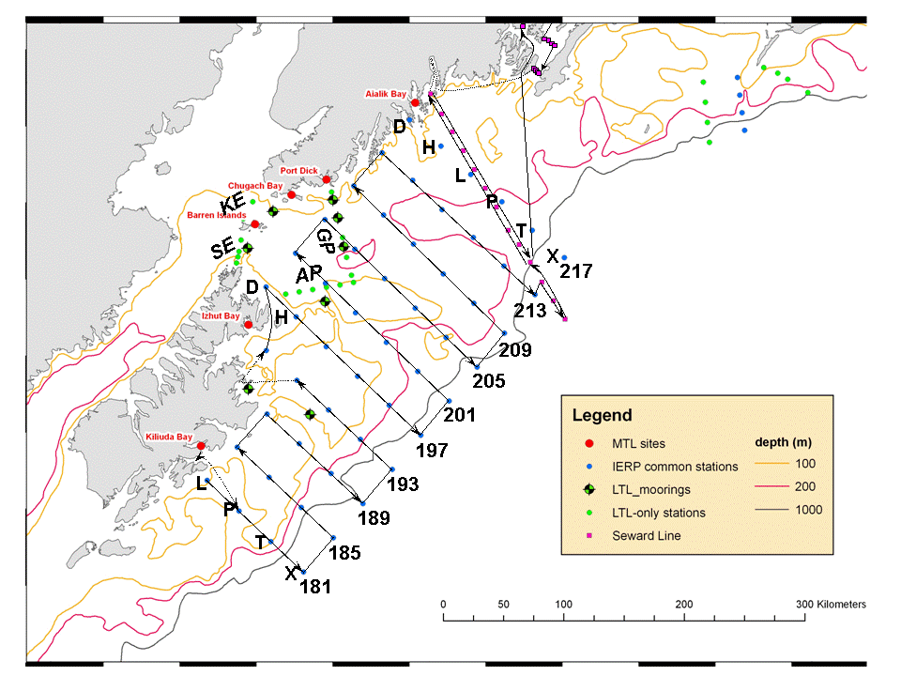
Table 1 – Mooring Locations
Mooring ID | Depth (m) | Descriptor | Longitude | Latitude
11GPP-32A | 157 m | Gore Point, inshore | -150.990 | 59.100
11GPP-34A | 144 m | Gore Point, mid | -150.933 | 58.967
11GPP-36A | 185 m | Gore Point, offshore | -150.867 | 58.750
11KEP-41A | 191 m | Kennedy Entrance | -151.867 | 59.033
11SVP-39A | 121 m | Stevenson Entrance | -152.250 | 58.767
11PCP-1A | 120 m | Portlock Canyon | -151.167 | 58.350
11CB-1A | 193 m | Chiniak Bay | -152.292 | 57.720
11CBP-3A | 146 m | Chiniak Bay, offshore | -151.443 | 57.517

Table 2. GOA-IERP CGOA FOCI stations

Station Name | Habitat | Longitude |  | Latitude
hl181 | shelf | -152.890 | 57.048
hp181 | shelf | -152.463 | 56.816
ht181 | shelf | -152.040 | 56.582
hx181 | slope | -151.614 | 56.348
hl185 | shelf | -152.466 | 57.290
hp185 | shelf | -152.037 | 57.061
ht185 | slope | -151.615 | 56.828
hx185 | slope | -151.192 | 56.594
hl189 | shelf | -152.040 | 57.532
hp189 | shelf | -151.611 | 57.304
ht189 | slope | -151.189 | 57.073
hx189 | slope | -150.770 | 56.838
hh193 | shelf | -152.025 | 58.003
hl193 | shelf | -151.611 | 57.773
hp193 | shelf | -151.186 | 57.545
ht193 | shelf | -150.764 | 57.315
hx193 | slope | -150.348 | 57.081
hd197 | shelf | -152.003 | 58.474
hh197 | shelf | -151.590 | 58.245
hl197 | shelf | -151.179 | 58.015
hp197 | shelf | -150.760 | 57.785
ht197 | shelf | -150.339 | 57.557
hx197 | slope | -149.926 | 57.322
hd201 | shelf | -151.563 | 58.716
hh201 | shelf | -151.152 | 58.487
hl201 | shelf | -150.744 | 58.257

Station Name | Habitat | Longitude | Latitude
ht201 | slope | -149.913 | 57.796
hx201 | slope | -149.504 | 57.561
hd205 | shelf | -151.119 | 58.958
hh205 | shelf | -150.712 | 58.729
hl205 | shelf | -150.306 | 58.499
hp205 | shelf | -149.897 | 58.267
ht205 | slope | -149.488 | 58.034
hx205 | slope | -149.081 | 57.799
hd209 | shelf | -150.678 | 59.197
hh209 | shelf | -150.268 | 58.971
hl209 | shelf | -149.865 | 58.741
hp209 | shelf | -149.465 | 58.505
ht209 | shelf | -149.061 | 58.272
hx209 | slope | -148.661 | 58.034
hd213 | shelf | -150.242 | 59.431
hh213 | shelf | -149.819 | 59.214
hl213 | slope | -149.421 | 58.983
hp213 | slope | -148.999 | 58.761
ht213 | shelf | -148.593 | 58.530
hx213 | slope | -148.185 | 58.299
hd217 | shelf | -149.806 | 59.664
hh217 | shelf | -149.371 | 59.454
hl217 | shelf | -148.967 | 59.228
hp217 | slope | -148.544 | 59.008
ht217 | slope | -148.143 | 58.777
hx217 | slope | -147.723 | 58.554

Table 3. SEWARD LINE LTOP STANDARD STATIONS
Latitude N  (degrees, minutes) |  | Longitude W  (degrees, minutes) |  |  | Station Name
Resurrection Bay Station
60 | 1.5 | 149 |  | 21.5 | RES2.5
Seward Line
59 | 50.7 | 149 |  | 28 | GAK1
59 | 46 | 149 |  | 23.8 | GAK1I
59 | 41.5 | 149 |  | 19.6 | GAK2
59 | 37.6 | 149 |  | 15.5 | GAK2I
59 | 33.2 | 149 |  | 11.3 | GAK3
59 | 28.9 | 149 |  | 7.1 | GAK3I
59 | 24.5 | 149 |  | 2.9 | GAK4
59 | 20.1 | 148 |  | 58.7 | GAK4I
59 | 15.7 | 148 |  | 54.5 | GAK5
59 | 11.4 | 148 |  | 50.3 | GAK5I
59 | 7 | 148 |  | 46.2 | GAK6
59 | 2.7 | 148 |  | 42 | GAK6I
58 | 58.3 | 148 |  | 37.8 | GAK7
58 | 52.9 | 148 |  | 33.6 | GAK7I
58 | 47.5 | 148 |  | 29.4 | GAK8
58 | 44.6 | 148 |  | 25.2 | GAK8I
58 | 40.8 | 148 |  | 21 | GAK9
58 | 36.7 | 148 |  | 16.7 | GAK9I
58 | 32.5 | 148 |  | 12.7 | GAK10
58 | 23.3 | 148 |  | 4.3 | GAK11
58 | 14.6 | 147 |  | 56 | GAK12
58 | 5.9 | 147 |  | 47.6 | GAK13
Prince William Sound Stations
60 | 22.78 | 147 |  | 56.17 |  | PWS1
60 | 32.1 | 147 |  | 48.2 |  | PWS2
Knight Island Passage Station
60 | 16.7 | 147 | 59.2 |  |  | KIP2
Hogan Bay Line
60 | 11.57 | 147 | 42 |  |  | HB1
60 | 10.754 | 147 | 38.5 |  |  | HB2
60 | 9.855 | 147 | 34.508 |  |  | HB3
60 | 8.807 | 147 | 30.04 |  |  | HB4
Montague Strait Line
59 | 57.257 | 147 | 55.602 |  |  | MS1
59 | 56.6 | 147 | 53.7 |  |  | MS2
59 | 55.9 | 147 | 51.4 |  |  | MS3
59 | 55.2 | 147 | 49.7 |  |  | MS4

