Preliminary Results from the Acoustic-Trawl Survey of the Eastern Bering Sea Shelf, OD0809

All of the following results are preliminary

Comments should be directed to:
Taina Honkalehto (206) 526-4237, taina.honkalehto@noaa.gov or
Neal Williamson (206) 526-6417, neal.williamson@noaa.gov

Area / Time of Operations: Eastern Bering Sea shelf, between 161○ W and 178○ E longitude, 2 June - 31 July 2008, Three survey legs. Survey extended into the Russian EEZ to 178○ E.

Materials:

Vessel: NOAA Ship Oscar Dyson

Acoustic System: Simrad ER60 echosounder system (18, 38, 70, 120 and 200 kHz). System calibrated before/after cruise, and during in ports in Captains Bay, Dutch Harbor, AK. Results indicated good performance; no significant instrument drift occurred during the survey.

Nets: Aleutian wing trawl (AWT--midwater trawl, head/foot rope 270 ft, vertical opening 90 ft, codend liner 0.5”), 83-112 bottom trawl (without roller gear, codend liner 1.25”), and Methot net (rigid 8 x 8 ft square mouth opening, 3x2 mm oval mesh body, 1mm codend mesh) for sampling larval fish and zooplankton.

Miscellaneous: Vessel comparison conducted with NOAA ship Miller Freeman (including 1 acoustic-buoy deployment), AWT codend-mesh liner comparison (0.5” and 1.25”), ME-70 multi-beam echosounder and Drop-TS tests/data were collected. BSIERP activities included CTD-fluorometer and XBT casts, underway water sample collections (salinity, chlorophyll fluorescence, oxygen, nutrients) to calibrate shipboard seawater monitoring system, and shipboard laboratory measurements of live zooplankton (primarily euphausiids) for TS-modeling.

Methods:

The acoustic survey design consisted of parallel, regularly spaced (20 nmi), north-south oriented transects. The survey was conducted from east to west at 11.5 - 12.5 kts. Total hauls included: 78 AWT, 42 Methot, and 13 bottom trawl. Sixty-two CTD casts and 92 XBT drops made. Eight of 31 transects (5 AWT, 1 bottom trawl, 5 Methot hauls) were in Russian waters.

Following completion of formal EIT survey, paired codend work consisted of 22 hauls (11 pairs) completed in 5 different areas where juvenile (2-3 year-old) and adult pollock were thought to occur.

At night, activities included collecting ME-70 data on juvenile pollock or rockfish schools, Drop-TS tests, and acoustic- buoy work (1 deployment with DY only (17 passes), 1 deployment with MF & DY (7 passes by each vessel)). Nighttime BSIERP work included CTDs and 10 Methot tows for TS-modeling project.

Preliminary Findings:

EIT Survey:

1) Pollock were detected throughout the surveyed area; most fish occurred west of the Pribilofs and particularly west from 176º W to the convention line (Fig 1).

2) Pollock size composition ranged from 11 to 79 cm FL. The dominant adult length modes were 51 cm east of 170ºW and 47 cm west of 170ºW (Fig 2). Juvenile pollock (<37 cm; likely 2-3 yr olds), were more abundant west of the Pribilofs. Few age-one fish were encountered. The 2006 yr class (2-yr olds; 18-29 cm FL) still appears to be relatively strong.

3) The vessel comparison study was limited to 3 days (excluding transit to/from site) due to Miller Freeman mechanical problems. About 500 nmi of useful side-by-side vessel data were collected. One acoustic-buoy deployment (7 passes by each vessel) was made over juvenile (age 2) pollock.

MACE BSIERP –

1) The euphausiid TS modeling project collected enough live specimens of Thysanoessa spinifera and T. rashii, and made sufficient measurements on the animals to satisfy project objectives. Several additional zooplankton species were also evaluated for material properties.

2) Bottom temperatures were generally less than 1°C on the shelf between 50 and 100m and greater than 3°C on the shelfbreak (Fig 3). The cool water layer extended into shallower water as the water depth decreased (Fig 4).

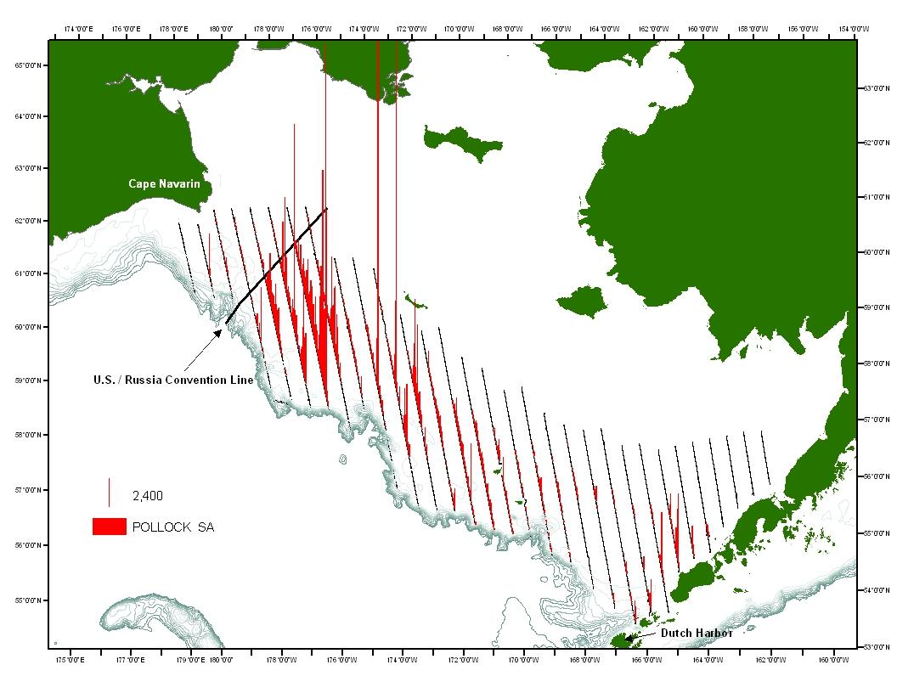
Figure 1: Distribution of midwater walleye pollock S_{A} (between 3m off the bottom and 16m below the surface), as surveyed by NOAA Ship Oscar Dyson in the eastern Bering Sea during June and July 2008. Transects numbered from 1 to 31 beginning in the east.

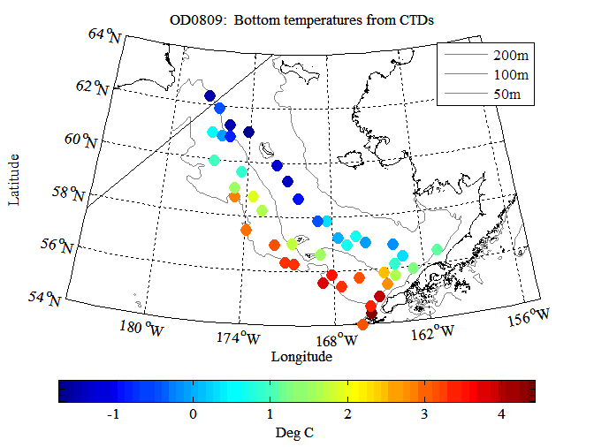
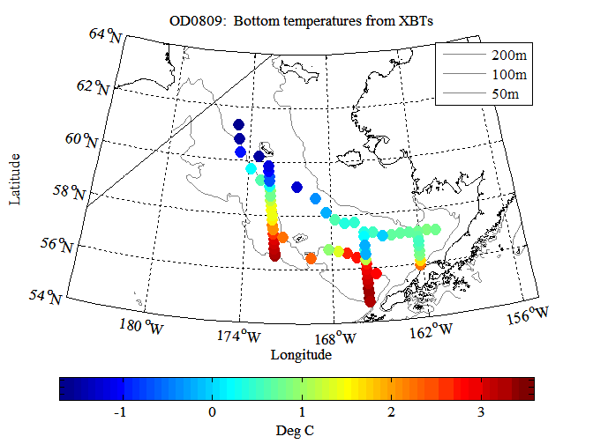
Figure 3. Bottom temperatures recorded from CTD (top) and XBT (bottom) casts during the summer EBS pollock survey (Leg 3 data not included). Transects with continuous casts are, from east to west, 3, 9, and 19.
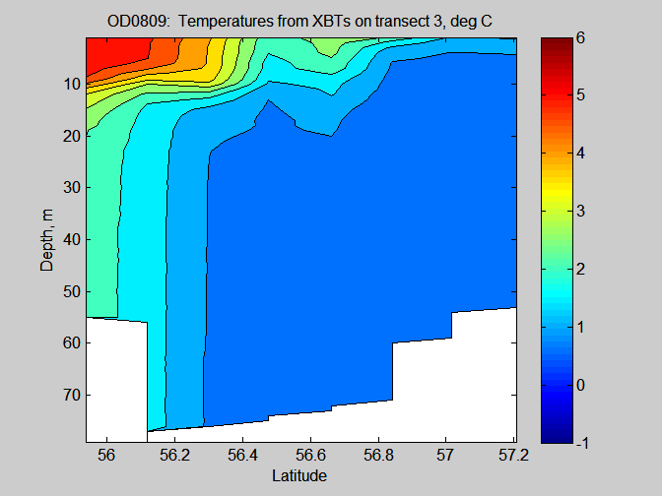
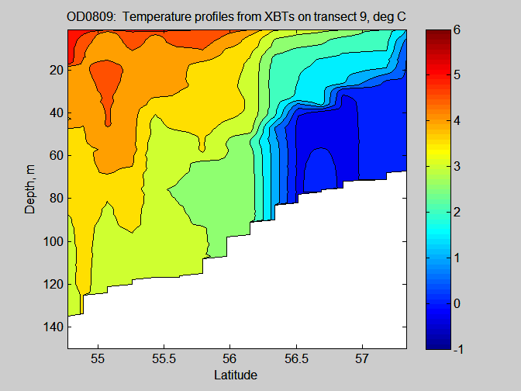
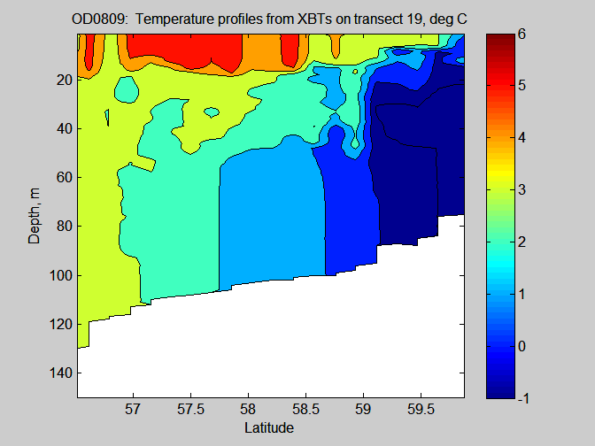

Figure 4. XBT temperature contour with depth for transects 3 (top), 9 (middle), and 19 (bottom) from the summer eastern Bering Sea walleye pollock survey.

