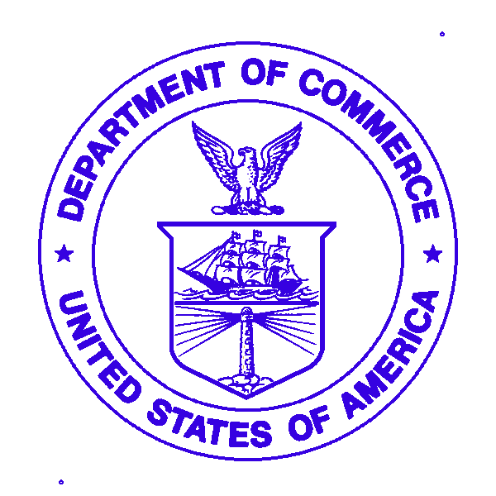 April 30, 2010
U.S. DEPARTMENT OF COMMERCE

National Oceanic and Atmospheric Administration

NOAA Ship Oscar Dyson - R224

1801 Fairview Ave East, Seattle, WA 98102

Mary
Mountain View Elementary School
36803 Allder School Road
Purcellville, VA 20132

Dear Mary,

Yes, there really was a white whale. He wasn’t pure white, he was more bleached. In February 2008, the albino killer whale was seen in the western Aleutians fisheries survey . The white killer whale was spotted with its pod about two miles off Kanaga Volcano, part of Alaska's Aleutian Islands. At the time, the Dyson was on a research mission assessing pollock fish stocks near Steller sea lion haul-out sites. I‘m sure you will read or Mr. Jenkins will tell you about Moby Dick by Herman Melville – a story about an albino Sperm Whale?

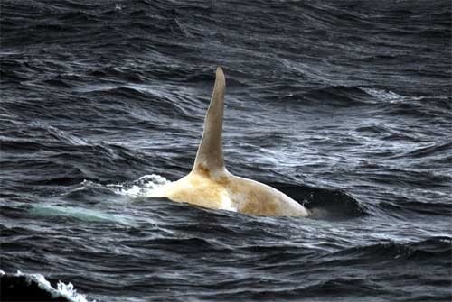
White killer whale swimming with its pod near the Aleutian Islands
Photo credit: H. Fearnbach, NMML, NMFS permit 782-1719

Your other question about Styrofoam -- for as long as styrofoam has been brought out to sea we’ve been shrinking cups or heads when operations call for deeper CTD’s. The deeper the CTD cast, the more the styrofoam bubbles shrink in the head and cups. Once they shrink, they don’t re-expand. We shall see if your lady head is more beautiful after being shrunk. Once you get all the cups back there, the class will have to figure out how to arrange the letters on the bottoms of the cups to spell out a message.

This is a picture from last year of the moorings the ship puts in the ocean to gather data. The ice is more present this year, so it has been a challenge to deploy the surface moorings. We do not want to put the mooring out, only to have them damaged by the ice floes and not able to collect data.

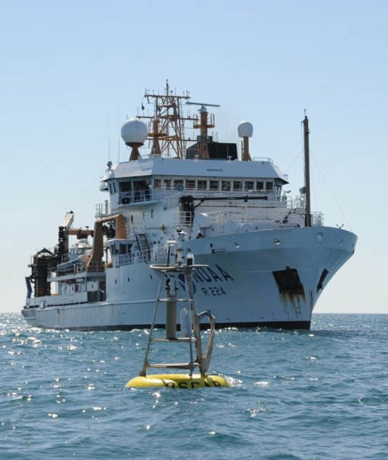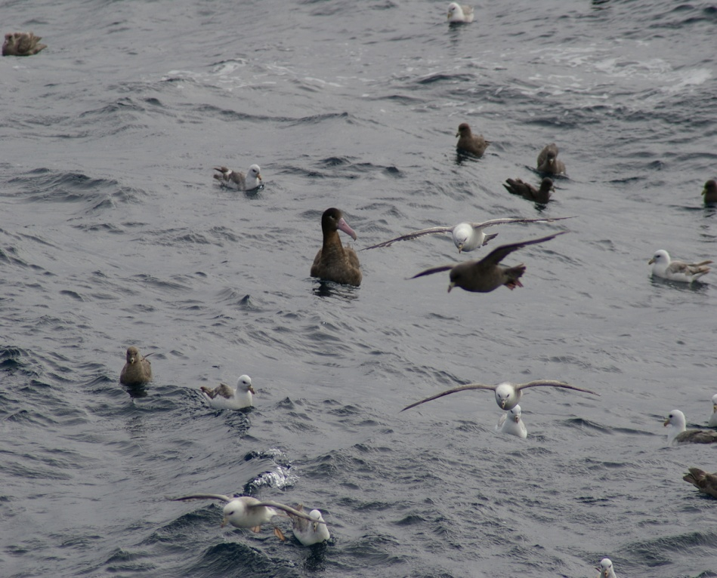

Some times on deep bottom trawls, scientists will find new species. On the surface, we occasionally see rare birds and animals. The short-tailed albatross is one of the rarer birds we see on the summer Bering Sea surveys. They have a characteristic bubble-gum colored beak.

Thank you very much for all the treats. The officers, crew, and scientists all enjoyed them.

Hope you find a good use for your shrunken cup.

Best regards,
Captain Mike

