Description of Underway pCO₂ System and data collected onboard the container ship Natalie Schulte from October 2010 through June 2012.

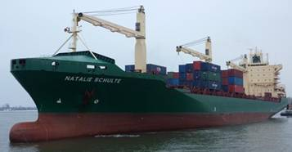

Under the support of NOAA's Climate Program Office (CPO), the Pacific Marine Environmental Laboratory (PMEL) is collaborating with other NOAA investigators and academic partners to document ocean carbon sources and sinks by outfitting research ships and commercial vessels with automated carbon dioxide sampling equipment to analyze the carbon exchange between the ocean and atmosphere. From the fall of 2010 through the spring of 2012, PMEL deployed an underway pCO₂ system on the Hamburg Sud container ship Natalie Schulte. The Natalie Schulte regularly traveled between Long Beach, California, and New Zealand, an important and dynamic equatorial Pacific region for sea surface flux of CO₂.

This report documents the underway pCO₂ measurements collected during 9 transits across the Pacific from March 2011 through June 2012. Two additional transits from October and December, 2010, are published in DOI 10.3334/CDIAC/OTG.VOS_NATALIE_SCHULTE_LINES.

PI:
Dr. Richard Feely
NOAA/PMEL
7600 Sand Point Way NE
Seattle, WA 98115
(206) 526-6214
Richard.A.Feely@noaa.gov

Data Processing and QC:
Catherine Cosca
NOAA/PMEL
7600 Sand Point Way NE
Seattle, WA 98115
(206) 526-6183
Cathy.Cosca@noaa.gov

System Installation, Maintenance, Troubleshooting:
Geoff Lebon
NOAA/PMEL
7600 Sand Point Way NE
Seattle, WA 98115
(206) 526-6884
Geoffrey.T.Lebon@noaa.gov

Ship Name: Natalie Schulte
Call Sign: C4AJ2
Country: Germany
Ship Owner: Schulte Thomas Reederei

Spatial and Temporal Coverage:
See table below for details on each cruise.

Cruises included in DOI 10.3334/CDIAC/OTG.VOS_NATALIE_SCHULTE_LINES:
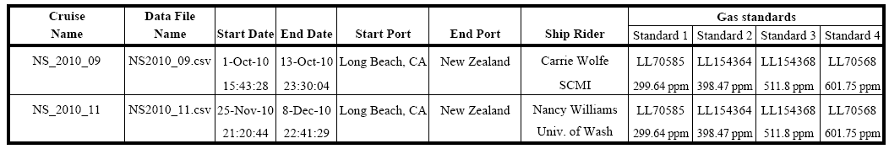
Cruises included in this report:
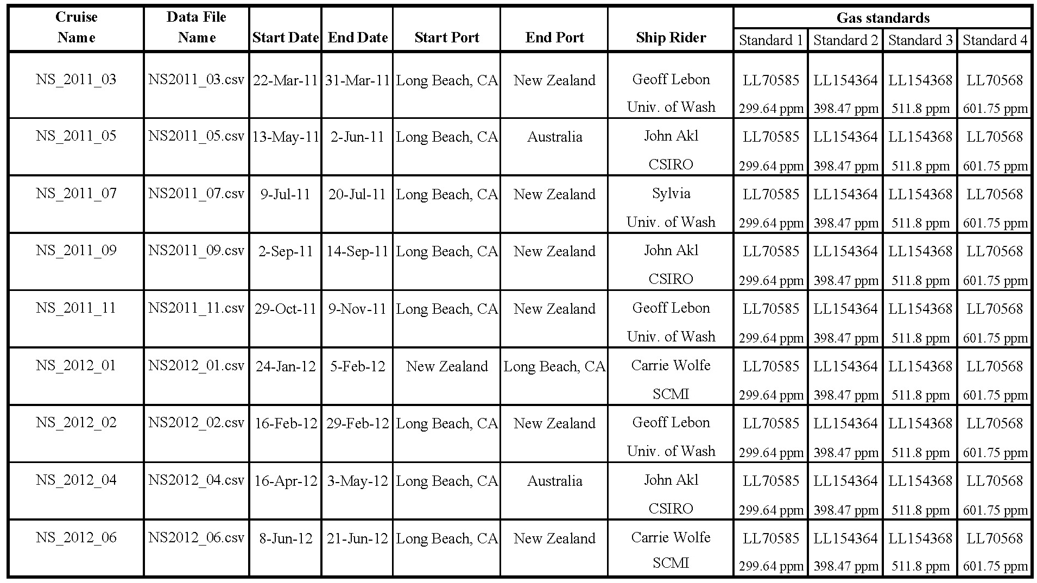

Location of data: www.pmel.noaa.gov/co2/

Experiment Name: pCO₂ on Ships

Sponsor: NOAA Climate Program Office/Climate Observation Division

Name/Model of pCO2 System: GO8050, built by General Oceanics.

Method Description:
Equilibrator type/specifications: Showerhead, volume of ~0.5 L with a headspace of ~ 0.8 L.
Water Flow rate: 3.5 L/minute
Headspace gas flow rate: 60 ml/minute
Measurement method: Infrared absorption of dried gas.
CO₂ Sensor: Licor 7000, Serial # IRG4-0560
Resolution/Uncertainty: ± 2 µatm for equilibrator measurements, ± 0.1 ppm for atmospheric measurements.

Temperature and salinity measurements:
Equilibrator Temperature: Hart Scientific model 1521 digital thermometer, serial number A77488, with an NIST traceable model 5610 thermistor probe, serial number A690613. Accurate to ± 0.01°C.
Sea Surface Temperature: A Seabird SBE 48 Hull mounted temperature probe, serial number 480024, was installed on hull approximately 10m below the sea surface. The SBE 48 was calibrated annually, with a reported accuracy of ± 0.01°C. Temperature was also measured at the seawater intake with a Seabird SBE 21 sensor. Accuracy: ± 0.01°C, Precision: ± 0.001°C.
Salinity: A Seabird SBE 45 thermosalinograph, serial number 4548581-0238, was mounted next to the underway pCO₂ system in the engine room. The unit was calibrated annually and provided salinity accurate to 0.1.

Pressure measurements: Pressure inside the equilibrator was measured with a Setra 239 differential pressure transducer, accurate to ± 0.15 hPa. The equilibrator was passively vented to a secondary equilibrator, and the Licor sample output was vented to the laboratory when CO2 measurements were made, thus equilibrator headspace pressure was assumed to be laboratory pressure. Pressure in the laboratory was measured with a GE Druck barometer with an accuracy of ± 0.01 %fs. A Druck barometer was also placed on the flying bridge of the ship for atmospheric pressure measurements.

Standard gases:
Standard gases are supplied by NOAA’s Climate Monitoring Diagnostics Laboratory in Boulder, CO, and are directly traceable to the WMO scale. Any value outside the range of the standards should be considered approximate, although the general trends should be indicative of the seawater chemistry. See attached table for standard concentrations for each cruise.

Sampling Cycle:
The system runs a full cycle in approximately 6 hours. The cycle starts with 4 standard gases, then measures two cylces of 6 atmospheric samples followed by 60 surface water measurements. Each new gas is flushed through the Licor Analyzer for 3 minutes prior to a 10 second reading from the analyzer during which the sample cell is open to the atmosphere. Subsequent samples of the same gas are flushed through the Licor Analyzer for 180 seconds prior to a stop-flow measurement.

Units:
All xCO₂ values are reported in parts per million by volume (ppmv) and fCO₂ values are reported in microatmospheres (µatm) assuming 100 % humidity at the equilibrator temperature.

Calculations:
The measured xCO₂ values are linearly corrected for instrument response using
the standard measurements.

Mixing ratios of dried equilibrated headspace and air are converted to fugacity of CO₂ in surface seawater and water saturated air in order to determine the fCO2. For ambient air and equilibrator headspace the fCO₂a, or fCO₂eq is calculated assuming 100% water vapor content:

fCO₂a/eq = xCO₂a/eq(P-pH₂O)exp(B₁₁+2d₁₂)P/RT

where fCO2a/eq is the fugacity in ambient air or equilibrator, pH₂O is the water vapor
pressure at the sea surface temperature, P is the barometric pressure, T is the
SST or equilibrator temperature (in K) and R is the ideal gas constant
(82.057 cm³·atm·deg⁻¹·mol⁻¹). The exponential term is the fugacity correction where
B₁₁ is the second virial coefficient of pure CO₂

B₁₁ = -1636.75 + 12.0408T - 0.032795T² + 3.16528E-5 T³

and d₁₂ = 57.7 - 0.118 T

is the correction for an air-CO₂ mixture in units of cm³·mol⁻¹ (Weiss, 1974).

The calculation for the fugacity at SST involves a temperature correction term for the
increase of fCO₂ due to heating of the water from passing through the pump and through
5 cm ID PVC tubing within the ship. The water in the equilibrator is typically 0.2 °C
warmer than sea surface temperature. The empirical temperature correction from
equilibrator temperature to SST is outlined in Weiss et al. (1982).

Δln(fCO₂)=(Teq-SST)(0.0317-2.7851E-4 Teq - 1.839E-3 ln(fCO₂eq))

where Δln(fCO₂) is the difference between the natural logarithm of the fugacity at Teq
and SST, and Teq is the equilibrator temperature in degrees C.

A detailed description of calculations and QC procedures can be found in Pierrot et al. (2009).

File Format

COLUMN HEADER DESCRIPTION

1. GROUP/SHIP: PMEL/Natalie Schulte

2. CRUISE_ID: NS_<Year>_<month>

3. JD_GMT: Decimal year day

4. Date_DDMMYYYY Date in the format DDMMYYYY

5. TIME_HH:MM:SS: GMT HH:MM:SS

6. LAT_DEC_DEGREE: Latitude in decimal degrees (negative values are in
southern hemisphere).

7. LONG_DEC_DEGREE: Longitude in decimal degrees (negative values are
in western latitudes).

8. xCO2W_PPM: Mole fraction of CO₂ (dry) in the headspace
equilibrator at equilibrator temperature (Teq) in
parts per million. Water comes from bow intake 5m below the water line.

9 xCO2A_PPM: Mole fraction of CO₂ in air in parts per million.

10 xCO2A_INTERPOLATED_PPM: xCO₂atm_ppm averaged linearly to match up with
measurements xCO₂eq_ppm

11 PRES_EQUIL_hPa: Barometric pressure in the equilibrator

12 PRES_SEALEVEL_hPa: Barometric pressure in the atmosphere

13. EqTEMP_C: Temperature in the equilibrator water.

14. SST(TSG)_C: Temperature from the ship's bow intake.

15. SAL(TSG)_PERMIL: Thermosalinograph salinity

16. fCO2W@SST_uATM: Fugacity of CO₂ in sea water in
microatmospheres calculated as outlined in the DOE Handbook.

17. CO2A_uATM: Fugacity of CO₂ in air in microatmospheres

18. dfCO2_uatm: Sea water fCO₂ - air fCO₂ in microatmospheres.

19. QC_FLAG: Quality control flag 2 = Good value
3 = Questionable value
4 = Bad value

20. QC_SUBFLAG: Descriptive quality control flag used when a value
receives a “3” QC flag
1 = Outside of Standard Range
2 = Questionable/interpolated SST
3 = Questionable EQU temperature
4 = Anomalous ΔT (EqT – SST)( ± 1°C)
5 = Questionable Sea Surface Salinity
6 = Questionable pressure
7 = Low EQU gas flow
8 = Questionable air value
9= Interpolated standard value
10 = Other, see metadata

References

DOE (1994). Handbook of methods for the analysis of the various parameters of the carbon
dioxide system in sea water; version 2. A.G. Dickson and C. Goyet, eds., ORNL/CDIAC-74.
Feely, R.A., R. Wanninkhof, H.B. Milburn, C.E. Cosca, M. Stapp, and P.P. Murphy (1998). A new automated underway system for making high precision pCO₂ measurements onboard research ships, Analytica Chim. Acta, 377, 185-191, 1998.
Pierrot, D., C. Neill, K. Sullivan, R. Castle, R. Wanninkhof, H. Luger, T. Johannessesn, A. Olsen, R. A. Feely, C. E. Cosca (2009). Recommendations for autonomous underway pCO2 measuring systems and data-reduction routines. Deep Sea Research Part II: Topical Studies in Oceanography, Volume 56, Issues 8-10, Pages 512-522.
Wanninkhof, R. and K. Thoning (1993) Measurement of fugacity of CO₂ in surface water using
continuous and discrete sampling methods. Mar. Chem. 44(2-4): 189-205.
Weiss, R. F. (1970) The solubility of nitrogen, oxygen and argon in water and seawater.
Deep-Sea Research 17: 721-735.
Weiss, R. F. (1974) Carbon dioxide in water and seawater: the solubility of a non-ideal gas.
Mar. Chem. 2: 203-215.
Weiss, R. F., R. A. Jahnke and C. D. Keeling (1982) Seasonal effects of temperature and
salinity on the partial pressure of CO₂ in seawater. Nature 300: 511-513.

For questions or comments contact:
Catherine Cosca
NOAA/PMEL
7600 Sand Point Way NE
Seattle, WA 98115
206-526-6183
cathy.cosca@noaa.gov

