Columbus Waikato/Cap Victor Master Readme File

As CO₂ concentrations increase in the atmosphere due largely to fossil fuel combustion and deforestation, it becomes increasingly important to understand the fate of this gas as it leaves the atmosphere. By measuring the partial pressure of CO₂ (pCO₂) in both the sea surface and atmosphere, the flux of CO₂ either into or out of the ocean can be calculated, affording a broader understanding of the distribution of CO₂ in the surface ocean.
In 2004, PMEL installed an underway pCO₂ system on the container ship Columbus Waikato to monitor atmospheric and surface water CO₂ concentrations as the ship traversed the Pacific Ocean from the western united states to New Zealand. In the time period between Feb 2004 and Feb 2006 we collected 13 data sets along this ship track.

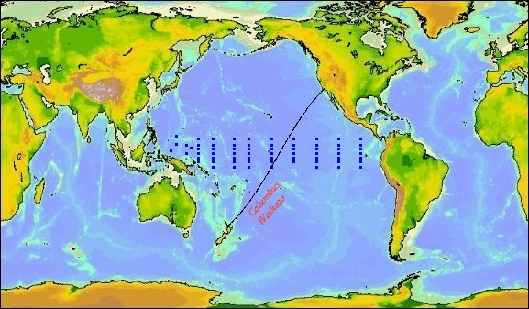

In March, 2006, the ship changed it’s route to as well as it’s name. The ship is now the Cap Victor, and the new ship track is shown below.

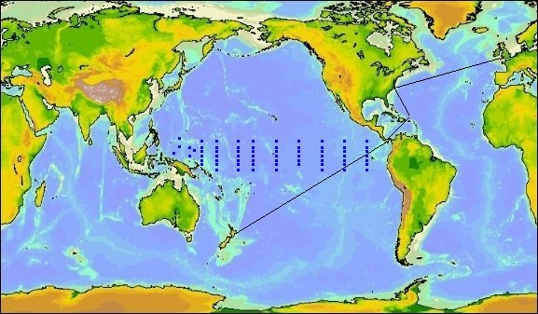

PMEL continues to measure pCO₂ while the Cap Victor is transiting the Pacific Ocean.

Analysis Method

The Underway pCO₂ system utilizes a Licor 6262 Infrared Analyzer (IR) to determine the mole fraction of CO₂ in the air and surface seawater. Seawater from an intake in the bow is continuously supplied to a plexiglas equilibrator consisting of a ~0.5 L water reservoir and ~0.8 L gaseous headspace. The water is showered into the equilibrator at a rate of approximately 2 liters/minute, and the headspace gas is circulated at a rate of 60 to 80 ml/minute. As the water flows through the equilibrator chamber, the dissolved CO₂ gas partitions between the water and the headspace. This air is subsequently sampled by the Licor analyzer to determine the mole fraction of CO₂ in the seawater. In the Licor, infrared radiation is passed through two gas sampling cells to detect the CO₂ absorption of the gases in the cells. The reference cell is continuously supplied with dried air scrubbed of CO₂, and the sample cell is supplied with the gas being measured. The IR outputs a reading proportional to the difference between the CO₂ absorption detected in the two cells. Because it is necessary for the gases in the reference and sample cells of the Licor analyzer to be at the same pressure, the flow of gas is halted for several seconds before the IR readings are saved so that both cells will be at ambient pressure.
Atmospheric air is also continuously supplied to the pCO₂ instrumentation by a 3/8” Decaron aluminum-lined tube that runs from the engine room, through several decks, then along the port side of the ship to the bow. Both the atmospheric air and the equilibrator air pass through naphion tubing and silica gel to condense and trap moisture.

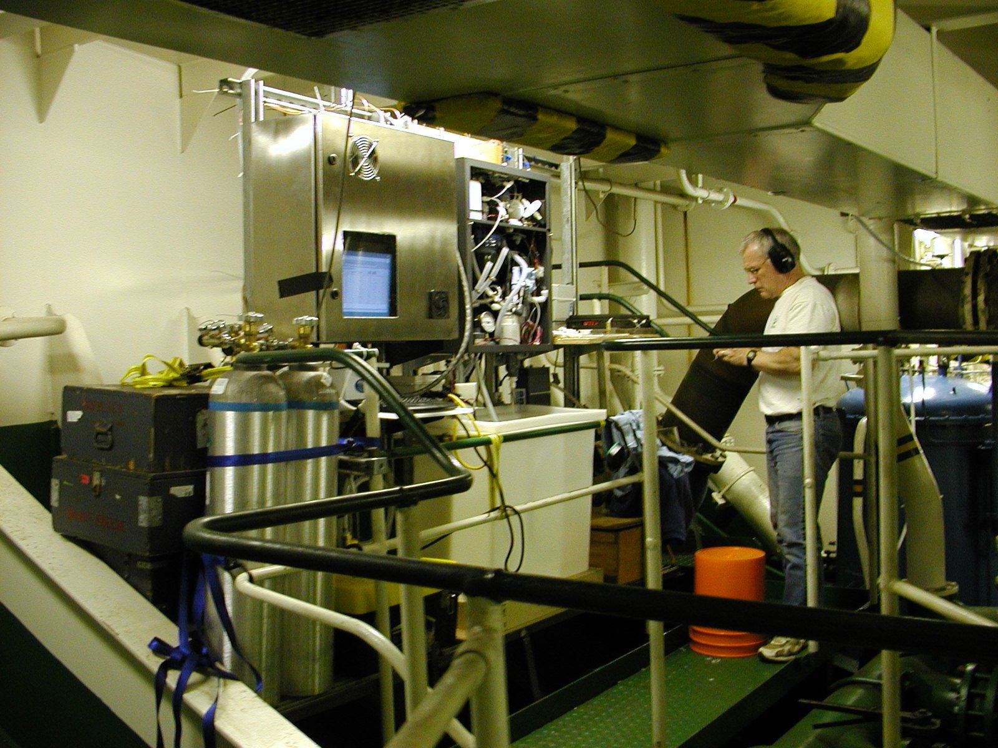

In addition to CO₂ values, the system collects the following data:
Surface seawater temperature at the seawater intake
Seawater temperature from the equilibrator
Conductivity and salinity from a Seabird TSG mounted next to the pCO₂ system
Barometric pressure in the Licor, and in the equilibrator
Latitude and longitude from a GPS mounted near the bridge
Sea surface temperature, salinity, and barometric pressure are necessary to calculate partial pressure of CO₂ (pCO₂) or fugacity (fCO₂) from the mole fraction values that are measured at the Licor IR. Equilibrator temperatures are used to correct for warming that occurs in the sea water as it travels from the bow intake to the wet lab since pCO2 is temperature dependant. Calculations of pCO₂ and fCO₂ are detailed in the Department of Energy handbook of methods for the analysis of the various parameters of the carbon dioxide system in sea water; version 2.
The underway pCO₂ system completes a full cycle of measurements every 112 minutes. The cycle starts with 4 standard gases traceable to the WMO scale, then measures 10 atmospheric samples, followed by 60 surface water samples. Each new gas is flushed through the Licor Analyzer for 4 minutes prior to a 10 second reading from the analyzer during which the sample cell is open to the atmosphere. Subsequent samples of the same gas are flushed through the Licor Analyzer for 30 seconds prior to a stop-flow measurement.

File Format

COLUMN HEADER DESCRIPTION
1. Group/Ship: PMEL/Waikato or PMEL/CapVictor

2. Cruise_ID: CW<Year>_<Month> or CV<Year>_<Month>

3. JD_GMT: Decimal year day

4. Date_MM/DD/YY: Date in the format mm/dd/yy

5. Date_DDMMYYYY Date in the format DDMMYYYY

6. Time: GMT HH:MM:SS

7. Latitude: Latitude in decimal degrees (negative values are in
southern hemisphere).

8. Longitude: Longitude in decimal degrees (negative values are
in western latitudes).

9. xCO2eq_ppm: Mole fraction of CO2 (dry) in the headspace
equilibrator at equilibrator temperature (Teq) in
parts per million. Water comes from bow intake 2m below the water line.

10. xCO2atm_ppm: Mole fraction of CO2 in air in parts per million.

11. xCO2_atm_ave_ppm: xCO2atm_ppm averaged linearly to match up with
measurements xCO2eq_ppm

12. Press_Equ_mbar: Barometric pressure in the equilibrator

13. Teq_°C: Temperature in the equilibrator water.

14. SST_°C: Temperature from the ship's bow intake.

15. Salinty: Thermosalinograph salinity

16. H2O_flow_l/min: Water flow through equilibrator in liters/minute.

17. IR_gas_flow_ml/min: Gas flow through the Licor infrared analyzer
before the flow is stopped in ml/minute.

18. Temp_IR_°C Temperature of the Licor sample cell in °C

19. fCO2sw _uatm: Fugacity of CO2 in sea water in
microatmospheres calculated as outlined in the DOE Handbook.

20. fCO2a_uatm: Fugacity of CO2 in air in microatmospheres

21. dfCO2_uatm: Sea water fCO2 - air fCO2 in microatmospheres.

22. QC Flag Quality control flag 2 = Good value
3 = Questionable value
4 = Bad value

23. Sub Flag Descriptive quality control flag used when a value
receives a “3” QC flag
1 = Standard out of range
2 = Questionable SST
3 = Questionable EqT
4 = Anomalous ΔT (EqT – SST)
5 = Excess of warming of the seawater
6 = Questionable salinity
7 = Questionable pressure
8 = Low equilibrator gas flow
9 = Questionable air value
10 = Interpolated standard value
11 = Other, see metadata

Collaborative Partners

Ms. Carolyn Wolfe, Southern California Marine Institute (http://www.scmi.us)
Dr. Paul Quay, University of Washington, School of Oceanography (http://www.ocean.washington.edu)
Dr. Bronte Tilbrook, CSIRO Marine and Atmospheric Research (http://www.cmar.csiro.au/research/co2.html)

References

DOE (1994). Handbook of methods for the analysis of the various parameters of the carbon
dioxide system in sea water; version 2. A.G. Dickson and C. Goyet, eds., ORNL/CDIAC-74.
Feely, R.A., R. Wanninkhof, H.B. Milburn, C.E. Cosca, M. Stapp, and P.P. Murphy, A new automated underway system for making high precision pCO₂ measurements onboard research ships, Analytica Chim. Acta, 377, 185-191, 1998.
Wanninkhof, R. and K. Thoning (1993) Measurement of fugacity of CO₂ in surface water using
continuous and discrete sampling methods. Mar. Chem. 44(2-4): 189-205.
Weiss, R. F. (1970) The solubility of nitrogen, oxygen and argon in water and seawater.
Deep-Sea Research 17: 721-735.
Weiss, R. F. (1974) Carbon dioxide in water and seawater: the solubility of a non-ideal gas.
Mar. Chem. 2: 203-215.
Weiss, R. F., R. A. Jahnke and C. D. Keeling (1982) Seasonal effects of temperature and
salinity on the partial pressure of CO₂ in seawater. Nature 300: 511-513.

