Cruise Report for the
2021 West Coast Ocean Acidification Cruise
Prepared by Brendan Carter: Brendan.Carter@noaa.gov
and Richard Feely: Richard.A.Feely@noaa.gov
with contributions from all cruise participants.

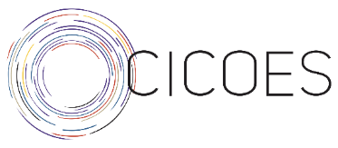

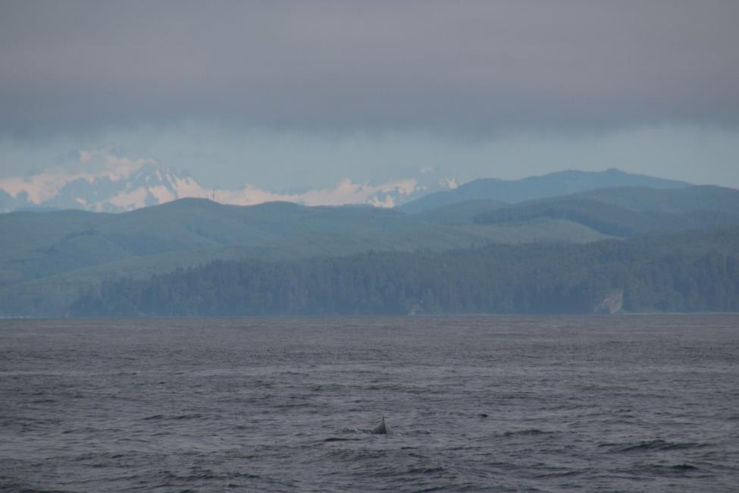
Photo Credit: Megan Shea

Project Summary

Section Name | 2021 West Coast Ocean Acidification (WCOA)
Expocode  Vessel | 33RO20210613  RV Ronald H. Brown
Leg 0  Chief Scientist Leg 0  Co-Chief Scientist Leg 0  Leg 1  Chief Scientist Leg 1  Co-Chief Scientist Leg 1  Leg 2  Chief Scientist Leg 2  Co-Chief Scientist Leg 2 | Dana Greeley  Julian Herndon  Richard Feely  Brendan Carter  Brendan Carter  Dana Greeley
Loading  Shelter-in-place (COVID-19)  Mooring work (Leg -1)  Transit (Leg 0)  WCOA Leg 1 Dates  WCOA Leg 2 Dates | 06/02/2021 to 06/05/2021  06/06/2021 to 06/13/2021  06/13/2021  06/19/2021 to 06/23/2021  06/23/2021 to 07/08/2021  07/08/2021 to 07/27/2021
Ports of call and personnel transfers  Small boat transfers: | Loading: San Diego, CA,  Mooring: San Diego, CA, to Monterey, CA,  WCOA Leg 0: Monterrey, CA, to Port Angeles, WA,  WCOA Leg 1: Port Angeles, CA, to Bodega Bay, CA,  WCOA Leg 2: Bodega Bay, CA, to San Diego, CA,  Monterey, CA; Astoria, OR; Newport, OR; Coos Bay, OR; Bodega Bay, CA; San Franciso, CA;
Stations occupied | 1 test station leg 0  71 CTD and 15 biological stations leg 1  63 CTD and 15 biological stations leg 2
Equipment deployed | 2 floats deployed on leg 1  Moorings deployed/serviced on leg 0

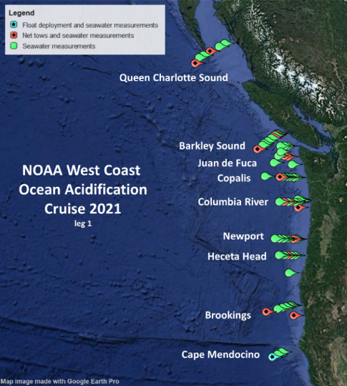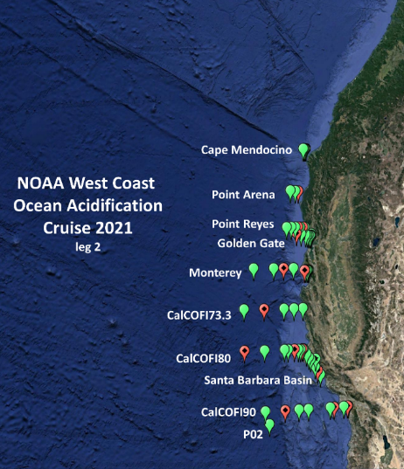
Maps of the stations occupied on Legs 1 and 2. Green marks indicate the locations of CTD stations. Red marks indicate the locations of CTD stations with extra biological sampling and net tows. The blue mark is the location of a CTD station where two Argo floats were deployed.

Abstract
This report details the 2021 occupation of the “West Coast Ocean Acidification 2021” (WCOA2021) hydrographic stations off the coast of the United States and Canada aboard the National Oceanic and Atmospheric Administration (NOAA) vessel the Ronald H. Brown co-sponsored by NOAA and the California Ocean Protection Council. This 45-day research cruise brought together an international team of scientists from the United States, Canada, Mexico, Finland, and the Netherlands to measure ocean carbonate chemistry, acidity, salinity, temperature, oxygen, nutrients, carbon and nitrogen isotopes, and chlorophyll from 17 transect lines of stations stretching from British Columbia, Canada to San Diego, California. Researchers also deployed net tows to sample phytoplankton, zooplankton, and fish to analyze how the marine food web is being affected by warming, ocean acidification, and deoxygenation in this region. The cruise is designed to characterize conditions along the West Coast of North America and continue to build a unique time-series of carbon and hydrographic measurements in areas expected to be highly impacted by ocean acidification. The biological sampling was conducted during the nighttime with vertical, Neuston, bongo, and Rita net deployments. The research cruise achieved its chemical and biological sampling objectives within the USA and Canadian exclusive economic zones, successfully capturing 133 CTD profiles on 17 transect lines with associated discrete sampling from a 24-position rosette, deploying two Argo floats with non-standard measurements (biogeochemical measurements and a radiometer), and conducting 216 net tows associated with 31 CTD stations with 99 tows on leg 1 and 117 tows on leg 2. The cruise captured records of widespread benthic hypoxia during June-July 2021 across the Washington and Oregon coastlines, evidence of strong upwelling off Cape Mendocino and collected biogeochemical cycling measurements across Southern California and within anoxic bottom waters in the Santa Barbara Basin.

Contents
1 Abstract 2
3 Involvement 4
3.1 Participating Institutions 4
3.2 Cruise Planning, Coordination, Logistics and Staging Team 5
3.3 Leg 1 Science Party 5
3.4 Leg 2 Science Party 6
3.5 Programs and PIs 7
4 Program and Project Overview 8
4.1 The WCOA2021 section 9
5 Unique Circumstances for WCOA2021 10
6 Cruise Narrative, Leg 1 11
7 Cruise Narrative, Leg 2 12
8 Underway Data Acquisition 15
8.1 SADCP 16
8.2 ASVCO2 16
8.3 O₂/Ar Equilibrator Inlet Mass Spectrometry (EIMS) 17
9 Water Sampling 18
9.1 Water sampling package 18
9.2 Underwater Electronics Package (CTD) 18
9.1.1 Sensor derived Bottle Data 20
9.2 Bottle Sampling 20
9.2.1 Oxygen 21
9.2.2 Discrete pH Analyses 23
9.2.3 Discrete Carbonate Ion Analyses 24
9.2.4 Dissolved Inorganic Carbon (DIC) 26
9.2.5 δ¹³C 29
9.2.6 Methane 31
9.2.7 Total Titration Seawater Alkalinity 34
9.2.8 Nutrients 36
9.2.9 Nitrous Oxide and nitrate isotopes 37
9.2.10 Discrete chlorophyll analyses 38
9.2.11 Discrete Salinity 39
9.2.12 ‘OMICs Group at PMEL/CICOES 39
9.2.13 UCLA seawater analyses 43
9.2.14 Domoic acid 45
9.2.15 Pelagic bacterial microbiomes 45
9.2.16 Stable isotope structure of particulate organic matter 46
10 Deployments 47
10.1 Floats 48
10.2 Net deployments 49
11 Data processing and management 61
11.1 Quality control 63
11.2 Collected Samples 63
12 Station-work efficiency 63
13 Appendix: Station Timing 64
14 WCOA2021 station notes 67

Involvement

Participating Institutions
United States Department of Commerce
National Oceanic and Atmospheric Administration (NOAA)
Pacific Marine Environmental Laboratory (PMEL)
7600 Sand Point Way NE
Seattle, WA 98115 USA
Telephone: 206-526-4314
Facsimile: 206-526-6744
Cooperative Institute for Climate, Ocean, and Ecosystem Studies (CICOES)
University of Washington (UW)
3737 Brooklyn Ave NE
John M. Wallace Hall
Box 355672
Seattle, WA 98195-5672
Phone: (206) 685-3673
FAX: (206) 685-3397

Other institutions and their abbreviations in this document (alphabetical)
Drexel Drexel University
GB Gettysburg University
LOV Laboratoire d'Océanographie de Villefranche
MBARI Monterey Bay Aquarium Research Institute
NWFSC Northwest Fisheries Science Center
PMEL Pacific Marine Environmental Laboratory
SCCWRP Southern California Coastal Water Research Project
Stanford Leland Stanford Junior University
UABC Universidad Autónoma de Baja California
UBC University of British Columbia
UCLA University of California Los Angeles
UD University of Delaware
UHel University of Helsinki
UM University of Michigan
USC University of Southern California
USF University of South Florida
UW University of Washington
Hollings-… NOAA Hollings scholars

Cruise Planning, Coordination, Logistics and Staging Team
The 2021 West Coast Ocean Acidification (WCOA2021) cruise objectives were organized and planned by the Cruise Planning Team working directly with the principal investigators over the past two years. The team developed cruise objectives and instructions, sample collection and preservation protocols, and made arrangements for staging and de-staging of the cruise. The team members and their respective roles are listed below.

Richard Feely - cruise objectives, sampling plans and chemical protocols
Simone Alin, cruise objectives, coordination with partners, and underway sampling
Nina Bednaršek - biological objectives and sampling protocols
Brendan Carter - cruise objectives, data synthesis and data management
Dana Greeley – cruise station location and time management, cruise staging and de-staging, CTD/Rosette instrumentation, DIC measurements
Julian Herndon – biological sampling net preparations, biological sample collection and preservation
LCDR Elizabeth Mackie – cruise instructions, personnel logistics, and country clearances

Leg 1 Science Party
Primary Task | Name | Affiliation | Additional Tasks
Chief Scientist | Richard Feely | PMEL
Co-Chief Scientist | Brendan Carter | UW | CTD deployments
CTD lead | Ryan McCabe | UW | Event logging, sampling
Data Manager | Jonathan Sharp | UW | DIC, CTD and float deployments
Salinity/CTD | Julian Herndon | UW | Oxygen sampling, Underway pCO₂, Chl.
Dissolved O₂ | Juhi LaFuente | UW
Nutrients | Eric Wisegarver | PMEL | Nitrate isotopes and nitrous oxide smpl.
DIC lead | Dana Greeley | PMEL
DI¹³C lead | Amanda Timmerman | UD | Domoic acid lead, underway O₂/Ar lead
DI¹³C | Qian Li | UD
N₂O | Noah Gluschankoff | Stanford | N₂O lead, nitrate isotopes, net deployments
Net tows lead | Megan Shae | Stanford | Biological synthesis
TALK lead | Samantha Mundorff | UW
TALK | Christopher Ikeda | UW
pH/carbonate | Katelyn Schockman | USF
pH/carbonate | Kalla Fleger | USF
pH/carbonate | Macarena Martin Mayor | USF
Methane lead | David Butterfield | UW | Methane and bacteria
Methane | Claire Zwiers | Hollings-UMich
HPLC | Elijah Catalan | UCLA | Float deployments
Bacteria | Alexandra Rodier | Hollings-USF
Specimen picking | Kelsey Chung | SCCWRP
Specimen picking | Jordan Chancellor | USC
eDNA lead | Sean McAllister | UW | Cell counts, µplankton, sequencing
eDNA | Katy Wnuk-Fink | Hollings-GB
Phytoplankton | Tanner Waters | UCLA | Chl. Sampling, eDNA at UCLA
Coccolithophores | Blanca Alvarez | UCLA | POC

Leg 2 Science Party
Duties | Name | Affiliation | Additional Tasks
Chief Scientist | Brendan Carter | UW
Co-Chief Scientist | Dana Greeley | PMEL | Station locations and timing
CTD lead | Ryan McCabe | UW | Event logging, sampling
Data Manager | Jonathan Sharp | UW | DIC, CTD deployments
Salinity/CTD | Julian Herndon | UW | Oxygen sampling, Underway pCO₂, Chl.
Dissolved O₂ | Juhi LaFuente | UW
Nutrients | Eric Wisegarver | PMEL | Nitrate isotopes and nitrous oxide smpl.
DIC lead | Andrew Collins | UW
DI¹³C lead | Amanda Timmerman | UD | Domoic acid lead, underway O₂/Ar lead
DI¹³C | Qian Li | UD
N₂O | Noah Gluschankoff | Stanford | N₂O lead, nitrate isotopes, net deployments
Nets lead | Megan Shae | Stanford | Nitrate isotopes and nitrous oxide smpl.
TALK lead | Samantha Mundorff | UW
TALK | Mariana Cupul Cortés | UABC
pH/carbonate | Katelyn Schockman | USF
pH/carbonate | Kalla Fleger | USF
pH/carbonate | Macarena Martin Mayor | USF
Methane lead | David Butterfield | UW
Methane | Claire Zwiers | Hollings-UM
HPLC | Elijah Catalan | UCLA
Sample picking | Kelsey Chung | SCCWRP
Sample picking | Jordan Chancellor | USC
eDNA lead | Sean McAllister | UW | Cell counts, µplankton, sequencing leads
eDNA | Katy Wnuk-Fink | Hollings-GB | Cell counts, µplankton, sequencing
Phytoplankton | Tanner Waters | UCLA | Chl. Sampling, eDNA at UCLA
Coccolithophores | Blanca Alvarez | UCLA | POC
Chlorophyll | Christopher Ikeda | UW | Deployments and sampling (assorted)

Programs and PIs
Program | PI | Institution | E-mail
Bacteria  Biomarkers for krill, fish, pteropods,  Carbon Isotopes in krill, fish, crabs | Linda Rhodes  Jonna Engström-Öst, Katja Antilla, Amelie Crespel  Nina Bednaršek  Steve Litvin  Nina Bednaršek | NWFSC  NOVIA,  UHel  MBARI | linda.rhodes@noaa.gov  Jonna.Engstrom-Ost@novia.fi  katja.anttila@utu.fi  amelie.crespel@utu.fi  ninab@sccwrp.org  litvin@mbari.org
Carbonate Ion | Robert Byrne | USF | rhbyrne@usf.edu
Chlorophyll | Richard Feely | PMEL | richard.a.feely@noaa.gov
Coccolithophores | Robert Eagle | UCLA | robeagle@g.ucla.edu
Domoic Acid | Nina Bednaršek Vera Trainer | NWFSC | vera.l.trainer@noaa.gov  ninab@sccwrp.org
DI¹³C | Wei Jun Cai | UD | wcai@udel.edu
Dungeness crab/pteropods, | Nina Bednaršek | SCCWRP | ninab@sccwrp.org
eDNA | David Butterfield | UW | David.a.butterfield@noaa.gov
Floats  Floats | Steve Riser  Andrea Fassbender | UW  PMEL | riser@ocean.washington.edu  Andrea.Fassbender@noaa.gov
Methane | David Butterfield | UW | David.a.butterfield@noaa.gov
Microplankton | David Butterfield | UW | David.a.butterfield@noaa.gov
Nitrate Isotopes | Karen Casciotti | Stanford | kcasciot@stanford.edu
Nitrous Oxide | Karen Casciotti | Stanford | kcasciot@stanford.edu
Nutrients | Calvin Mordy | UW | Calvin.W.Mordy@noaa.gov
O₂/Ar (underway) | Wei Jun Cai | UD | wcai@udel.edu
Oxygen | Jan Newton | UW | janewton@uw.edu
pCO₂ (underway) | Rik Wanninkhof | AOML | Rik.Wanninkhof@noaa.gov
pCO₂ (ASVCO₂) | Sophie Chu | UW | Sophie.chu@noaa.gov
pH | Robert Byrne | USF | rhbyrne@usf.edu
Phytoplankton (entire community)  PlanktoScope  Pteropod shells | Robert Eagle  Fabien Lombard Nina Bednaršek Adam Larson  Thibaut Pollina  Josellyn Sessa,  Nina Bednaršek | UCLA  LOV  SCCWRP  Stanford  Stanford  Drexel  SCCWRP | robeagle@g.ucla.edu  fabien.lombard@imev-mer.fr  ninab@sccwrp.org  aglarson@stanford.edu  thibaut.pollina@gmail.com  js4558@drexel.edu  ninab@sccwrp.org
PIC | Robert Eagle | UCLA | robeagle@g.ucla.edu
POC | Robert Eagle | UCLA | robeagle@g.ucla.edu
Salinity  Isotopes: krill, salps/pyrosomes  Satellite seascapes | Richard Feely  Brian Hunt  Nina Bednaršek  Maria Kavanaugh | PMEL  UBC  SCCWRP  OSU | richard.a.feely@noaa.gov  b.hunt@oceans.ubc.ca  ninab@sccwrp.org  maria.kavanaugh@oregonstate.edu

Program and Project Overview
Hydrographic measurements were made offshore of the west coasts of the United States and Canada on the RV Ronald H. Brown on the West Coast Ocean Acidification cruise in June and July of 2021 (WCOA2021). This measurement program reoccupied many of the hydrographic stations that were measured previously by WCOA cruises that sailed in 2007, 2011, 2012, 2013, and 2016. The WCOA cruises collectively aim to measure the coastal and shelf waters from Baja California, Mexico to the Queen Charlotte Sound in British Columbia, Canada, and to create an enduring near-synoptic record of natural and anthropogenic ocean acidification, deoxygenation, and biogeochemical cycling in these essential waters. This coastline is a natural laboratory for the chemical and ecological impacts of ocean acidification and deoxygenation due to spring and summertime wind-driven upwelling of old, cold waters that are rich in remineralized carbon and nutrients and poor in oxygen. The upwelled nutrients drive intense cycling of organic matter that is created through photosynthesis in the surface ocean and degraded through biological respiration in subsurface and benthic habitats. These biogeochemical processes create natural gradients in seawater temperature, oxygen, nutrients, pH and carbon concentrations, thereby allowing observations of a range of conditions (e.g., saturated vs. corrosive with respect to carbonate minerals, ventilated vs. hypoxic, and cold vs. warm) all from near-synoptic transects of the region. The upwelled nutrients also fuel productive ecosystems with valuable fisheries in this area. This region is an area of interest and concern for several ongoing climate changes including global warming and associated increases in the frequency of marine heatwaves, ocean acidification and deoxygenation, and shifts in wind patterns and natural oceanic circulation pathways that have a potential to impact biological, ecological and ecosystem parameters along the CCE. There is also concern that regional warming or deoxygenation will lead to enhanced production or mobilization of greenhouse gases such as methane and nitrous oxide that are trapped and/or created in shelf sediments. The WCOA2021 cruise provides a critical climate timeseries that speaks to all these topics of interest and concern.

The WCOA cruises fill a unique niche within the spectrum of ocean observing efforts by combining high-quality measurements of critical aspects of seawater chemistry with a parallel research effort focusing on ecological observations. The ecological observations are both targeted—collecting and assessing key indicator species for ocean acidification, hypoxia and temperature gradients—and expansive, using net tows, biomarkers, isotopes, -omics approaches, including environmental DNA (eDNA) tools and combined approaches to characterize the responses across various levels of biological organization, from genes to cellular, individual, population and community responses (composition and function). This growing timeseries of chemical and biological observations, combined with more specialized biological analyses, allows scientists to relate changing environmental conditions to shifting ecosystem outcomes.

This research cruise and subsequent analysis of the data is funded predominantly by the Ocean Acidification Program (OAP) of the National Oceanic and Atmospheric Administration (NOAA) and the California Ocean Protection Council. Numerous academic partner institutions and NOAA research laboratories participated with funding from assorted funding agencies. The NOAA Hollings program also made substantial contributions by funding the involvement of 3 junior scientists who assisted PIs with the collection, measurement, and interpretation of a variety of data types.

The WCOA2021 section
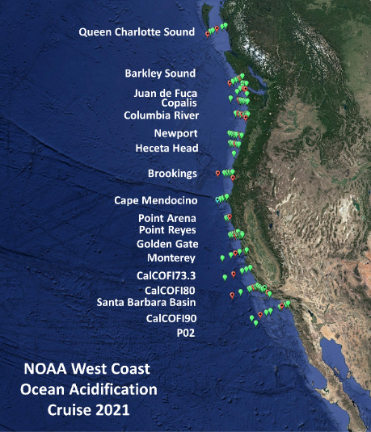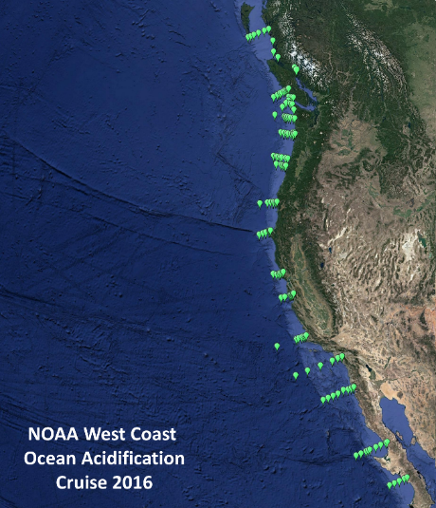
Figure 4.1 Maps of the WCOA2021 (left) and WCOA2016 (right) sections. The 2016 occupation is shown for reference. Previous occupations had narrower geographical extents than the 2016 occupation. Comparing these maps shows how added station density was achieved by relocating the stations within the Mexican EEZ to priority locations along Leg 2.

There are three major differences between WCOA2021 and the previous occupation during WCOA2016. First is that the 2021 cruise went from north to south while the 2016 cruise went from south to north. This was both to accommodate mooring work that occurred during the initial northward transit of the cruise performed by a group led by Dr. Uwe Send of Scripps Institution of Oceanography, and to time the northernmost portions of the transect with the peak in megalopae larvae abundance (the 2016 cruise started about 1 month earlier in the year than the 2021 cruise). The second major difference is that WCOA2021 was limited to US and Canadian waters. A permit request was submitted to Mexico according to established procedures and timetables, but it was not approved in time for scientists to secure visas to enter the country (a difficulty exacerbated by the need to maintain a COVID-19 “bubble” prior to the cruise and at sea), so, early in the process, the cruise time was restructured to instead achieve enhanced sampling within the US EEZ, which is the third difference. The timeseries stations within Mexico were moved northward to coincide with other regional timeseries and to address gaps in previous WCOA station plans. Specifically, lines were added to occupy a historical “Golden Gate Transect” that extends into the San Francisco Bay; to fill a gap extending from Point Arena, CA; to reoccupy stations that have been repeatedly measured along the “CalCOFI 73.3” line; to allow sampling of the Santa Barbara Basin and methane seeps along the CA coastline; and to reoccupy a station along the “World Ocean Circulation Experiment P02” GO-SHIP line. The P02 line has been occupied three times by major GO-SHIP hydrographic expeditions since 1993 and provides an ideal benchmark for deep-ocean comparisons that can be used to validate the quality of the WCOA2021 data and tie it more closely to the global hydrographic record, in keeping with best practices for coastal cruises.

Unique Circumstances for WCOA2021
Unique Circumstances: There were two unusual challenges for this cruise beyond the ambitious sampling plan: The first challenge was intense complications from the COVID-19 pandemic that took hold across the globe in 2020 several months before the originally planned start of the cruise. As a result of the pandemic, the cruise was delayed by approximately one full year, numerous foreign national partners and sampling program Principal Investigators were unable to participate in the cruise in person, berthing was not available to crew or scientists within the vessel when in port, and cruise planners needed to contend with massive additional logistical challenges associated with keeping cruise participants as safe as possible despite traveling and working in proximity. Throughout the planning process, which took place over a period in which vaccines were developed and distributed at uneven rates across demographics and between nations, the recommended guidance for preventing COVID-19 outbreaks at sea evolved continuously, rapidly, and separately at each of the many institutions involved in the cruise planning. As one example, the need to offload the Brown immediately upon return to port (as the vessel and her crew would quickly re-enter a “shelter in place” period) led to the requirement that station work cease approximately two days before making port. This period was needed to complete sample analysis backlogs, submit preliminary data, and prepare all scientific equipment for offloading in port.

The second complication, as noted earlier, came from the permitting. When it became clear that the work within the Mexican EEZ would not be approved in time for planning, some days of ship time needed to steam through Mexican waters were returned. Some additional days were retained to steam into international waters to deploy biogeochemical Argo floats that were originally intended for deployment within the Mexican EEZ. However, after the cruise was underway these floats were recalled due to a potential bug in the float controls, reducing the need for these days of ship time. As the cruise was already underway, this ship time was redirected to accomplish important scientific priorities within the US EEZ (see: 4.1).

Acknowledgements to the Captain and crew of the Ronald H. Brown, and Mother Nature: We were also blessed with good fortune while at sea and benefitted from the Ronald H. Brown and her systems being in excellent working order. While the winds were often a factor in our station planning, the weather did not force any significant delays aside from several cautious transits and one cancelled station, and the Ronald H. Brown performed with perfection: we suffered no delays from mechanical problems until the final stations. The Brown also maintained a high speed throughout the cruise, often transiting between (and sometimes along) lines with an average speed-over-ground of >12 knots, except when additional time was requested for sampling and data processing. Cooperation and collaboration with Captain Keith Golden and the crew of the Ronald H. Brown was outstanding. Collectively, the high performance of the Brown and her crew were a boon for the research operations and enabled the deep-comparison station to be occupied along the P02 line near the end of the cruise. We also want to especially thank Scientific Survey Technicians Bryce Dewees and Sophia Tigges who went above and beyond their science support responsibilities and often helped with the collection of samples from the both the net tows and the Niskin bottles.

Cruise Narrative, Leg 1
On this first leg of the cruise, the scientists identified a hypoxic layer of oxygen-depleted, low pH bottom waters that occurs seasonally along the continental shelf of Washington and Oregon when strong winds blowing along the coast in spring and summer trigger upwellings that bring cold, nutrient-rich water to the surface (Figure 6.1). These waters fuel blooms of phytoplankton that is used for many invertebrates and zooplankton taxa, including krill, copepods, and pteropods, larval crabs, larval echinoderms, gelatinous zooplankton and fish, which were all the objects of our investigations. When these blooms die off, they sink to the bottom, where their decomposition consumes oxygen, leaving less for organisms, such as crabs and bottom-dwelling fish. The measurements of low dissolved oxygen and ocean pH are consistent with an event that has the potential to create “dead zones” later this summer. Based on the University of Washington’s CICOES J-SCOPE model projections, indications are that the hypoxic, low-pH waters in Oregon and Washington will persist, and perhaps intensify through the late summer and early fall months. A NOAA media release was prepared and published based on these preliminary results.
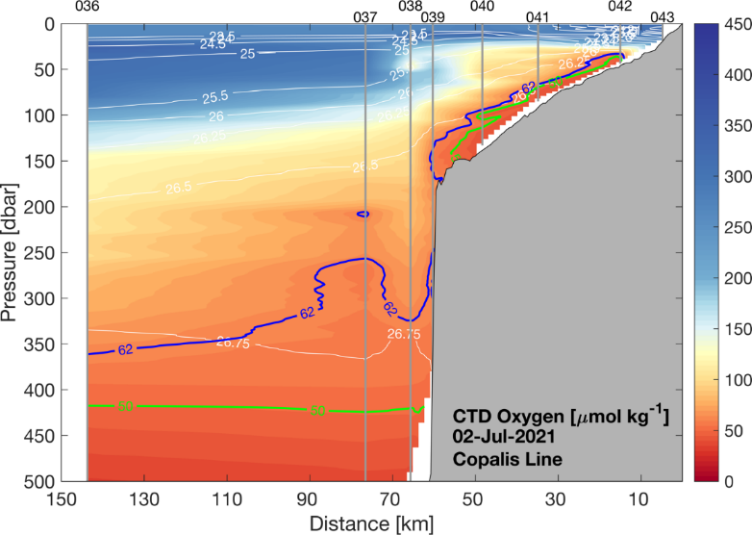
Figure 6.1. Dissolved oxygen section showing a hypoxic layer (< 62µmol O₂ kg⁻¹) along the Copalis Line from the region west of the shelf break to the coast. Figure prepared by Ryan McCabe.

At one station on the Washington coast the hypoxic, low pH waters were delineated by a very sharp decrease in pH that was visible in the color change of the pH samples (Figure 6.2). These large pH changes that we observed during this cruise are an excellent example of what is referred to as “Coastal Acidification”, which is defined as “a combination of ocean uptake of atmospheric CO₂ and other coastal chemical additions and subtractions that can be driven by natural or anthropogenic processes.” The measured pH change went from 8.35 in the surface water to 7.26 at a depth of 24 m, providing one of the greatest pH gradients observed on OAP West cruises.

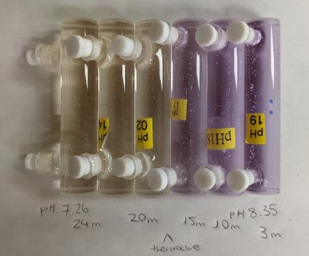 | Figure 6.2. Very large change in pH at the Sokul station in coastal waters off Washington State. The is an excellent example of “Coastal Acidification” due primarily to high respiration at depth causing hypoxia and low pH waters. Visualization prepared by Kalla Fleger and Macarena Martin-Mayor of the University of South Florida.

July 8 marked the end of cruise Leg 1 and the beginning of Leg 2 with a personnel transfer in Bodega Bay, CA. At that point, the ship had completed 71 stations and a test station, which included 72 CTD deployments, 97 net deployments, and 2 Argo float deployments.

Cruise Narrative, Leg 2

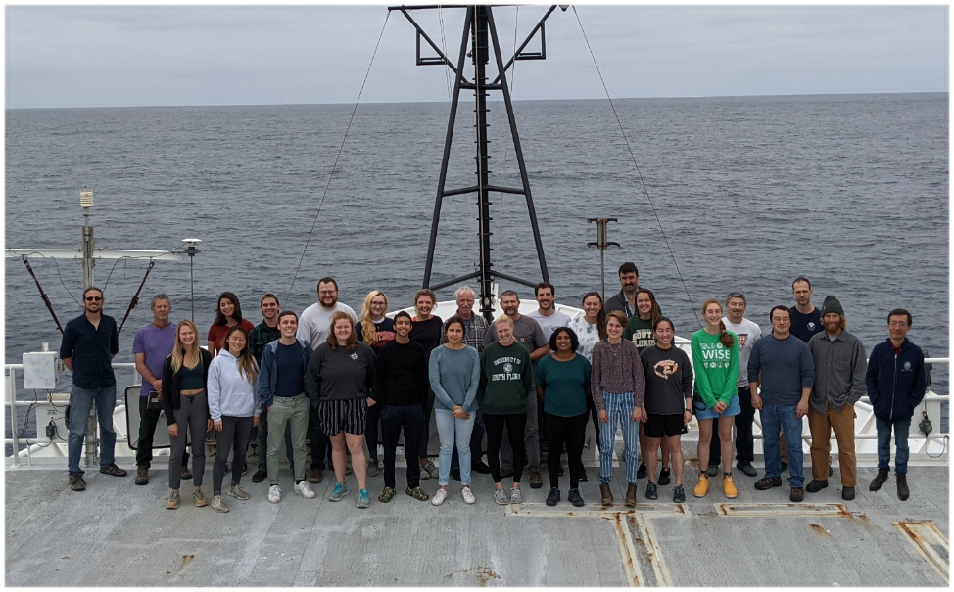
Figure 7.1 The leg 2 science party, missing Richard Feely and Alexandra Rodier who were present for leg 1.

Leg 2 occupied a portion of the coastline with more generously spaced stations than Leg 1. The progress was slowed somewhat further by several days of rough weather at the start of the cruise. Aside from the innermost station along the Cape Mendocino line (which was cancelled because it was deemed too close to rocks to occupy in rough weather) this slowed rather than halted or prevented operations. As a result, the cruise was able to progress southward along the coast collecting all intended measurements. The longer transits allowed all groups to keep up with sampling demands and allowed the analysts with faster instruments to conduct several tests of their systems using leftover seawater and unusual sampling approaches. In summary, the extra time was well spent.

The coastal approach for the Cape Mendocino line revealed dramatic upwelling with surface oxygen saturations measured with multiple systems as ~50%. Here the isopycnal surfaces shoaled sharply to the surface near the narrow continental margin and we saw broad outcropping of density anomaly surfaces denser than 26.25 kg m^{₋3} σθ (Figure 7.1). Nutrient concentrations also revealed an elevated nitrate plume extending about 20 nautical miles offshore. Comparing this to previous years showed the upwelling to be as strong as found on any previous WCOA occupation, and significantly stronger than all other years besides the 2007 occupation. This observation is perhaps not surprising considering the sustained 30-35 knot southerly winds experienced when the ship was 3 or more nautical miles from shore (see station notes)!
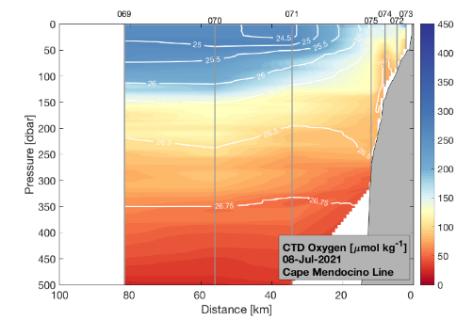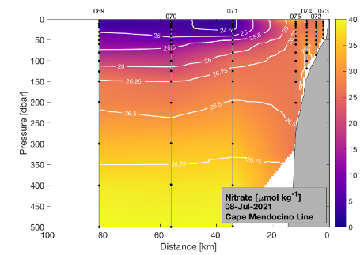
Figure 7.1. Left Oxygen plotted in color with contours of potential density anomaly in kg m^{₋3} as measured on the Cape Mendocino line. Right Nitrate plotted for the same section.

Leg 2 also provided exciting opportunities for the methane sampling teams to measure the influences of coastal seeps on dissolved methane distributions. On the “CalCOFI” CC80 line, which approaches the Santa Barbara Basin, their measurements increased dramatically nearshore, and they measured µmol kg^{₋1} levels of dissolved methane in surface waters near the La Goleta seep site, which indicates very highly elevated concentrations. Once within the Santa Barbara Basin, measurements were collected of deep anoxia in the Basin (i.e., no detectable oxygen concentrations). The driving force behind this anoxia is the same organic matter cycling that drives coastal hypoxia along the northern portion of the WCOA section, only in the Santa Barbara Basin a shallow sill prevents exchange of these ~500 m deep water with the open ocean. Oxygen is only introduced to the deep basin periodically through rare ventilation events that occur sporadically. The signature of denitrification is visible in the deep nitrate distributions, with a deep basin minimum (Fig. 7.2, right panel). We eagerly await the nitrate isotope data, to see the potential fractionation signal of water column and sedimentary denitrification within this Basin.
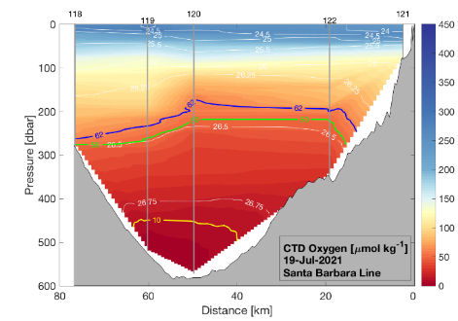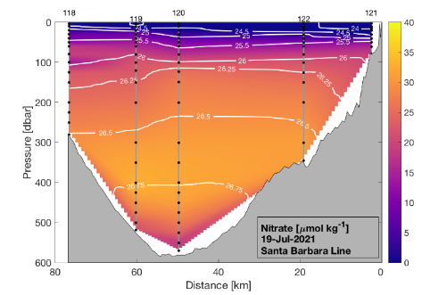
Figure 7.2. (Left) Oxygen plotted in color with contours of potential density anomaly in kg m^{₋3} as measured on the Santa Barbara Basin line. Colored contours are also given for several oxygen concentrations highlighting the very low values in the deep basin. (Right) Nitrate is plotted in color. The minimum in the deep basin suggests significant sedimentary and/or water column denitrification which is a process that occurs when respiration continues in anoxic environments.

Biologically, leg 2 was different from leg 1, with the transition point being near the Point Reyes and Golden Gate lines. Roughly speaking, north of this point pteropods, megalopae, and jellyfish were commonly found in our nets with salps being a large contributor to biomass, particularly in the northernmost lines (Figure 7.3, left). South of this point these creatures were commonly replaced by abundant krill and copepods, with the immense biomass coming from a broadly-sustained pyrosome bloom extending from the Monterey Line through the southern extent of the 2021 section in Southern California. These bioluminescent creatures could be seen at night as a glowing blue wake off the aft of the Ronald Brown for much of leg 2 (Figure 7.3, right).

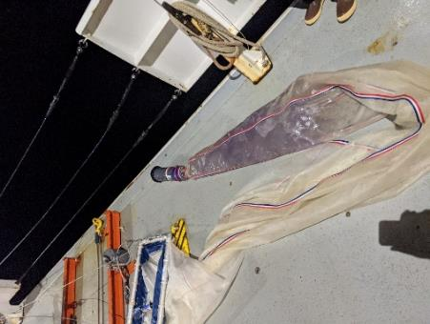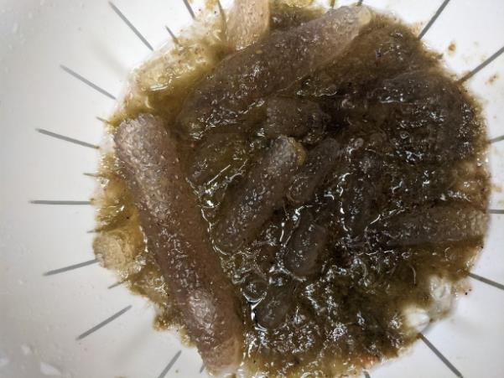
Figure 7.3. Biomass heavyweights for our cruise: The jellyfish and salps which were commonly found on leg 1 and northern leg 2 (left, showing a neuston station PR4) were overtaken by pyrosomes on the southern half of leg 2 (right, showing the catch from the 100 µm bongo at ML60).

Underway Data Acquisition

Navigation data were acquired at 1-second intervals from the ship’s Furuno GP150 P-Code GPS receiver by the SIO/ODF Linux system from the start of the cruise. In addition, centerbeam depth data, with a correction for hull depth included in each data line, were acquired directly from the ship’s Seabeam/Kongsberg EM122 system. These data were used to connect the timestamps for each cruise deployment with position and ocean depth information.

The centerbeam depths were also continuously displayed, and data were manually recorded at cast start/bottom/end on CTD Cast Logs.
Various underway data were sent from the ship’s computer systems to a serial feed on the Linux system. These data were stored at 1-second intervals:
- Winch payout (uncorrected meters)
- Winch speed (meters/minute)
- Winch tension (pounds)
- Multibeam Bottom Depth (meters to tenths) - corrected for Sound Velocity but not for hull depth (approx. 5.8m more)
- UTC Julian Date (day of year in 2015)
- UTC Time (hh:mm:ss) (hh=hours, mm=minutes, ss=seconds)
- GPS Latitude (ddmm.mmmmH) (d=degrees, m=minutes to 4 places, H=Hemisphere)
- GPS Longitude (dddmm.mmmmH)
- TSG Sea Surface Temp (SST - degrees Celsius)
- TSG Internal Water Temp (deg. Celsius)
- TSG Sea Surface Salinity (psu)
- True Wind Speed (knots) - divide by 1.9438445 to get m/sec
- True Wind Direction (compass degrees)
- Barometer - Sea Level (millibars)
- Relative Humidity (%)
- Air Temperature (degrees Celsius)
- GPS SOG (knots and m/s)
- GPS COG (degrees)
- GYRO Heading
- ADCP Speedlog Astern (knots)
- ADCP Speedlog Port (knots)
- TSG Conductivity (S/m)
- Underway Seawater System Flow Rate (GPM)
- Underway Seawater System Fluorometer (ug/L)
- PIR Radiation (W/m^2)
- SPP Radiation (W/m^2)

SADCP
Shipboard Acoustic Doppler Current Profiler data were collected continuously throughout the cruise using as system integrated on the Ronald H. Brown. These data are automatically transmitted to Jules Hummon, who separately archives the data: jules.hummon@noaa.gov.

ASVCO2
Prepared by Sophie Chu (sophie.chu@noaa.gov)

The new generation of the Autonomous Surface Vehicle CO₂ (ASVCO₂) system was installed on the R/V Ronald H. Brown prior to departure of the West Coast Ocean Acidification cruise. The purpose of this deployment was to collect data from the ASVCO2 to use as validation in comparison to the General Oceanics (GO) underway pCO₂ system. Tubing was plumbed into an outlet for the underway seawater manifold to carry the seawater through an equilibrator where the ASVCO₂ system could measure the air and seawater pCO₂ and record the data to a nearby laptop computer. It was found that the ASVCO₂ internal clock drifted linearly during the deployment, but this drift was corrected to match with the ship’s GPS time. Preliminary results show good agreement with the GO underway system. Additional calculations need to be made to the data to correct for temperature warming between the seawater intake and equilibrator for each system and conversion from xCO₂ to fCO₂. Once these corrections are made and additional data is processed, a mean residual and standard deviation will be calculated between the two pCO₂ systems to provide validation of the ASVCO₂ system’s accuracy and precision.
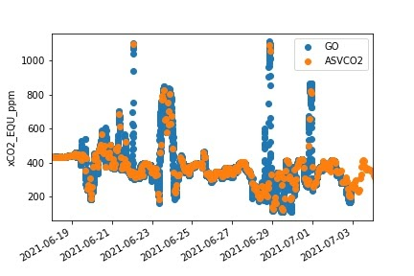
Figure 8.1 Comparison of GO and ASVCO2 underway pCO₂ preliminary results.

8.3 O₂/Ar Equilibrator Inlet Mass Spectrometry (EIMS)
The EIMS measured O₂/Ar using the underway system following Cassar et al. (2009). In short, underway seawater is passed through a coarse filter into an inner container at ~ 3L/min. The seawater overflows the inner container into an outer container that acts as an insulator. The inner container had an aanderaa oxygen sensor. Water was pumped from the inner container at ~100 mL/min through a fine mesh sock and through an equilibrator, where gases from the seawater equilibrate in the headspace. A capillary in the headspace directs gas to a mass spectrometer and measures mass 18, 28, 32, 40, 44 and 45. Discrete oxygen samples were collected eight times to calibrate the oxygen sensor. The coarse filter was cleaned once a day and the fine filter was changed whenever it became dirty.

The EIMS ran for most of the cruise with some underway seawater issues during the first week of the cruise. Unfortunately, the ship lost power on 21July causing the system to go down for the last 4 days of the cruise.

Water Sampling

Water sampling package
With the exception of ~10 stations, all rosette casts were lowered to within 8-12 meters of the bottom using the altimeter on the CTD-rosette package. Three exceptions came early on leg 1 before the altimeter and its communications were stable and trusted, and it was decided to keep the package well off the seafloor. Later, in a handful of very shallow coastal stations it was decided to proceed to ~4 m off the ocean floor to ensure we profiled most of the water column. No scheme rotation was employed, and depths are largely fixed throughout the section excepting the deep bottles, which were triggered at the deepest point on the profile.

9.2 Underwater Electronics Package (CTD)
A Sea-Bird Electronics (SBE) SBE9plus CTD was connected to a 24-position SBE32 carousel and terminated to the ship’s wire on the starboard side forward winch. Power to the CTD, carousel, and other instruments attached to the CTD was provided through the sea cable from the ship’s SBE11plus deck unit in the computer lab.

The CTD supplied a standard SBE-format data stream at 24 Hz. Instruments included dual temperature, conductivity, and oxygen sensors, a fluorometer, an oxygen reduction potential instrument (ORP; responds to reduced chemicals, such as Fe²⁺, H₂S, H₂ in hydrothermal plumes), two prototype SBE pH sensors, and an altimeter. The CTD system was outfitted with dual pumps. Primary temperature, conductivity and dissolved oxygen were plumbed into one pump circuit; and secondary temperature, conductivity and oxygen were plumbed into the other. The two prototype pH sensors were plumbed into a third dedicated pump. One of the pH sensors worked intermittently and then failed early in the cruise; the second one failed a short time later during Leg 1. The ORP was removed from the CTD prior to the final three stations.
The CTD and sensors were deployed vertically. Most casts were lowered to within 10 meters of the bottom using the altimeter on the CTD-rosette package. Exceptions to this were early on Leg 1 before the altimeter and its communications were stable and trusted (prior to station 004). At those stations, the rosette was kept well above the bottom depth reported by the ship’s multibeam sounder. Other exceptions to the 10 m buffer occurred at some of the shallow coastal and estuarine stations, where the rosette package was lowered to within 5 m of the bottom. Bottle samples were generally taken at standard pressures (in decibars) of: 3, 10, 15, 20, 30, 40, 50, 60, 80, 100, 125, 150, 200, 300, 400, 500, 750, 1000, 1500, 2000, 2500, 3000, 3500, 4000, and near bottom. On occasion samples depths were altered to better capture the oxygen minimum, or the sub-surface chlorophyll maximum.

Table 11.2.1: WCOA 2021 Underwater Package Configuration
Manufacturer / Model | Serial No. | Calib. Date | Stations Used
Markey DESH-5 Winch w/ Rochester 0.322 wire | FWD | n/a | 999, 998, 001-134_01
 | AFT | n/a
Reterminations prior to stations |  |  | 099, 132_02
Sea-Bird SBE 11plus Deck Unit | 11P111660 |  | 999, 998, 001-134_01
Sea-Bird SBE 32 Carousel Water Sampler | 32-1311 | n/a | 999, 001-043
 | 32-1202 | n/a | 998, 044-134_01
Sea-Bird SBE 9plus CTD | 1410 | 13-Dec-19 | 999, 998, 001-132_01
Paroscientific Digiquartz Pressure | 136939
Sea-Bird SBE 9plus CTD | 1338 | 3-Oct-17 | 132_02-134_01
Paroscientific Digiquartz Pressure | 141577
Primary Sea-Bird Sensors:
SBE 3plus Temperature (T1) | 03-6202 | 3-Dec-19 | 999, 998, 001-132_01
 | 03-6224 | 1-Sep-17 | 132_02-134_01
SBE 4C Conductivity (C1) | 04-4907 | 10-Dec-19 | 999, 998, 001-132_01
 | 04-4722 | 21-Sep-17 | 132_02-134_01
SBE 43 Dissolved Oxygen | 43-3650 | 3-Jan-18 | 999, 998, 001-132_01
 | 43-1890 | 13-Jun-20 | 132_02-134_01
SBE 5 Pump | 05-10162 | n/a | 999, 998, 001-132_01
 | 05-9293 | n/a | 132_02-134_01
Secondary Sea-Bird Sensors:
SBE 3plus Temperature (T2) | 03-6203 | 4-Dec-19 | 999, 998, 001-132_01
 | 03-6255 | 1-Sep-17 | 132_02-134_01
SBE 4C Conductivity (C2) | 04-4913 | 10-Dec-19 | 999, 998, 001-132_01
 | 04-4723 | 21-Sep-17 | 132_02-134_01
SBE 43 Dissolved Oxygen | 43-3651 | 3-Jan-18 | 999, 998, 001-132_01
 | 43-1835 | 15-Aug-20 | 132_02-134_01
SBE 5 Pump | 05-10029 | n/a | 999, 998, 001-132_01
 | 05-9292 | n/a | 132_02-134_01
Other Sensors connected to CTD:
Valeport VA500 Altimeter | 59677 | 3-Dec-18 | 999, 998, 001-134_01
WET Labs ECO-FLRTD | 6199 | 28-Apr-20 | 999, 998, 001-134_01
PMEL ORP | 12 | unknown | 999, 998, 001-132_01
SBE prototype pH | 0003 | unknown | 999, 001-053
SBE prototype pH | 0007 | unknown | 999, 001-053
SBE 5T Pump for pH sensors | 05-10101 | n/a | 999, 001-053

Sensor derived Bottle Data
The CTDO data and bottle trip files were acquired by SBE SeaSave V7 version 7.26.7.107 on the ship’s Windows 10 workstation. Pre-cruise calibration data were applied to CTD Pressure, Temperature and Conductivity sensor data acquired at full 24-Hz resolution. Bottles were closed on the upcast through the software, and were tripped 30 seconds after stopping at a bottle depth to allow the rosette wake to dissipate and the bottles to flush. The upcast continued 15 seconds after closing a bottle to ensure that stable CTD and reference temperature data were associated with the trip. On two occasions, this procedure was abandoned and bottles were instead tripped without stopping at selected depths on the upcast in an effort to avoid deteriorating weather conditions. This occurred on stations 070 and 071 at pressures >200 dbar, and at times on other casts for the surface samples only when the sea state was rough and the mixed layer depth was deeper than the next deepest bottle.

After each cast Sea-Bird Data Processing Version 7.26.7 software module DATCNV was used to produce a rosette file that was then converted to a bottle file using the routine BOTTLESUM. The resulting bottle files were copied to the public science drive for users. Simplified versions of the standard Sea-Bird bottle file were also constructed approximately once per day using a custom Perl script provided by Sean McAllister. The script essentially read in the bottle files, ignoring the header information and the rows of standard deviations in order to provide users with a tab delimited text file containing only the average sensor variables for each tripped bottle. These simplified bottle files were then copied to the public science drive.

Bottle Sampling
At the end of each rosette deployment water samples were drawn from the bottles in the following order:

- Dissolved O2
- Total scale pH
- Carbonate ion concentration
- Dissolved Inorganic Carbon (DIC)
- DI¹³C
- N₂O
- Total Alkalinity (TAlk)
- Nutrients
- Chlorophyll
- Salinity
- Bacteria
- eDNA (NOAA)
- cell counts
- miroplankton
- sequencing
- eDNA (UCLA)
- total phytoplankton
- coccolithophores
- PIC
- POC
- HPLC (pigments)
- Domoic Acid

The sample order was not strictly enforced after nutrients, and individual analysts frequently granted one another permission to sample out of order for these later samples. The order of the samples collected was verified at the time of collection by a designated "sample cop." The log kept by the sample cop noted any sampling problems, the temperature of the water as measured by the dissolved oxygen sampler, and any issues with the Niskin-type bottles (e.g., leaky valves and lanyards caught in end-caps).

Oxygen
Report Prepared by: Juhi LaFuente – University of Washington
Sampling by: Juhi LaFuente, Julian Herndon ( NOAA PMEL), & Chris Ikeda (SFU RTC)
Sample analysis and data processing by: Juhi LaFuente
Principal Investigator: Jan Newton University of Washington, Applied Physics Laboratory

Equipment and Techniques

Dissolved oxygen analyses were performed with a Metrohm 776 Dosimat using visual endpoint detection. Samples were collected using protocol of Codispoti 1988 and titrated following the Carpenter modification of the Winkler method (Carpenter, 1965; Winkler, 1888).

Sampling
Prior to each sampling event the reagent dispensers were primed to expel air bubbles in order to avoid the introduction of air into the sample via the dispensers.

Dissolved oxygen samples were drawn from Niskin-type bottles into calibrated 125-150 ml iodine titration flasks using silicon tubing. Air bubbles from the tubing were removed before the tube was placed at the base of the sample flask and inverted to rinse the sides.

Once upright, the flask was allowed to fill and overflow by two flask volumes and the glass stopper was rinsed with water from the bottle. The tubing was pinched slowly and was carefully removed from the flask to avoid any turbulence.

Samples were immediately fixed with 1 ml of MnCl2 and 1 ml of NaOH/NaI using two calibrated Optifix dispensers. The flasks were then stoppered and shaken well. DIW was added to the neck of each flask to create a water seal. Each sample was subsequently shaken again after it had settled (a period greater than 20 minutes or more) and DIW was added to the neck of each flask again.

Once collected, samples were stored in wooden boxes each containing 24 flasks. 10 boxes of flasks were rented from pooled equipment through the University of Washington’s School of Oceanography. Once they were full boxes of samples were stored in the main lab where they came to room temperature before being analyzed.

Analysis
Samples were titrated with a Metrohm 776 Dosimat using Carpenter strength Sodium Thiosulfate. Standards and Blanks were run at a minimum of twice a day. Three standards (Std) were run with the results from 2 of the 3 falling withing .001 ml of each other. Two blanks (Blk) were run with acceptable values within a range of -.001-.001. Standards and blanks were re-run and reagents were checked if they did not fall into the acceptable range.

The burette reading for each sample was recorded on a data sheet which also included the station name and flask number. Data was then entered into excel. Oxygen (mg/l) was calculated in excel using the following equations:

Rblk= Blk1- Blk2
O2 (mg/L) = 16*([Bottle factor*(Buret-Rblk)]-.0016)
Bottle factor = 50/[(bottle volume -2)(Avg of stds - Rblk)]

Volumetric Calibration

2ml Optifix Dispensers were used for dispensing 1 ml of each MnCl2, NaOH-NaI and H2SO4 and a 10ml Optifix dispenser was used for the KIO3 Standard solution. Dispensers for reagents were calibrated prior to the cruise and the dispensed volumes were routinely checked with a graduated cylinder to ensure the proper volume of reagent was being dispensed.

For the oxygen flasks, a spreadsheet with the calibration information for each case/flask was provided by Pooled Equipment at UW. This included information about each flasks dry, wet, and volumetric weight, room temperature when calibrated, temp correction factor and flask volume.

Duplicate Samples
Duplicate samples were drawn at the near bottom and surface at most casts. At some casts only one duplicate was taken due to constraints with the water budget. A total of 207 sets of duplicates were collected the pooled standard deviation of all sets was .131 mg/l after four sets of outliers were identified and removed the pooled standard deviation was .042 mg/l. Reps The average of each set of duplicates was reported with a QC code of 6 (see table below)

Quality Coding
WOCE Bottle Quality Codes were assigned to each sample as follows:
WOCE Code | Reasoning
2. collected, reported, normal | Most samples
3. collected, reported, but something looks fishy about the data | Replicates with large differences
4. collected, reported, but we know something is wrong with the data | Air bubbles in sample, samples not capped after collection
5. collected, something went wrong and there is no number to report | Over titrated
6. collected, reported, the value is the average of two or more replicates | Samples reported as an average of two replicates

Discrete pH Analyses
Analysts: Katelyn Schockman, Kalla Fleger, and Macarena Martín Mayor (USF)
PI: Robert H. Byrne (USF)

Sampling
Samples were collected for pH analysis immediately following O₂ in the rosette sampling sequence. Seawater samples were collected from the Niskin bottles directly in 10-cm glass cylindrical optical cells (~30 mL volume) using a section of silicone tubing (~15 cm long). One end of the silicone tubing was first attached to the nipple of the Niskin bottle. The nipple was pushed in to initiate flow, and the silicone tubing was squeezed to eliminate air bubbles. The other end of the silicone tubing was attached to the optical cell, which was agitated to eliminate any residual bubbles. After ~15 seconds of sample flow, the cell was capped at one end. The silicone tubing was then detached from the optical cell and, with the water still flowing, the other cap was rinsed and used to seal the optical cell. Samples collected this way are not exposed to the atmosphere, and each cell is flushed with at least three cell volumes of seawater. The samples were collected, taken into the lab, and rinsed with tap water to eliminate salt on the outside of the cells. The cells were dried thoroughly, and the optical windows were cleaned with Kimwipes immediately before measurement. Samples were thermostatted at 25 ºC (±0.05 °C) in a custom-made, 36-position cell warmer.

Calculation and Measurement
The pH_{T} of each sample was determined on an Agilent 8453 spectrophotometer setup with a custom-made temperature-controlled cell holder. Only the tungsten lamp was turned on. The UV lamp was turned off to prevent photodegradation of organic matter in the samples by UV light. A custom macro program running on Agilent ChemStation was used to guide the measurements and data processing. The macro automated the procedures of sample input, blank and sample scans, quality control, and data archiving. The quality control steps included checking the baseline shift after dye injection and monitoring the standard deviation of multiple scans. Absorbance blanks were taken for each sample and 10 μL of purified m-cresol purple (10 mmol/kg) were added for the analysis. pH_{T} (total scale) was calculated according to Müller and Rehder (2018):
$${pH}_{T}=-\log\left(K_{2}^{T}e_{2}\right)+\log{(\frac{R-e_{1}}{1-R\frac{e_{3}}{e_{2}}})}$$
with R being the ratio of absorbances measured at 578 nm (λ₂) and 434 nm (λ₁), corrected for baseline changes using absorbance measured at 730 nm (λ₃): $R = (λ_{2}A – λ_{3}A / (λ_{1}A – λ_{3}A)$. The salinity and temperature dependence of $K_{2}^{T}e_{2}$ is provided in Table 1 of Müller and Rehder (2018). The temperature and salinity dependence of $e_{1}$and $\frac{e_{3}}{e_{2}}$ are given in Eq. (6-7) of Muller and Rehder (2018).
These equations are applicable for samples between temperature (278.15 ≤ T ≤ 308.15) and salinity (0 ≤ S ≤ 40). In all our measurements at sea, T ≈ 298.15. The pH is calibration-free (no calibrations are needed). Duplicate pH samples, collected from discrete samples taken from Niskin bottles (N =206), displayed a standard deviation of 0.001.

Perturbation Determination for pH

Small changes in sample pH (measurement perturbations; Clayton and Byrne, 1993) created by the addition of titrant to samples were quantified using samples collected from profiles. For each perturbation determination, ∆pH was defined as ∆pH = pHfinal – pHinitial, where pHinitial is the total scale pH taken after a single titrant addition and pHfinal is the total scale pH after a second titrant addition.
An equation developed using this perturbation data was used to correct pH measurements:
pH⁰ = 1.004∙pH – 0.0277 where pH is the raw pHT measurement and pH0 is the perturbation-corrected pHT measurement.

Quality Control
All spectrophotometric pH measurements were tentatively flagged if the baseline shifted more than 0.002 absorbance units. A series of five spectra were averaged for each determination, and samples were rerun if the overall standard deviations were higher than 0.0004. This process was repeated until the standard deviation of multiple readings was within 0.0004. Absorbance values were saved so that the quality criteria can be evaluated in the future.
A total of 1879 pH samples collected from the 133 stations. Perturbation-corrected pH_{T} measurements were reported along with their associated quality-control flags. pH_{T} was reported at the measurement temperature of approximately 25 ºC, with the exact measurement temperature specified as an average of temperature measurements at the beginning and end of each set of samples.

Discrete Carbonate Ion Analyses
Analysts: Katelyn Schockman, Kalla Fleger, and Macarena Martín Mayor (USF)
PI: Robert H. Byrne (USF)

Sampling
The carbonate ion [CO₃²⁻]_{T} samples were collected in 10-cm quartz cylindrical optical cells in the same manner as the pH samples. Samples were collected after pH in the rosette sampling sequence.

Calculation and Measurement
The carbonate ion concentration of each sample was determined on an Agilent 8453 spectrometer setup with a custom-made temperature-controlled cell holder. A custom macro program was used to guide the measurements and data processing in a similar manner as was done for pH measurements. The UV lamp was turned on for carbonate ion analysis. A UV blank was taken for each sample and 20 μL of 0.022 M PbClO₄ were added (Acros Organics, 99% purity). Absorbances (A) were measured at two wavelengths on the Pb(II) absorbance peak (₁λ = 234 nm and ₂λ = 250 nm) and at a non-absorbing wavelength (₃λ = 350 nm). Absorbance values were used to calculate absorbance ratios: $R = (λ_{2}A – λ_{3}A / (λ_{1}A – λ_{3}A)$ (Byrne and Yao, 2008).

The ratios were corrected for spectrophotometer wavelength offsets using the equation given in Sharp et al. (2017): $R^{0}=R-0.265·∆λ_{241.1}$. Corrected absorbance ratios ($R^{0}$) are calculated using an instrument-specific wavelength offset at 241.1 nm ($∆λ_{241.1}$), which was determined using SRM 2034 from the National Institute of Standards and Technology. Carbonate ion concentrations ([CO₃²⁻]_{T}) were then calculated using the equation:
$$-\log\left[{CO}_{3}^{2-}\right] _{T}=\log\left\{\frac{{{}_{CO3}^{∙}β}_{1}}{e_{2}}\right\}+\log\left\{\frac{R^{0}-e_{1}}{1-R^{0}·\frac{e_{3}}{e_{2}}}\right\}$$
where _{CO3}β₁ is the formation constant for PbCO₃⁰ and the $e_{X}$ terms are molar absorptivity ratios. The coefficients for the parameters were taken from Sharp and Byrne (2019). Duplicate carbonate ion samples, collected from discrete samples taken from Niskin-type bottles (N =147), displayed a standard deviation of 1.2 μmol/kg.

Quality Control
All spectrophotometric [CO₃²⁻]_{T} measurements were tentatively flagged if the baseline shifted more than 0.002 absorbance units. A series of five spectra were averaged for each determination, and samples were rerun if the overall standard deviations were higher than 0.001 for $\log{{[CO}_{3}^{2-}] _{T }}$measurements. This process was repeated until the standard deviation of multiple readings was within 0.001. Absorbance values were saved so that the quality criteria can be evaluated in the future.

A total of 1474 carbonate ion samples were collected from the 133 stations. In the [CO₃²⁻]_{T} data set, calculated carbonate ion concentrations and corrected absorbance ratios (R⁰, see above) were reported, along with their associated quality-control flags. [CO₃²⁻]_{T} was reported at the measurement temperature of approximately 25 ºC, with the exact measurement temperature specified as an average of temperature measurements at the beginning and end of each set of samples.

References
Byrne, R.H. and Yao, W. (2008) Procedures for measurement of carbonate ion concentrations in seawater by direct spectrophotometric observations of Pb(II) complexation. Mar. Chem. 112, 128-135.
Clayton, T.D. and Byrne, R.H. (1993) Spectrophotometric seawater pH measurements: total hydrogen ion concentration scale calibration of m-cresol purple and at-sea results. Deep Sea Res. Part I. Oceanogr. Res. Papers 40, 2115-2129.
Müller, J.D. and Rehder, G. (2018) Metrology of pH Measurements in Brackish Waters—Part 2: Experimental Characterization of Purified meta-Cresol Purple for Spectrophotometric pHT Measurements. Front. Mar. Sci. 5.
Sharp, J.D. and Byrne, R.H. (2019) Carbonate ion concentrations in seawater: Spectrophotometric determination at ambient temperatures and evaluation of propagated calculation uncertainties. Mar. Chem. 209, 70-80.
Sharp, J.D., Byrne, R.H., Liu, X., Feely, R.A., Cuyler, E.E., Wanninkhof, R. and Alin, S.R. (2017) Spectrophotometric Determination of Carbonate Ion Concentrations: Elimination of Instrument-Dependent Offsets and Calculation of In Situ Saturation States. Environ. Sci. Technol. 51, 9127-9136.

Dissolved Inorganic Carbon (DIC)

PI: Richard A. Feely (NOAA/PMEL)
Technicians: Dana Greeley, Jonathan Sharp, Andrew Collins (NOAA/PMEL)

Sample collection:
Samples for DIC measurements were collected from Niskin bottles into 310 ml borosilicate glass flasks using silicone tubing according to procedures outlined in the PICES Publication, Guide to Best Practices for Ocean CO₂ Measurements. The flasks were rinsed three times and filled from the bottom with care not to entrain any bubbles, overflowing by at least one-half volume. The sample tube was pinched off and withdrawn, creating a 6 ml headspace, followed by addition of 0.12 ml of saturated HgCl₂ solution in order to halt any biological activity. The sample bottles were then sealed with glass stoppers lightly covered with Apiezon-L grease and were stored at room temperature for a maximum of 12 hours.

Equipment:
DIC analysis was performed via coulometry using two analytical systems (PMEL1 and PMEL2) simultaneously on the cruise. Each system consisted of a coulometer (CM5015-O UIC Inc) coupled with a Dissolved Inorganic Carbon Extractor (DICE). The DICE system was developed by Esa Peltola, Denis Pierrot (NOAA/AOML) and Dana Greeley (NOAA/PMEL) to modernize a carbon extractor called SOMMA (Johnson et al. 1985, 1987, 1993, and 1999; Johnson 1992).

DIC Analysis:
In coulometric analysis of DIC, all carbonate species are converted to CO₂ (gas) by addition of excess hydrogen ion (acid) to the seawater sample, and the evolved CO₂ gas is swept into the titration cell of the coulometer with pure air or compressed nitrogen, where it reacts quantitatively with a proprietary reagent based on ethanolamine to generate hydrogen ions. In this process, the solution changes from blue to colorless, triggering a current through the cell and causing coulometric generation of OH⁻ ions at the anode. The OH⁻ ions react with the H⁺, and the solution turns blue again. A beam of light is shone through the solution, and a photometric detector at the opposite side of the cell senses the change in transmission. Once the percent transmission reaches its original value, the coulometric titration is stopped, and the amount of CO₂ that enters the cell is determined by integrating the total change during the titration.

DIC Calculation:
Calculation of the amount of CO₂ injected is based on that of the CO₂ handbook (DOE 1994). The concentration of CO₂ ([CO₂]) in the samples was determined according to:

[CO₂] = Cal. Factor * (Counts – Blank * Run Time)* K µmol/count
pipette volume * density of sample

where Cal. Factor is the calibration factor, Counts is the instrument reading at the end of the analysis, Blank is the counts/minute determined from blank runs performed at least once for each cell solution, Run Time is the length of coulometric titration (in minutes), and K is the conversion factor from counts to micromoles.

The instrument has a salinity sensor, but all DIC values were recalculated to a molar weight (µmol/kg) using density obtained from the CTD’s salinity. The DIC values were corrected for dilution due to the addition of 0.12 ml of saturated HgCl₂ used for sample preservation. The total water volume of the sample bottles was 305.55 ml (calibrated by Dana Greeley, PMEL). The correction factor used for dilution was 1.0004. A correction was also applied for the offset from the CRM. This additive correction was applied for each cell using the CRM value obtained at the beginning of the cell. The average (± SD) correction was -0.85 ± 1.49 µmol/kg for PMEL 1 and 4.19 ± 1.15 µmol/kg for PMEL 2. The consistently low offset on PMEL 2 can likely be explained by a slightly inaccurate pipette calibration. A post-cruise calibration will be performed, which should confirm this.

The coulometer cell solution was replaced after a maximum of 25 – 28 mg of carbon was titrated, typically after 9 – 12 hours of continuous use. The average (± SD) blanks for PMEL 1 and PMEL 2 were 17.9 ± 7.3 and 29.1 ± 6.81 counts, respectively.

Calibration, Accuracy, and Precision:
The stability of each coulometer cell solution was confirmed three different ways:
- Gas loops were run at the beginning of each cell;
- CRM’s supplied by Dr. A. Dickson of Scripps Institution of Oceanography (SIO), were analyzed at the beginning of the cell before sample analysis;
- Duplicate samples from the same bottle were collected for ~10% of the total taken from each cast.

Each coulometer was calibrated by injecting aliquots of pure CO₂ (99.999%) by means of an 8-port valve (Wilke et al., 1993) outfitted with two calibrated sample loops of different sizes (~1ml and ~2ml). The instruments were each separately calibrated at the beginning of each cell with a minimum of two sets of these gas loop injections. The accuracy of the DICE measurement is determined with the use of standards (Certified Reference Materials [CRMs], consisting of filtered and UV irradiated seawater) supplied by Dr. A. Dickson of SIO. The CRM accuracy is determined manometrically on land in San Diego and the DIC data reported to the database have been corrected to this batch (#188) CRM value. The CRM certified value for this batch is 2099.26 µmol/kg¹.

The precision of the two DICE systems can be demonstrated via the replicate samples. Approximately 9% of the niskins sampled were duplicates taken as a check of our precision. These replicate samples were interspersed throughout the station analysis for quality assurance and integrity of the coulometer cell solutions. The average absolute difference from the mean of these replicates was 0.73 µmol/kg - no major systematic differences between the replicates were observed².

The pipette volume was determined by taking aliquots of distilled water from volumes at known temperatures. The weights with the appropriate densities were used to determine the volume of the pipettes.

Calibration data during this cruise:

UNIT | Ave L Loop Cal Factor | Ave S Loop Cal Factor | Pipette | Ave CRM¹ | Std Dev (CRM)¹ | Dupes²
PMEL 1 | 1.002600 | 1.00718 | 27.58879 ml | 2100.11, n= 57 | 1.49 | 0.7
PMEL 2 | 1.004289 | 1.00119 | 26.41234 ml | 2095.07, n = 45 | 1.15 | 0.77

Summary:

The overall performance of the analytical equipment was very good during the cruise. At the time of submission, our data includes 30 samples flagged as “questionable”, and 2 samples flagged as “bad”. Of those flagged as “questionable”, 21 of 30 samples were flagged as such due to the low salinity encountered in the stations located in the Columbia River. The remaining questionable values seemed to result from drift in the coulometer cell, which will be accounted for in post-cruise data quality control.

Including duplicates, 1,874 samples were analyzed from 133 CTD casts for DIC. The DIC data reported to the database directly from the ship are to be considered preliminary until a more thorough quality assurance can be completed shore side.

References:
DOE (U.S. Department of Energy). (1994). Handbook of Methods for the Analysis of the Various Parameters of the Carbon Dioxide System in Seawater. Version 2.0. ORNL/CDIAC-74. Ed. A. G. Dickson and C. Goyet. Carbon Dioxide Information Analysis Center, Oak Ridge National Laboratory, Oak Ridge, Tenn.
Dickson, A.G., Sabine, C.L. and Christian, J.R. (Eds.), (2007): Guide to Best Practices for Ocean CO₂ Measurements. PICES Special Publication 3, 191 pp., Feely, R.A., R. Wanninkhof, H.B. Milburn, C.E. Cosca, M. Stapp, and P.P. Murphy (1998): "A new automated underway system for making high precision pCO2 measurements aboard research ships." Anal. Chim. Acta, 377, 185-191.
Johnson, K.M., A.E. King, and J. McN. Sieburth (1985): "Coulometric DIC analyses for marine studies: An introduction." Mar. Chem., 16, 61-82. Johnson, K.M., P.J. Williams, L. Brandstrom, and J. McN. Sieburth (1987): "Coulometric total carbon analysis for marine studies: Automation and calibration." Mar. Chem., 21, 117-133.
Johnson, K.M. (1992): Operator's manual: "Single operator multiparameter metabolic analyzer (SOMMA) for total carbon dioxide (CT) with coulometric detection." Brookhaven National Laboratory, Brookhaven, N.Y., 70 pp. Johnson, K.M., K.D. Wills, D.B. Butler, W.K. Johnson, and C.S. Wong (1993): "Coulometric total carbon dioxide analysis for marine studies: Maximizing the performance of an automated continuous gas extraction system and coulometric detector." Mar. Chem., 44, 167-189.
Johnson, K.M., Körtzinger, A.; Mintrop, L.; Duinker, J.C.; and Wallace, D.W.R. (1999). Coulometric total carbon dioxide analysis for marine studies: Measurement and internal consistency of underway surface TCO2 concentrations. Marine Chemistry 67:123–44. Lewis, E. and D. W. R. Wallace (1998) Program developed for CO2 system calculations. Oak Ridge, Oak Ridge National Laboratory. http://cdiac.ornl.gov/oceans/co2rprt.html
Wilke, R.J., D.W.R. Wallace, and K.M. Johnson (1993): "Water-based gravimetric method for the determination of gas loop volume." Anal. Chem. 65, 2403-2406

δ¹³C
Prepared by: Amanda Timmerman (ahvtimmerman@gmail.com)
Samples also analyzed by: Qian Li
University of Delaware
Background
The flux and storage of carbon between the atmosphere, surface ocean and deep ocean are important for understanding the global carbon cycle. Carbon dioxide gas that enters the ocean becomes either aqueous carbon dioxide, bicarbonate or carbonate, and collectively are called dissolved inorganic carbon (DIC). Phytoplankton convert DIC to organic carbon. Some of the organic carbon is exported from the surface ocean to the deep ocean via the biological carbon pump, where it is removed from being in contact with the atmosphere. One way to estimate the amount of carbon available for export is to measure net community production (NCP). During WCOA2021, we quantified NCP using two different approaches: δ¹³C of DIC (δ¹³C_{DIC}) and O₂/Ar. Using two concurrent methods will help constrain carbon export rates and improve regional and global NCP estimates.
Air-sea gas exchange drives δ¹³C_{DIC} in surface waters toward equilibrium, however, δ¹³C_{DIC} normally deviates in surface waters due to mainly biological productivity. During photosynthesis, phytoplankton fractionate carbon by preferentially using the lighter isotope (¹²C), leaving isotopically heavier DIC. There are other factors that influence gas exchange, though to a lesser degree. For example, there is also an overall decrease in δ¹³C_{DIC} caused by the burning of fossil fuels with lower δ¹³C. During air-sea gas exchange, this enrichment in the lighter isotope also decreases the δ¹³C_{DIC}, collectively called the Suess effect. Consequently, δ¹³C_{DIC} can be used to both estimate NCP and track anthropogenic carbon.
The concentration of oxygen in the surface water is the result of a combination of physical and biological processes. To remove some non-biological processes, the ratio of oxygen to argon is used because argon has similar physical properties but is inert (Craig and Hayward 1987). This mass balance approach integrates processes that occur in the surface ocean mixed layer over the residence time of oxygen in the surface water, which is on the order of weeks. If vertical and horizonal mixing are negligible, then the major source of oxygen is photosynthesis and the major removal processes are respiration and air-sea gas exchange.
δ¹³C methods
DIC and δ¹³C_{DIC} are measured simultaneously by coupling a CO₂ extraction device and a Cavity Ring-Down Spectroscopy (CRDS; Bass et al., 2012; Call et al., 2017) using a modified Su et al. (2019) method. In short, CO₂-free gas lowers the CO₂ of the system to 1-2 ppm to establish a baseline. Phosphoric acid is added to a 3.5 mL sample in the reactor where CO₂ is released. The gas stream passes through a condenser before going to the Picarro 213li CRDS analyzer for CO₂ detection. A single CRDS detector measures both ¹²CO₂ and ¹³CO₂ concentrations. The integrated area under the curve estimates the DIC concentration. When the CO₂ is above a threshold value, the δ¹³C_{DIC} is averaged. The system has 8 sample ports and 1 standard port. To quantify NCP, both DIC and DI¹³C budgets will be combined and calculated based on Quay et al. (2009). This mass balance approach assumes steady state with no flux of DIC from physical processes. Anthropogenic carbon will be calculated using the extended multiple linear regression approach (Friis et al. 2005).
Samples were collected from all stations and unique depths using a combination of bottles and vials. 1141 bottle samples (250 mL) were collected (1278 including duplicates) and will be analyzed at the University of Delaware. 683 vial samples (60 mL) were collected and analyzed at sea. An additional 166 vials were collected to be analyzed at the University of Delaware, 151 of which will be used to test if vials are suitable for sample storage. In addition to bottle and vial samples, the CO₂ extraction device was also set to an automated underway mode for the steam north from San Diego to Port Angeles and for the first two transects (QC and BS). This allows sample water to go directly into the system once every 30 minutes. A bicarbonate standard (-0.8 per mil) was analyzed about once per day. A second bicarbonate standard (-3.5 per mil) was analyzed once every 3-4 days as a sample. A CRM was analyzed once every 3-4 days as a sample. 32 comparison samples were collected for analysis following Atekwana and Krishnamurthy (1998). Four reproducibility tests were conducted at sea using stable seawater to ensure there is no bias between the sample and standard ports. Three headspace experiments were conducted to determine if there are differences in DIC and δ¹³C_{DIC} between vials with and without a headspace. Two of the experiments were short term (days) and the last was longer (about a month).
References
Atekwana, E.A. and Krishnamurthy, R.V., 1998. Seasonal variations of dissolved inorganic carbon and δ13C of surface waters: application of a modified gas evolution technique. Journal of Hydrology, 205(3-4), pp.265-278.

Bass, A.M., Bird, M.I., Munksgaard, N.C. and Wurster, C.M., 2012. ISO‐CADICA: Isotopic–continuous, automated dissolved inorganic carbon analyser. Rapid Communications in Mass Spectrometry, 26(6), pp.639-644.

Call, M., Schulz, K.G., Carvalho, M.C., Santos, I.R. and Maher, D.T., 2017. Coupling infrared gas analysis and cavity ring down spectroscopy for autonomous, high-temporal-resolution measurements of DIC and δ 13 C–DIC. Biogeosciences, 14(5), pp.1305-1313.

Cassar, N., Barnett, B.A., Bender, M.L., Kaiser, J., Hamme, R.C. and Tilbrook, B., 2009. Continuous high-frequency dissolved O2/Ar measurements by equilibrator inlet mass spectrometry. Analytical Chemistry, 81(5), pp.1855-1864.

Craig, H. and Hayward, T., 1987. Oxygen supersaturation in the ocean: Biological versus physical contributions. Science, 235(4785), pp.199-202.

Friis, K., Körtzinger, A., Pätsch, J. and Wallace, D.W., 2005. On the temporal increase of anthropogenic CO2 in the subpolar North Atlantic. Deep Sea Research Part I: Oceanographic Research Papers, 52(5), pp.681-698.

Quay, P.D., Stutsman, J., Feely, R.A. and Juranek, L.W., 2009. Net community production rates across the subtropical and equatorial Pacific Ocean estimated from air‐sea δ13C disequilibrium. Global biogeochemical cycles, 23(2).

Su, J., Cai, W.J., Hussain, N., Brodeur, J., Chen, B. and Huang, K., 2019. Simultaneous determination of dissolved inorganic carbon (DIC) concentration and stable isotope (δ13C-DIC) by Cavity Ring-Down Spectroscopy: Application to study carbonate dynamics in the Chesapeake Bay. Marine Chemistry, 215, p.103689.

Methane
Purpose
Like CO₂, methane is an important greenhouse gas, with increasing atmospheric concentrations. The oceans are a minor, but significant part of the global methane flux to the atmosphere. Although they constitute a small fraction of the total marine area, coastal margins and estuaries are estimated to be the largest source of methane from the marine environment, comparable to the entire flux from all open ocean areas. The fluxes of methane from seafloor sources to the ocean are still relatively poorly known. It is generally thought that most methane in the ocean is rapidly oxidized in the water column before it reaches the air-sea interface. This certainly appears true when looking at open ocean data, where methane decreases to less than one nanomol/liter in mid-water depths. Results from the Gulf of Mexico following the Deepwater Horizon oil well blowout also suggest that microbial oxidation is capable of rapidly removing high concentrations of methane in cold, deep water.

Along Cascadia Margin (roughly Cape Mendocino to Queen Charlotte Sound), multibeam sonar studies have found 1300 clusters of methane gas seeps (defined by 300 m radius), with approximately 40-50% of the seafloor mapped. Many seeps are located on the shelf and there is a zone of increased seep prevalence near 500 meters on the slope, near the upper limit of methane hydrate stability. Although individual sites have been studied in great detail, e.g. the Hydrate Ridge site and Barkley Canyon, there have been no systematic regional surveys to assess the fate of seep methane in the water column. Given the large number of seeps along Cascadia, it is likely that there is a significant methane plume that may support a chemosynthetic methane-oxidizing microbial community.

When methane is oxidized it consumes oxygen and contributes to higher CO₂, potentially affecting these important biogeochemical properties that are the focus of the WCOA project.
CH4 + 2O₂ = CO₂ + 2H₂O
Water column concentrations of methane in the immediate vicinity of methane seeps reach micromolar or higher as methane bubbles dissolve and methane-rich fluids diffuse up out of the seafloor. Methane-rich fluids are diluted and transported by coastal currents. Seasonal upwelling can bring methane-rich fluids from the slope and shelf to the surface where they will enter the atmosphere. The West Coast OA project plan is perfect for a survey of methane in the coastal zone. It provides a baseline to compare with future expeditions.

Goal
The primary goal is to collect and analyze methane from every station and every depth to get maximum resolution of the methane distribution. A secondary goal is to work on method development for methane oxidation rate. We will use the data to calculate air-sea flux of methane and to understand the sources, transport, and fate of methane in the water column.

Methods
Samples are collected in 140-ml Monoject plastic syringes with stopcock valves. The syringe tip is inserted into the bottle outlet, the outlet valve is pushed open, 50ml water are drawn into the syringe, the outlet is closed, the syringe is rinsed and bubbles are flushed out; a second 50ml rinse is collected, again flushing out all bubbles; the syringe is filled to the 100ml mark and the syringe valve is closed. Each syringe has a unique ID # that is recorded in the sample log. Our GC log sheet includes the station ID, bottle number, depth, and syringe number.

Samples are taken into the lab. Using a low-pressure regulator, we add 40ml of helium to each syringe, shake vigorously for 30 seconds and allow to warm to room temperature (one hour minimum). Samples are shaken again a second time after 30 minutes. After samples reach room temperature, they are analyzed by gas chromatography.

The samples are analyzed on an SRI model 8610 gas chromatograph with a PLOT capillary column and flame ionization detector (FID). The carrier gas is ultrapure helium at 21 psi and the column temperature is constant at 50°C. The run time is 4 minutes per analysis and methane elutes at 2.5 minutes. The flame is fueled by hydrogen (5 psi) from a VICI hydrogen generator and ultra-zero air (20 psi). This GC also has a Valco Helium ionization pulse discharge detector that is also sensitive to methane and hydrogen, but the FID is the most stable and accurate detector and we only report results from the FID.

The SRI GC is connected to a laptop computer and PeakSimple software collects the data. The methane peak area for the FID is integrated and peak areas are transferred to a spreadsheet. The instrument response is calibrated with a series of methane standards made from a stock 100 ppm methane standard (Scott Specialty Gases). Standards of 2, 5, 10, 25, and 50 ppm were made by diluting the stock standard with high-purity helium in syringes. The FID response is linear over this range. After the initial calibration using all standards, we ran helium blanks, 5 and 10 ppm standards daily to check the stability of the response.

We took replicate samples from the same bottle on nearly every cast and analyzed both to determine the standard deviation. With 182 pairs analyzed, the average methane concentration was 14.7 nM, the median was 8.0 nM, and the relative standard deviation was 5.2%. This estimated precision includes all operational elements that affect the measurements. It is consistent with previous estimates of the overall precision of the method. This method can reliably quantify dissolved methane to 1.5 nM concentration (0.08 ppm in gas phase). Based on the data collected during this cruise, at lower concentrations, detector noise leads to higher uncertainty and we cannot reliably detect peaks below 0.8 nM due to noise in the FID baseline. As a check on consistency (accuracy), we analyzed clean marine air. On 31 analyses, the average methane concentration in air was 1.877 ppm with standard deviation of 0.100 ppm. These results are consistent with the average concentration for methane in the atmosphere. It is possible that some samples are slightly elevated from high surface methane concentrations. We exclude the air samples from La Goleta seep, where methane gas was actively venting at the sea surface.

Methane oxidation experiments. We worked on method development to quantify the rate of disappearance of methane from samples without using any enrichment or isotope addition. The simple concept is to collect multiple samples from a single Niskin sampler, using serum bottles and rubber setpa, and keep the samples in the dark at lab temperature (18°C). Samples were analyzed in time series. The results are inconsistent and difficult to interpret and are not reported. This method requires further development.

Results
We made a total of 1938 individual analyses for dissolved methane concentration, including replicate samples. All of the results were contributed on board to the merged dataset. Data quality for nearly all of the results is good. There are a few exceptions for samples lost in processing due to handling errors or for niskins with suspected leaks. These are noted with QC flags. A small percentage of deep samples were below detection and are reported as such.

Preliminary Data Analysis
We plotted vertical profiles for every cast during the cruise. Claire Zwiers analyzed the merged data using Surfer software to make vertical sections and surface contour plots of dissolved methane. We used the surface dissolved methane, temperature, salinity and atmospheric methane concentration to calculate the difference between methane saturation and dissolved methane concentration at the surface. Many areas were significantly enriched. We made a preliminary analysis of the air-sea methane flux using the delta-methane values and measured wind speeds from the ship’s met sensor data.

Conclusions
The cruise was highly successful for this first regional methane survey. We accomplished our goal of analyzing every depth from every station. We expect to learn a lot from these results and relate them to the microbial community analysis done by Sean McAllister, as well as to the work of many scientists on board who are working on many aspects of physical and chemical oceanography. Methane is affected by, and can possibly be a good tracer for upwelling and major currents and we expect to find interesting relationships with further data analysis. We appreciate the opportunity to be on this cruise.

Total Titration Seawater Alkalinity

PI: Richard A. Feely PMEL/NOAA
Analytical team:
Ms. Sam Mundorff, Analytical Lead
Mr. Chris Ikeda
Ms. Mariana Cupul Cortés
Mr. Julian Herndon, Team Lead and data processing.
With gratitude to the onboard survey technicians, Mr. Bryce Dewees and Ms. Sophia Tigges who went above and beyond their science support responsibilities and often conducted sampling of the bottles.

Data Summary:
Approximately 1728 samples were analyzed from 133 CTD Casts. Replicates were analyzed on approximately 10% of the Niskins sampled. The average absolute difference from the mean of all the replicates was 0.9µmol/kg. The number of accepted Certified Reference Materials (CRMs; supplied by the Dickson Lab at Scripps Institution of Oceanography [SIO]; Batch 188, certified value: 2264.96) analyzed was 138, with an average measured value of 2263.11 µmol/kg and a standard deviation 1.78. When the average of the CRMs analyzed for a shift or a subset of samples was outside of +/-2.0 µmol/kg of the certified CRM value, a correction was applied to those samples, where the average difference was added or subtracted from each sample in the set.

There were numerous instrumental challenges for the TA analysis team. Initial difficulties with the primary analytical instrument were significant enough to require setting up a second, backup instrument. Subsequently and at different times throughout the cruise, both water temperature controllers failed (primary and backup), both mass flow controllers failed (primary and backup) requiring a workaround with an aquarium pump, a number of temperature sensors failed and had to be replaced, several components for the sample dispensing system failed (including the pump, some solenoids, and a temperature sensor), requiring taking components from the backup system to keep it functional. The software for both the analytical instrument and the sample dispensing system also presented some challenges. Despite this, and thanks to efforts of the team and other personnel onboard (particularly Dr. Carter, Dr. Sharp and Mr. Greeley), we were able to analyze all the samples collected. However, the time lost to instrument issues slowed our data processing, and a software issue related to changes to calibration coefficients requires some additional data processing to correct. The data affected by the calibration coefficients are being individually recalculated and manually entered into a spreadsheet as the overwrite function in the recalculate module of the software does not appear to function while the instrument is in “Sea Mode”.

Methodology:
Seawater samples for total alkalinity were drawn directly from the Niskin bottles into 300mL borosilicate glass (Corning Pyrex/Schott Duran) bottles as described in SOP1 of “The Guide to Best Practices for Ocean CO₂ Measurements” (Dickson A.G., Sabine L.S. and Christian J.R, Eds., 2007), using silicone tubing. The bottles were then sealed with glass stoppers lightly coated with Apiezon-L grease. The flasks were rinsed three times and filled from the bottom with care not to entrain any bubbles, overflowing by at least one full volume. The sample tube was pinched off and withdrawn, creating a ~1% headspace and preserved with small volume of a saturated mercuric chloride solution (0.12 mL) and the final alkalinity concentration corrected for this addition.

The samples were subsequently analyzed according to SOP3b of “The Guide to Best Practices for Ocean CO₂ Measurements”, using a two stage, potentiometric, open cell titration system built by the Dickson Lab in 2016 at SIO. The samples were titrated with coulometrically analyzed hydrochloric acid made and certified by the Dickson lab. Sample and instrument temperature were controlled and sample size was measured volumetrically using an automated Sample Dispensing System built by the Dickson lab. The instrument was controlled and alkalinity determined by software developed by the Dickson Lab. Instrument accuracy was monitored at regular intervals (every 10-20 samples) using CRMs consisting of filtered and UV irradiated seawater supplied by the Dickson Lab (SIO-UCSD).

Method References:
Bates, R.G. Determination of pH. Theory and Practice. A Wiley-Interscience Publication, Second Edition.
Dickson, A.G., Sabine, C.L. and Christian, J.R. (Eds.) 2007. Guide to best practices for ocean CO2 measurements. PICES Special Publication 3, 191 pp.
Dickson A.G. (1981). An exact definition of total alkalinity, and a procedure for the estimation of alkalinity and total inorganic carbon from titration data. Deep-Sea Res. 28, 609-623.
Dickson A.G. (1992). The development of the alkalinity concept in marine chemistry. Marine chemistry 40:1-21-2, 49-63.
Dickson, A. G., Afghan, J. D. & Anderson, G. C. (2003). Reference materials for oceanic CO2 analysis: A method for the certification of total alkalinity. Marine Chemistry 80, 185–197
Gran G. (1952). Determination of the equivalence point in potentiometric titrations. Part II. The analyst, 77, 661-671.
Wolf-Gladrow, D.A. et al. (2007). Total alkalinity: The explicit conservative expression and its application to biogeochemical process.

Nutrients
Prepared by Eric Wisegarver

Equipment and Techniques

Dissolved nutrients (phosphate, silicate, nitrate, nitrite, and ammonium) were measured by using a Seal Analytical AA3 HR automated continuous flow analytical system with segmented flow and colormetric detection.

Detailed methodologies are described by Gordon et al. (1992).

Silicic acid was analyzed using a modification of Armstrong et al. (1967). An acidic solution of ammonium molybdate was added to a seawater sample to produce silicomolybic acid. Oxalic acid was then added to inhibit a secondary reaction with phosphate. Finally, a reaction with ascorbic acid formed the blue compound silicomolybdous acid. The color formation was detected at 660 nm. The use of oxalic acid and ascorbic acid (instead of tartaric acid and stannous chloride by Gordon et al.) were employed to reduce the toxicity of our waste steam.

Nitrate and Nitrite analysis were also a modification of Armstrong et al. (1967). Nitrate was reduced to nitrite via a copperized cadmium column to form a red azo dye by complexing nitrite with sulfanilamide and N-1-naphthylethylenediamine (NED). Color formation of nitrate + nitrite was detected at 540 nm. The same technique was used to measure nitrite, (excluding the reduction step), and nitrate concentrations were determined by the difference of these two analyses.

Phosphate analysis was based on a technique by Bernhart and Wilhelms (1967). An acidic solution of ammonium molybdate was added to the sample to produce phosphomolybdate acid. This was reduced to the blue compound phosphomolybdous acid following the addition of hydrazine sulfate. The color formation was detected at 820 nm.

Ammonium analysis was based on a technique by Kerouel and Aminot (1997). An o-phthaldialdehyde reagent containing sulfite is added to the sample. The reagent reacts with ammonium and the resulting fluorescence is detected using a fluorometer with a 370 nm excitation fliter and 418-700 nm emission filter.

Sampling and Standards

Nutrient samples were drawn in 60ml HDPE Nalgene sample bottles that had been stored in 10% HCl. The bottles are rinsed 3-4 times with sample prior to filling. Samples were then brought to room temperature prior to analysis. Fresh mixed working standards were prepared before each analysis. In addition to the samples, each analysis consisted of a 4 point standard curve with each concentration run in duplicate at the beginning. Also, one mixed working standard from the previous analytical run was used at the beginning of the new run to determine differences between the two standards. Low Nutrient Seawater (LNSW) was used as a medium for the working standards.

The working standards were made by the addition of 3, 6, and 9 ml of secondary nitrite and ammonium standards and 6, 12, and 18 ml of a secondary mixed standard (containing silicic acid, nitrate, and phosphate) into a 250ml calibrated volumetric flask of LNSW. Working standards were prepared daily.

Dry standards of a high purity were pre-weighed at PMEL. All standards were dissolved at sea. The secondary mixed standard was prepared by the addition of nitrate and phosphate primary standards to the silicic acid standard. Nutrient concentrations were reported in micromoles per liter. Lab temperatures were recorded for each analytical run. All the pump tubing was replaced three times during the WCOA 2021 cruise.

Approximately 1750 samples were analyzed.

Reference:
Armstrong, F.A.J., Stearns, C.R. and Strickland, J.D.H. (1967) The measurement of upwelling and subsequent biological processes by means of the Technicon AutoAnalyzer and associated equipment. Deep-Sea Res. 14:381-389.
Bernhard, H. and Wilhelms, A. (1967) The continuous determination of low level iron, soluble phosphate and total phosphate with AutoAnalyzer. Technicon Symposia, I. pp.385-389.
Gordon, L.I., Jennings Jr., J.C., Ross, A.A. and Krest, J.M. (1993) A suggested protocol for the continuous automated analysis of seawater nutrients (phosphate, nitrate, nitrite and silicic acid) in the WOCE Hydrographic program and the Joint Global Ocean Fluxes Study, WOCE Operations Manual, vol. 3: The Observational Programme, Section 3.2: WOCE Hydrograghic Programme, Part 3.1.3: WHP Operations and Methods. WHP Office Report WHPO 91-1; WOCE Report No. 68/91. November 1994, Revision 1, Woods Hole, MA., USA, 52 loose-leaf pages.
Kerouel, R. and Aminot, A. (1997) Fluorometric determination of ammonia in sea and estuarine waters by direct segmented flow analysis. Marine Chemistry 57:265-275.

Nitrous Oxide and nitrate isotopes

PI: Dr. Karen Casciotti (kcasciot@stanford.edu)
Co-PI and Cruise Participant: Noah Gluschankoff (noahglu@stanford.edu)
Nitrous Oxide Sample Collectors: Noah Gluschankoff, Eric Wisegarver (NOAA PMEL)

Intellectual Merit: Nitrate is a biologically limiting nutrient in global oceans and can be replenished in coastal waters through upwelling or local production via nitrification. Nitrous oxide (N₂O) is a potent greenhouse gas that depletes stratospheric ozone and is formed in the oxygenated ocean as a reaction byproduct during nitrification, however, its cycling is poorly understood. Limited investigation of nitrous oxide concentrations and its isotopes have been performed along the North American West Coast despite the region’s well described seasonal upwelling which brings aged, nitrous oxide rich waters to the surface relative to atmospheric concentrations. Together, the isotopes of nitrogen and oxygen of nitrate and nitrous oxide can inform about the North American West Coast’s nitrous oxide flux, production/source mechanisms, and the role that local production via nitrification plays into its cycling.

Nitrous Oxide Sampling: Samples were filled through silicone tubing into duplicate 160 mL glass serum bottles. The silicone tubing was pinched from the top to bottom to ensure no bubbles remained within the tubing. The bottles were overflowed three times with water before withdrawing the tubing. A small (~ 1mL) headspace was introduced, and the bottles were capped with grey butyl septa immediately after sampling. After sampling the last bottle from each cast, N₂O samples were returned to the lab, then individually uncapped, poisoned with 100 uL of saturated mercuric chloride solution via pipette, and recapped and crimped with aluminum crimp seals. The bottles were then wrapped with bubble wrap and stored indoors at room temperature in the forward storeroom.

Nitrate Isotope Sampling: Samples for nitrate isotope analyses were collected in duplicates from every station and depth, including surface samples, where nitrous oxide samples were collected. Samples for nitrate isotope analyses were collected into 250 mL HDPE bottles after triple rinsing them at the sampling rosette. These bottles were reused throughout the cruise and were labelled 1-24 to match the 24-bottle rosette (1: Bottom Depth; 24: Surface Bottle). Immediately after collection from the sampling rosette, samples were returned to the lab and hand filtered through 0.22 um Sterivex filters into new 50 mL HDPE bottles from 60mL plastic syringes. Prior to filling the bottles, the syringe and filters were rinsed with 10mL of sample. Additionally, each new 50 mL HDPE bottle was rinsed with 5-10 mL of filtered sample. Finally, each bottle was filled with approximately 50mL of filtered sampled and immediately placed in the -20°C walk-in freezer once all samples were filtered for a given cast.

Nitrate Sample Collectors: Noah Gluschankoff, Eric Wisegarver (NOAA PMEL), Meghan Shea (Stanford), Ryan McCabe (NOAA PMEL)
Nitrate Sample Filterers: Noah Gluschankoff, Eric Wisegarver (NOAA PMEL)

Analysis of Samples: Nitrous oxide and nitrate isotopic analysis will be performed in the Casciotti Laboratory at Stanford University. Nitrous oxide analysis will follow the method outlined in McIlvin & Casciotti 2010 and nitrate isotopic analysis will follow the methods outlined in Sigman et al. 2001 and Casciotti et al. 2002.

Discrete chlorophyll analyses

Lead: Julian Herndon (PMEL)
Data Analysis and Quality Control: Christopher Ikeda (PMEL, SFSU RTC)
Sample Collection: Tanner Waters (UCLA)
Bryce Dewees (NOAA, Survey Tech)
Sophia Tigges (NOAA, Survey Tech)

Sample Analysis: Tanner Waters (UCLA)
Target Depths for Sample Collection: Surface and chlorophyll maximum depth
Number of Samples analyzed: 271
Method: Samples for extracted chlorophyll a analysis were collected into 250-mL amber HDPE Nalgene bottles. Samples (containing 50 - 100 mL) were filtered through a 25-mm Whatman GF/F (cat. #1825-025) using an oilless vacuum pump at low pressure (< -5.0 inHg); filtration generally occurred within 30 minutes of sample collection. Filtered samples were stored within borosilicate glass culture tubes (cat. #14-955-411) and stored in the dark at -20 ˚C for up to a day to accumulate sufficient sample to extract at one time. Chlorophyll a was extracted by adding 90 % acetone (i.e., 100 % acetone (Fisher Chemical, cat. #A19-4) diluted with 18.2 MΩ • cm ultra-pure water) to the borosilicate tubes containing the filter and allowed to steep in the dark for 24 hours at -20 ˚C. After the extraction period, the sample was allowed to warm to room temperature in the dark to measure the amount of extracted chlorophyll a using the non-acidification method (Welschmeyer, 1994) with a Turner Designs Trilogy fluorometer equipped with the non-acidification module (cat. #7200-046-W). The fluorometer was calibrated using certified chlorophyll a standards from Turner Designs (cat. #10-850). The standard curve had 4 points covering chlorophyll a concentration from 0.56 µg • L-1 to 11.49 µg • L-1 with a resultant r2 of 0.9998, which was used to determine the concentration of chlorophyll a as µg • L-1 from the raw fluorescence measured for each sample.

Relevant References:
Lorenzen, C.J., and J. Newton Downs. 1986. The specific absorption coefficient of chlorophyllide a and pheophorbide a in 90% acetone, and comments on the fluorometric determination of chlorophyll and pheopigments. Limnology Oceanography 31: 449-452.
Parsons, T.R., Maita, Y., and C.M. Lalli. 1984. A manual of chemical and biological methods for seawater analysis. Pergamon Press, Oxford, 173 p.
Welschmeyer, N.A. 1994. Fluorometric analysis of chlorophyll a in the presence of chlorophyll b and pheopigments. Limnology Oceanography 39: 1985-1992.
Yentsch, C.S., and D.W. Menzel. 1963. A method for the determination of phytoplankton chlorophyll and pheophytin by fluorescence. Deep-Sea Research 10: 221-231.

Discrete Salinity
Salinity samples were collected in small borosilicate bottles that were rinsed three times prior to filling. The salinity bottles all contained plastic inserts in their screw-on lids. Samples were stored on the ship and will be analyzed at the University of Washington after the cruise. In total, 275 salinity samples were collected on the cruise including eight duplicates.

‘OMICs Group at PMEL/CICOES
Report by Sean McAllister (sean.mcallister@noaa.gov)
Sample collection: Sean McAllister & Katy Wnuk-Fink
The broad goal of PMEL ‘OMICs on this cruise is to use eDNA to track biodiversity and abundance of microbes, invertebrates, fish, and other species-of-interest in Pacific coastal communities, while at the same time exploring the chemosynthetic and trophic interactions of these communities within methane seep plumes. To accomplish these goals, we collected several types of samples, including eDNA/sequencing filters (identical technique for different onboard uses, see below), cell counts, microplankton, and preserved plankton tow splits/individuals. In addition, we collected and preserved samples for thiamine analysis for Chris Suffridge. Sample inventories are reported in the cruise report documents, with the exception of the sampling event at La Goleta methane seep and the preservation of plankton tow splits/individuals (see below).
eDNA filtering (n = 691 filters from 525 unique samples, 18 negative controls). The water samples were filtered for every station from the surface, middle or 100 m (depending on bottom depth), and bottom bottles, with several stations on the shelf break/slope sampled for finer resolution at the bottom. Additional resolution was also chosen for the Columbia River and Santa Barbara Basin lines. To collect DNA from the water column, 1 L of water from those select CTD Niskins was collected and filtered across a 0.22 µm Sterivex filter cartridge by peristaltic pump. To preserve the DNA and cells, the cartridge was filled with 95% ethanol and stored at -20˚C. Several precautions were taken to prevent contamination of samples. These include: 1) use of 10% bleach for 15-20 min to sterilize bottles and tubing in between sampling followed by a 3X rinse with either 18.2 MΩ MilliQ water or with water from the sampled Niskin. 2) Sterilization of work surfaces and gloves during sampling. 3) Avoidance of water splash/sampling castoff of others at the CTD. 4) We ran a negative control sample roughly every station line. Due to limits on MilliQ water half-way through cruise, we switched from attaching the Sterivex on the outlet end of the tubing to attaching it to the inlet, allowing us to use non-sterile tubing through the peristaltic pump. We additionally began to rinse more bottles with sample water. Collection of eDNA was highly successful. We will report eDNA extraction yield (ng of DNA per liter of seawater filtered) as a rough proxy for biomass from each sample. Additionally, once sequenced, we will provide the relative abundance of certain species, total relative abundance for the predicted methane oxidizing community, as well as links to NCBI BioProject accession numbers to access the raw data. The eDNA sequence data QC flag applies to the relative abundance and accession data, as all three are linked to successful sequencing.

Cell counts (n = 145). Useful for understanding the absolute abundance of total cells in the water column, these samples were taken from surface, middle or 100 m (depending on bottom depth), and bottom bottles from the stations located closest and furthest from shore, as well as a mid point on the line. For these samples, 9 mL of Niskin water was poured into a sterile syringe, measured, and then aliquoted to a 15 mL falcon tube with 1 mL of 32% paraformaldehyde. Falcon tubes were then wrapped in parafilm and stored at 4˚C. Data will be reported as total cell counts (cells per mL of seawater).

Microplankton (n = 61). Microplankton samples will allow us to look at the differences in microplankton communities at the sea floor (bottom bottle) and within the rising seep plume (2nd and 3rd bottles from bottom). Three different preservation techniques were used following published techniques by the Strom lab (see Strom et al., 2007. Microzooplankton grazing in the coastal Gulf of Alaska: Variations in top-down control of phytoplankton, Limnol. Oceaogr., 52:1480-1494; Strom et al., 2016. Spring phytoplankton in the eastern coastal Gulf of Alaska: Photosynthesis and production during high and low bloom years, Deep-Sea Research II, 132:107-121.). CTD water samples were preserved in (all final concentrations) 1) 0.5% glutaraldehyde with DAPI; water filtered onto 0.6 µm filter and frozen at -80˚C on slide – targeting nanoflagellates, 2) 5% acid Lugol’s, stored at room temp targeting ciliates, and 3) 20% borax-buffered formalin, stored at room temp – targeting diatoms. Organism counts for each of these preservation techniques will be reported in individuals per mL. Note: by the end of the cruise, some microplankton supplies ran out, so only one or two of the other preservatives were used; see notes on CTD logs.

Thiamine sampling (n = 20). Outflow from eDNA filters was collected for select samples on the GGTX and ML lines. In all cases, gloves were carefully sterilized, and the pump flow rate was lowered to the lowest setting that would turn the pump head (generally 25-30 unitless pump rate on Alexis Peristaltic Pump). After collection of ~1 L of water, 1 mL of 1 M HCl was added, mixed well, and stored at -20˚C. Samples for Chris Suffridge, who may also report data.

Sequencing effort. Onboard sequencing did not go quite to plan, primarily due to the choice in nanopore protocol modification (Zymo clean and concentrator kit substituted for magnetic bead cleanup), which could not be fixed outright. However, we were able to produce sequence data with reduced yield from n = 48 sequencing filters (same as eDNA filters but dedicated to sequencing onboard). Primary data product from the Nanopore long read sequencer were 16S microbial libraries from those samples, though COI and mitochondrial genome projects were also attempted. Data will be submitted in the same fashion as the eDNA filtering products.
Net tow preservation. Approximately 25 mL per net tow were preserved in non-buffered 95% ethanol for DNA work. All were brought to 50 mL in 95% ethanol, then exchanged using the appropriate net filter size a day later. The intent is to metabarcode these samples for comparison with morphology estimates. Individual organisms, including one Dungeness crab, one squid, and 48 pteropod individuals, were also picked from the net tow samples, stored in 95% ethanol and exchanged a day later. All stored at -20˚C. See table for samples.

Table 1. Net tow preservation samples.
SampleID | Station | Date (UTC) | Net type | Organism
WCOA 1.P | CR24 (#33) | 7/1/21 | Vertical 200 | Community
WCOA 2.P | C41 (#37) | 7/2/21 | Vertical 200 | Community
WCOA 3.P | C41 (#37) | 7/2/21 | Bongo 200 | Community
WCOA 4.P | Ecola (#44) | 7/3/21 | Vertical 200 | Community
WCOA 5.P | NH10 (#50) | 7/4/21 | Vertical 200 | Community
WCOA 6.P | HH20 (#56) | 7/5/21 | Vertical 200 | Community
WCOA 7.P | HH20 (#56) | 7/5/21 | Bongo 200 | Community
WCOA 8.P | B66 (#60) | 7/6/21 | Neuston | Community
WCOA 9.P | PA3 (#78) | 7/10/21 | Bongo 200 | Community
WCOA 10.P | ML60 (#97) | 7/14/21 | Vertical 200 | Community
WCOA 11.P | CC73.3-70 (#107) | 7/16/21 | Vertical 200 | Community
WCOA 12.P | CCE1 (#109) | 7/17/21 | Vertical 200 | Community
WCOA 13.P | CCE2 (#113) | 7/18/21 | Vertical 200 | Community
WCOA 14.P | SB4 (#120) | 7/19/21 | Vertical 200 | Community
WCOA 15.P | 90-35 (#127) | 7/21/21 | Bongo 200 | Community
T94.1E | BS64 | 6/27/21 | Neuston | Squid
T95.1E | BS6 | 6/28/21 | Neuston | Dungeness crab (Metacarcinus magister)
T96.1E–T99.1E | QC43 (n = 4) | 6/26/21 | Neuston | Pteropod (Limacina helicina)
T100.1E–T109.1E | BS64 (n = 10) | 6/27/21 | Neuston | Pteropod (L. helicina)
T110.1E–T124.1E | ChaBa (n = 15) | 6/29/21 | Neuston | Pteropod (L. helicina)
T125.1E–T134.1E | C41 (n = 10) | 7/2/21 | Neuston | Pteropod (L. helicina)
T135.1E–T139.1E | HH20 (n = 5) | 7/5/21 | Neuston | Pteropod (Heliconoides sp.)
T140.1E–T143.1E | B66 (n = 4) | 7/6/21 | Neuston | Pteropod (L. helicina)

Sampling at La Goleta
La Goleta is a previously studied methane/hydrocarbon seep site (e.g. Leifer et al., 2010. Geologic control of natural marine hydrocarbon seep emissions, Coal Oil Point seep field, California. Geo-Mar Lett 30:331-338). Unfortunately, hydrocarbon emissions at the surface prevented us from deploying the CTD as planned. We did, however, take a few surface water samples with “scientific buckets” (simply a bleached/3X MilliQ-rinsed orange bucket).
Site Name: La Goleta
Lat, Long: 34˚22.50193’ N, 119˚51.22622’ W
Depth: 60.46 m
Underway system temp: 16.072˚C
Underway system salinity: 33.4543 PSU
pH (by eye w/ dye): ~8
Bucket 1: 9:30am 7/19/21 local, surface: E869 eDNA filter, S869 sequencing filter, LG Bucket 1 cell counts, LG Bucket 1 microplankton
Bucket 2: 9:45am 7/19/21 local, surface: E870 eDNA filter
Bucket 3: Not sampled for bio
Underway system: 10:15am 7/19/21 local, 5.2 m deep: E871 eDNA filter
Methane oxidation rate experiments (n = 9). To support the methane oxidation rate experiments (see methane section), we eDNA filtered the same niskins where these samples were taken, and also filtered the end time point bottle to see how the community had changed. See samples below.

Unique ID | Station/Niskin | Bottle Number
E913 | NH30 N3 | 7 (end)
E914 | JF23 N4 | 7 (end)
E915 | NH35 N3 | 7 (end)
E916 | HH29 N3 | 7 (end)
E917 | Stn87 (enrichment; 20 mL 50 ppm CH4) | 7 (end)
E918 | CR24 N4 | 7 (end)
E919 | C32 N3 | 7 (end)
E920 | Stn87 (no CH4 added) | 6 (end)
E921 | La Goleta Seep | 4 (day 5)

UCLA seawater analyses
Researchers: Tanner Waters, Blanca Alvarez, Elijah Catalan

The UCLA science group collected samples at each of the biological stations and along the Columbia River to measure particulate organic carbon (POC), particulate inorganic carbon (PIC), HPLC, phytoplankton diversity, coccolithophore E. huxleyi diversity, virus diversity, and environmental DNA.

Sample Collection Methodology and Scientific Objectives:

Phytoplankton Diversity:
Phytoplankton samples from the surface and deep chlorophyll maximum were taken for analysis off ship by FlowCytobot. 30 mL of water from the CTD is taken at each depth and preserved with 30 mL of 4% paraformaldehyde (PFA) for a final concentration of 2% PFA. Samples are stored at -20^{C} in 60 mL amber Nalgene bottles until the end of the cruise where they’ll be sent to Dr. Maria Kavanaugh at OSU for analysis. These samples were taken to understand how phytoplankton diversity changes across various chemical gradients measured by the other groups on the WCOA cruise. These samples will also be compared to the phytoplankton diversity measured using environmental DNA to compare various methods effectiveness in capturing marine plankton diversity.

Environmental DNA (UCLA):
Environmental DNA was sampled in triplicate from the surface and deep chlorophyll maximum. One liter of water per replicate was filtered through a 0.2um Sterviex filter. Once fully filtered, the filters are preserved in 100% molecular grade ethanol and stored at -20^{C} for the remainder of the cruise. At each station, one liter of mili-Q water is filtered as a negative control to account for any possible contamination. After the cruise, these samples will be measured in the Eagle Lab at UCLA using 16s primers to measure phytoplankton diversity and possibly other primers for other taxonomic diversity data. These samples were taken to understand how phytoplankton diversity changes across various chemical gradients.

HPLC
High Performance Liquid Chromatography (HPLC) is a form of chromatography that pumps a sample analyte in a solvent at high pressure through a column with chromatographic packing material. This will be used to separate and identify algal pigments that are present in seawater samples. Mapping algal pigments is important in order to understand the distribution of phytoplankton communities which form the base of the food web in the ocean. Samples for HPLC were taken to examine the abundance and distribution of a suite of chlorophylls and carotenoids useful to ocean color research along the West Coast. Before each sampling at each station, filtered seawater was used to clean filtration cups. 4 liters of seawater were taken from the surface for a HPLC sample and a duplicate sample. 2 Liters of seawater were taken from the deep chlorophyll max which was determined based on CTD measurements for another sample. After the water were collected I filtered 1-2 liters for each sample using a vacuum pump through a GCF filter ensuring the filter never ran with suction while dry. While filtering the first liter, if a green color showed on the filter the second liter was not filtered. If instead the color was not visible, I filtered the entire second liter. For the duplicate sample I used 2 filters on top of one another in one of the filtration funnels and filtered as normal. Pigments are photosensitive so foil was used to cover the filtration cups, so that it would mask the light and prevent contamination during filtration. When all water is filtered, I used forceps to fold the filter in half, pigment side inside, and placed it into a pre-combusted foil pack. Foil packs are labelled with the cruise name, sample type, station name, niskin number, and volume filtered. A “dry” blank was included for every station which is just an unfiltered filter placed into a labeled envelope. Finally labeled envelopes were stored in a plastic bag in the -80 freezer where they were stored for the duration of the cruise.

POC
Particulate organic carbon (POC) is an important component in the carbon cycle and serves as a primary food source in marine food webs. Samples of POC were taken to examine its abundance and distribution along the West Coast. Before each sampling at each station, filtered seawater was used to clean filtration cups. 4 liters of seawater were taken from the deep chlorophyll max for a POC sample and a duplicate sample which was determined based on CTD measurements. 2 Liters were taken from the surface for another sample. After the water samples were collected I filtered 2 liters for each sample using a vacuum pump through a pre-combusted GCF filter ensuring the filter never ran with suction while dry. For the duplicate sample I used 2 filters on top of one another in one of the filtration funnels and filtered as normal. The upper filter was the duplicate sample (labeled as “duplicate”) and the bottom filter was the wet blank. Pigments are photosensitive so foil was used to cover the filtration cups, so that it would mask the light and prevent contamination during filtration. When complete, I used forceps to fold the filter in half, pigment side inside, and placed it into a pre-combusted foil pack. Foil packs are labelled with the cruise name, sample type, station name, niskin number, and volume filtered. A “dry” blank was included for every station which is just an unfiltered pre-combusted filter placed into a labeled envelope. Finally labeled envelopes were stored in a plastic bag in the -80 freezer. Technically, POC samples do not need to be frozen but were stored alongside HPLC samples for the duration of the cruise.

The seawater volume filtered for PIC and coccolithophores varied depending on the biomass in the water the sample was taken from. Stations with high algae concentrations or biomass had less water filtered.

PIC
For PIC, a total of 67 samples were filtered from 34 stations and 67 depths. A maximum of 3 liters of water was collected directly from niskin bottles on the CTD rosette into a 20 liter carboy. The carboy was rinsed in between uses with miliQ water and then 0.5 liters from the niskin before our seawater sample was taken. Samples were directly filtered through a filtration device hooked onto a vacuum pump through GF/F filters. Seawater was filtered 200 mL at a time through a funnel and care was taken to not allow the filter to run dry. Once the water was filtered, it was folded onto itself and stored in a -20°C freezer until post-cruise analysis.

Coccolithophore community
For total coccolithophores a total of 67 samples were filtered from 34 stations and 67 depths. A maximum of 4 liters of water was collected directly from niskin bottles on the CTD rosette into a 20 liter carboy. The carboy was rinsed in between uses with miliQ water and then 0.5 liters from the niskin before our seawater sample was taken. Samples were directly filtered through a filtration device hooked onto a vacuum pump through GF/F filters. Seawater was filtered 200 mL at a time through a funnel and care was taken to not allow the filter to run dry. The filter was set in a petri dish, air dried, and stored at room temperature.

Virus
Lastly for virus samples, a total of 134 1 ml samples were taken from a total of 34 stations and 67 depths. A 1 ml sample of water collected from our seawater sample and pipetted into a cryovial, labeled, flash frozen in liquid nitrogen and stored at -20.

Domoic acid
Pseudo-nitzschia (PN) is a diatom that can produce a neurotoxin called domoic acid (DA). DA bioaccumulates, causing neurological and gastrointestinal issues in humans.
Particulate domoic acid (pDA) and whole water (WW) samples were collected from all biology stations (31) and one addition station in the north (station 5). For pDA, 1L of seawater was filtered onto 0.45 µm, 47 mm membrane filters. Filters were stored in falcon tubes at -80C. Samples will be analyzed using the ELISA method (Trainer et al. 2007). For WW samples, about ~18 mL of seawater from the surface niskin were collected and preserved with ~2mL diluted buffered formaldehyde (18.5%). WW will be used for PN counts using microscopy (Trainer and Suddleson 2005). Additional microscopy samples were collected using a rita net. The rita net was hand deployed for about 3 minutes. About 1/3 of the codend was preserved and will be analyzed the same as the WW samples.

Pelagic bacterial microbiomes
Analyses by Linda Rhodes (Northwest Fisheries Science Center, Seattle WA; NOAA Fisheries)
Sample collections by Alexandra Rodier (NOAA Hollings Scholar 2021)

Cruise objectives were to address three principal inquiries.
- How does pelagic bacterial community structure change with ocean chemistry?
- Are there bacterial taxa that are indicators for OA?
- How does community structure & indicator taxa compare between WCOA 2016 & WCOA 2021?

The sampling approach & methods included the following:
1. Collect water that is co-analyzed for chemistry (carbon, nutrients, other abiotics) & for bacterial community structure (DNA sequencing for bacterial/archaeal 16S rDNA) & bacterial abundance.
a. Filter duplicates of 1 L of water from niskins bottles to 0.2 µM, flash-freeze in liquid nitrogen with long-term storage at -80°C.
b. Preserve duplicates of 3 ml of water from niskin bottles to 0.2% paraformaldehyde, flash-freeze in liquid nitrogen with long-term storage at -80°C.
2. Target locations where OA is most likely to appear (nearshore sites, some shelf sites) & at multiple depths for depth-associated effects.
a. Sample up to three stations nearest to shore along each transect in leg 1 (northern leg).
b. Sample at three depths at each station (within 3m of surface, within 3m of maximum depth, approximate midpoint).

Actual collections: A total of 93 samples representing 31 stations from the northern leg (leg 1) were collected & preserved. The table below displays the stations & depths sampled.

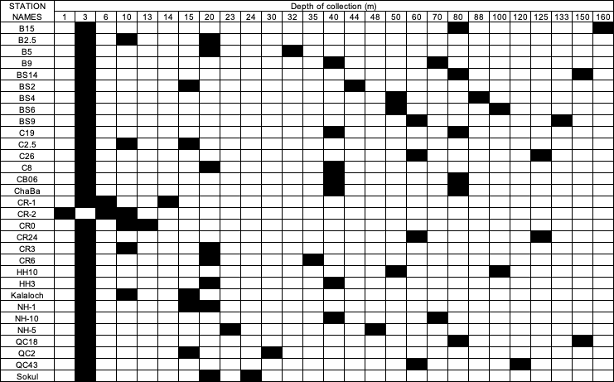

Stable isotope structure of particulate organic matter
Analyses by Paul Chittaro (Northwest Fisheries Science Center, Seattle WA; NOAA Fisheries)
Sample collections by Alexandra Rodier (NOAA Hollings Scholar 2021)

Cruise objectives were to address two principal inquiries.
- To understand the spatial variability of stable isotopes (i.e., dC and dN) at the base of the food web.
- Investigate relationships between stable isotopes, carbon chemistry gradients, and oceanographic conditions.

The sampling approach & methods included the following:
1. Collect water from the scientific seawater supply.
a. Filter duplicates of up to 4L of water through pre-combusted glass fiber filter, long-term storage at -20°C.
2. Target stations at nearshore stations (where bacterial information is also being collected) & at far offshore stations for each transect.

Actual collections: A total of 26 duplicate samples representing 26 stations from the northern leg (leg 1) were collected & preserved. The table below displays the stations & water volume filtered for POM.

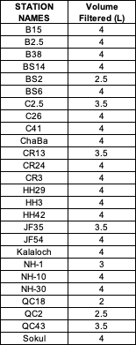

Deployments

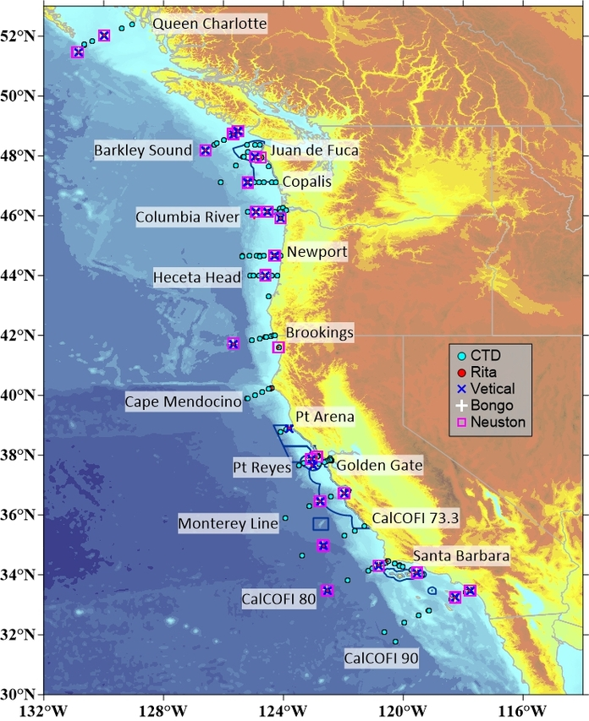
Figure 10.1 CTD and net deployment locations

Floats
Both deployed floats were deployed at station CM45 (i.e., 45 nautical miles off Cape Mendocino, ~125.2 °W 39.89 °N). Both floats began reporting data according to expectations:
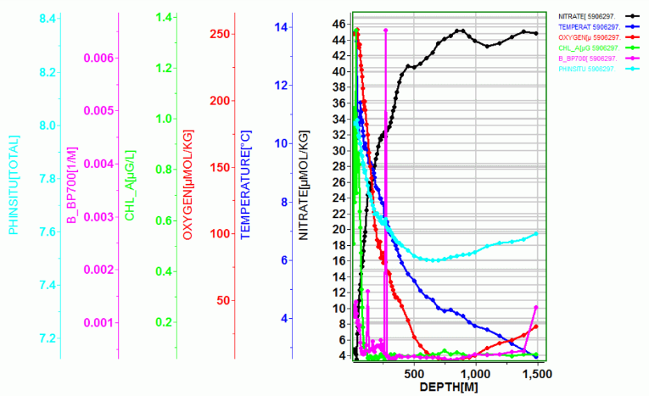
A comparison between the station oxygen and the float oxygen data appears to show good agreement, though all data are preliminary:
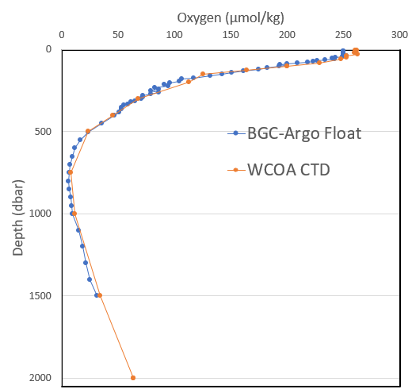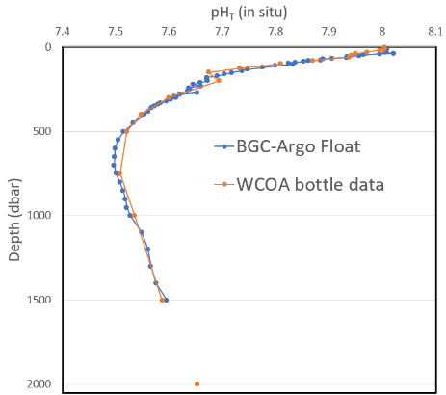

Net deployments

Compiled By: Meghan Shea, Jordan Chancellor, Kelcey Chung, Bryce Dewees
Summary:

During WCOA 2021 on the NOAA Ship Ronald H Brown, we conducted a biological station almost every evening, with a CTD cast and a series of net tows, including:
- 2 20 µm Rita net deployments
- 1 200 µm Vertical net deployment
- 1 75 µm Vertical net deployment
- 2 505 µm Neuston net deployments
- 1 Bongo net deployment with 2 335 µm nets
- 1 Bongo net deployment with 1 100 µm net and 1 200 µm net

On a typical night, the full sample suite would take approximately 2-3 hours to collect. During WCOA 21, we deployed nets at 31 distinct biological stations, with 216 individual nets deployed over the course of the cruise (62 Rita nets, 50 vertical nets, 57 Neuston nets, and 47 Bongo nets). Samples from the nets were processed with a combination of bulk preservation, picking of individual organisms, and imaging with a PlanktoScope; all processing types will require additional analysis after the cruise to produce cruise data.

Personnel:
- Net Deployments: Bryce Dewees (NOAA, RHB), Sophia Tigges (NOAA, RHB) Meghan Shea (Stanford), Noah Gluschankoff (Stanford), Chris Ikeda (NOAA, PMEL)
- Preservation & Picking: Kelcey Chung (SCCWRP), Jordan Chancellor (USC)

Net Rigging & Preparation:
**more images of all net rigging in this Google Photo album**

Rigging:
A line was attached to the Rita net opening with a bowline knot and a large shackle was zip-tied onto the opening to help the net sink well.

The Neuston net came pre-rigged, but the bridle was re-configured to allow the weight (80 lbs) to be properly attached to the bottom of the net with quick release links. Using fishing line and metal crimps, the SeaGear flow meter was attached diagonally in the center of the frame.
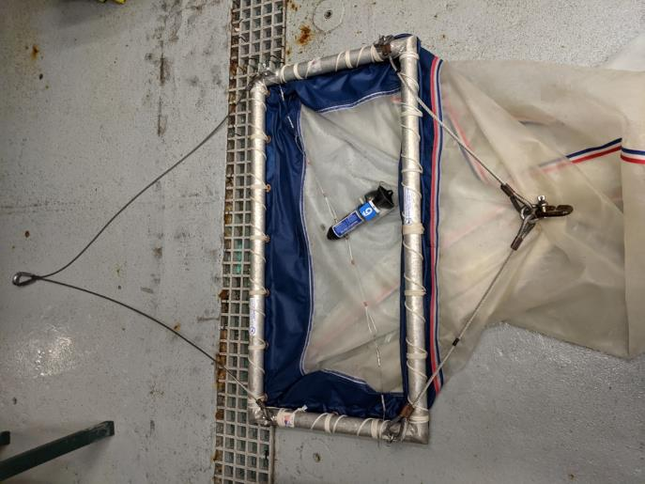
Figure 1 Neuston Net rigging
The vertical nets came partially rigged, but we re-attached the nets to the frames more securely using two half-hitches between each grommet. We then added three guide lines from the frames (knotted to attach), through the D-rings on the sides of the nets, down to ~1 foot beneath the bottom of the cod end (spliced to a shackle for attachment) to create a connection point to attach the weight (50 lbs) with a quick release link. In response to some initial tangling, we secured these rib lines in place to each of the external D-rings (rather than just running them through the rings). Using fishing line and metal crimps, the TSK flow meters were attached in the center of the frame.

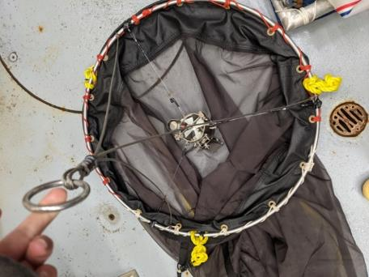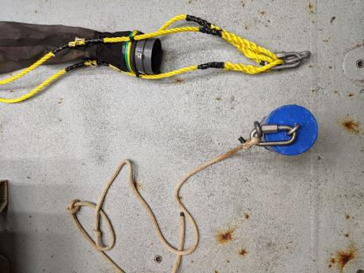
Figure 2 Top of vertical net rigging Figure 3 Bottom of vertical net rigging
Bongo nets were attached to the frames using designated hose clamps that came with the nets. The hose clamps were then taped over with duck tape to add extra reinforcement and cover any sharp edges. Holes were drilled in the sides of each Bongo net to give a place to attach the General Oceanics flow meters using fishing line and metal crimps. A shackle was added to the top of the center piece of the frame to attach the net to the ship’s winch, and a shackle and quick release link were added to the bottom of the frame to create a place to attach the weight (80 lbs).

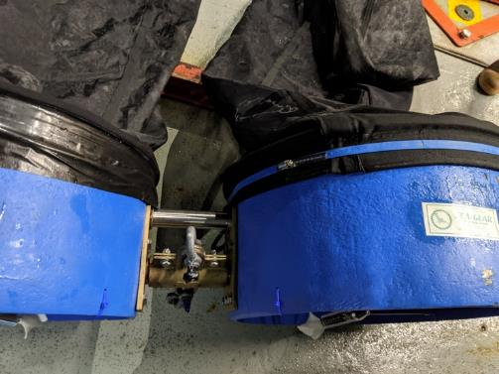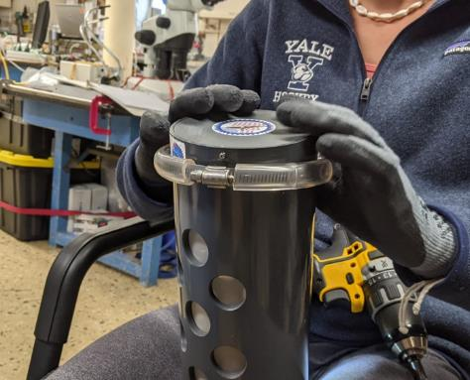
Figure 4 Bongo net rigging Figure 5 Ex. of bumper being added to the bottom of a cod end
Cod Ends:
To protect the cod ends from bumps against the side of the ship, bumpers were added to the bottom of each using hose clamps inside tygon tubing, with electrical tape wrapped around to secure. (NOTE: This would be easier with tygon tubing larger than the hose clamp. Our tubing was close to the same size as the hose clamp, so we cut it into small segments to make it easier to string onto the hose clamp.)

Because we did not have 505 µm cod ends, we removed the mesh from several of our back-up cod ends and replaced it with 505 µm mesh. (NOTE: we used a combination of silicon glue and PVC piping glue, neither of which worked particularly well. A two-part epoxy would probably be best).

All cod ends were attached to the bottom of the nets using hose clamps that came with the cod ends. When possible, the hose clamps in the groove of the cod end, and above the bottom seam of the net, to prevent the net from sliding. All hose clamps were taped over with electrical tape to protect the net from any sharp edges.

Calibration:
The General Oceanics flow meters (for Bongos) came pre-calibrated. These flow meters were filled with water per the instructions included with the flow meters. The water in the flow meters was topped off once in the middle of the cruise, and probably could have been topped off more frequently.

The TSK (for verticals) and SeaGear (for Neustons) flow meters were not pre-calibrated. However, their values were compared against the GO flow meters for realistic flow rates.

The Sensus Ultra pressure sensors were sent to a fixed depth on the CTD to verify their accuracy and record any discrepancies between them (calibration files in Pressure Sensor Files folder in Net Tows).

Organization:
Using a paint pen, all pressure sensors were labelled with the net they would be used with, so they could be easily attached to the same net each time. Using colored electrical tape, the bottom of each net and the top of each cod end was given a unique color code, so that the cod ends could be easily matched to their respective nets. This color code was also used on the data sheets and the coolers used to store the cod ends after retrieval.

Net Deployments:
**see RB2102_WCOA_Net_Tow_SOP_.docx for more technical net deployment information

The net team consisted of one of the ship’s survey technicians and two to three scientists on deck, a scientist in the computer lab, a winch operator provided by the ship, and one of the ship’s officers on the bridge. The survey technician would radio in all actions of the deployment and recovery of the nets to the other stations. The computer operator would record the time and metadata (GPS latitude and longitude, wind speed, wind direction, sea surface temperature, ship speed over ground, and bottom depth) in an SCS event for “net in water”, “net out of water”, and when applicable “net at depth”. The computer operator would also monitor the multibeam sonar for changes or hazards related to bathymetry. The net team on deck would prepare, deploy, monitor, recover, rinse the samples down to the cod end, remove the samples, and reset the nets. All net deployments required one person to tend the second winch cable that was connected to the CTD and through a block that would extend along with the hydro boom and the block the winch cable was through for all the net operations. The remaining members on deck would assist the survey technician with handling the nets.

Typically, we deployed the vertical nets first, followed by the Neuston nets, followed by the bongos. The biomass in the vertical nets would help inform the parameters used for the bongo nets. The Rita net would either be deployed during the biological station CTD cast (if a deep enough cast for the computer operator to handle the net event logging) or at the end of the net evolution (to allow time to run the PlanktoScope sample afterward).

For all nets except the hand-deployed Rita, the bridle would be attached to the winch with a shackle (with a zip tie through it for extra security). In addition, the attachment clips on the cod ends were always taped over with electrical tape to ensure they could not open accidentally during deployment.

For the Rita net, the net would be rinsed with saltwater and then deployed by hand over the side of the ship while the ship was stationary. It would be held at the surface for 3 minutes (recorded with a stopwatch) and then retrieved and rinsed very gently with saltwater. The Rita net would be deployed identically twice.

For the vertical nets, a pressure sensor would be attached to the top of the bridle with a zip tie and the TSK flow meter would be reset before each deployment. The net would be rinsed with saltwater, laid out on deck to check for tangles, and attached to the winch cable. On the Ronald H Brown, we elected to use the aft hydro-winch so the block would tend aft during the net tows and not interfere with the other block on the extended hydro boom. A 50 lb weight with guide line would be attached to the bottom of the net rigging with quick links. With the ship stationary and the guide lines down, the survey tech would raise the net as high as possible, and then boom out so that the net frame was over the edge of the deck. The scientist assisting with deployment would lower the weight down using the guide line until the net rigging took the tension, at which point the line would be released and the net would be fully boomed out and sent down to the target depth (100 m, or ~20 m above bottom depth, whichever was more shallow) at 30 m/minute and then brought up at 30 m/min. Unless wind conditions were too challenging, the net would be rinsed with saltwater while hanging next to the ship, and then recovered by the survey tech and scientist pulling up together on the net rigging to bring the weight back on deck. After full retrieving the net, the flow meter would be read. We would deploy the 200 µm vertical net first, followed by the 75 µm vertical net.

For the Neuston net, the SeaGear flow meter would be reset before each deployment. The net would be rinsed with saltwater and attached to the winch. An 80 lb weight would be attached to the bottom of the net bridle with quick links. To deploy, the survey tech would guide the frame and weight up over the side of the science deck, and the scientist would guide the net itself over the side of the ship, throwing the cod end at the last possible moment (to prevent it from swinging back and forth and hitting the side of the ship). The Neuston would be lowered down to just beneath the surface (deep enough that wouldn’t exit the water between waves) and towed for 20 minutes, with the ship speed between 1-2 knots (enough to keep the net spread out and not bunched up). Unless wind conditions were too challenging, the net would be brought back to the side of the deck, the flow meter would be read (to prevent it from spinning more during retrieval/rinsing), and the net would be rinsed with saltwater while hanging next to the ship. The scientist would then pull up the cod end by hand while the survey tech guided the weight and the frame back on deck. The Neuston would be deployed twice during each evolution, with the same net but a new cod end attached (so we wouldn’t have to wait for the picking team to finish with the original cod end before deploying again).

For the bongo nets, the General Oceanics flow meters would be recorded before each deployment (but not reset), and a pressure sensor would be attached to the top of the frame with a zip tie. The nets would be rinsed with saltwater and attached to the winch. An 80 lb weight would be attached to the bottom of the net frame with quick links. To deploy, the survey tech would guide the frame and the weight up over the side of the science deck, and the scientist would guide the net itself over the side of the ship, throwing the outboard cod end first followed by the inboard cod end to try to prevent the nets from twisting on themselves during deployment. If possible, another scientist would help the survey tech guide the bongo frame. Using a wire angle chart, the wire out required to reach the target depth at an ideal wire angle of 45° would be determined (usually 141 m wire to reach 100 m target depth), and the winch would wire out at 30 m/min. A scientist would monitor the wire angle while the net was in the water, and the ship speed would be adjusted via radio communication between the survey tech and bridge as needed to keep the wire angle in the target range of 38-52°. The ship speed was typically between 1-2 knots while towing the bongo nets. Once the wire out value was reached, the net would be paused if necessary to adjust the wire angle, and then retrieved at between 10-30 m/min, depending on how much biomass was captured in the vertical nets. A scientist would continue to monitor the wire angle during recovery. Wire angles were recorded at 75m (or a half halfway point on a shallower cast), at target depth, at 75m on the way back up, and at surface. Next, unless wind conditions were too challenging, the net would be brought back to the side of the deck, the flow meters would be read and their values recorded (to prevent them from spinning more during retrieval/rinsing), and the net would be rinsed with saltwater while hanging next to the ship. The scientist would then pull up the cod ends by hand while the survey tech (and an additional scientist, if available) guided the weight and the net frame back on deck. We would deploy the bongo net with two 335 µm cod ends first, followed by the bongo net with one 100 µm and one 200 µm cod end. The 100 µm net was placed on the outside location of the net frame to lead the net to pull away from the ship if there were different drag coefficients between using two different

After deployment, all nets would be rinsed thoroughly in freshwater and stored in a fish tote on deck.

To increase efficiency, we would set up the next net in the evolution at the back of the deck while the previous net was in the water, and we would re-attach and tape the cod ends onto the nets before we put them away so they would be ready for the next station. We also had a designated cooler for each net, so that the deployment team could put the cod end in the cooler and set it aside easily if the picking team was not on deck.

Processing:

Rita Net & PlanktoScope:

For the first Rita net, the cod end would be gently tapped against the bottom of the sink to remove any excess water. Then, the contents would be poured into a 250 ml Nalgene bottle, the cod end mesh would be rinsed gently with filtered seawater (made before the deployment by filling a squirt bottle with seawater passed through the Rita net mesh), and any remaining liquid would be added to the Nalgene bottle. Buffered ethanol would be added (approximately the same volume as seawater in the bottle) and the sample would be stored in the fridge.

For the second Rita net, the cod end would be gently tapped against the bottom of the sink to remove any excess water. Then, the contents would be poured into a 250 ml Nalgene bottle, the cod end mesh would be rinsed gently with filtered seawater (made before the deployment by filling a squirt bottle with seawater passed through the Rita net mesh), and any remaining liquid would be added to the Nalgene bottle. The Nalgene bottle would be gently inverted to mix the sample, and ~18 ml of sample would be added to three scintillation vials (a little bit into each vial at a time, also to help mix the sample). One scintillation vial would be set aside for the PlanktoScope, and the other two would have ~2 ml of formalin added and be stored at room temperature.

The PlanktoScope sample would be filtered immediately through a homemade 200 µm sieve (since the flow cell was only 200 µm wide) and the PlanktoScope would be turned on and rinsed with 25 mL of DI water three times. The sample data would be entered into the PlankotScope software (latitude, longitude, time of sample etc.), and sample would be gently poured into the syringe (at an angle, to decrease pressure on cells during the pour), and 3 mL would be slowly passed through the PlankoScope to clear out any freshwater in the tubing (NOTE: the PlanktoScope protocol wanted the tubing to be dried between the freshwater rinses and the sample processing, but I had trouble with air bubbles being introduced when the sample was added, so I kept a small amount of freshwater fully in the tubing before I introduced the sample). With the sample visible in the flow cell, the focus would be adjusted and fluidic acquisition would be set up (pumped volume: .02 mL, 0.5 seconds before image to stabilize) and 500 images of the sample would be taken (monitoring for bubbles or other issues during the acquisition). (NOTE: It was often tricky to get the focus right, so I would check the images in the Gallery as soon as acquisition started and stop the acquisition and readjust as needed). After fluidic acquisition, the rest of the sample would be passed through the PlanktoScope to remove it, and the system would be cleaned again with 25 mL of DI water three times.

Abbreviated Bulk Preservation Protocol

Following each deployment, cod ends were sieved through a net of the same mesh size and preserved according to the following protocol:

Net | Size | Preservation Method | Storage Method | Notes
Rita | 20 | Buffered Ethanol | Room Temperature | 250 mL jar
Rita | 20 | Buffered Formalin | Room Temperature | 3 X 20 mL scintillation vials
Vertical | 75 | Buffered Ethanol | Room Temperature
Vertical | 200 | Buffered Ethanol | Room Temperature
Neuston | 505 (#1) |  | -80 | Preserve whatever is left after picking, excludng gelatinous material
Neuston | 505 (#2) | Buffered Ethanol | Room Temperature
Bongo | 100 | Buffered Ethanol | Room Temperature
Bongo | 200 | Buffered Ethanol | Room Temperature
Bongo | 335 (#1) | Buffered Ethanol | Room Temperature
Bongo | 335 (#2) | Buffered Formalin | Room Temperature

Bulk Cod End Preservation Notes

Bottle size was determined based off the amount of organic material obtained from each net tow

Picking for species of interest was carried out from both of the Neuston tows. If the requested number of species individuals could not be obtained from the Neuston nets, picking was continued from the Bongo 335 tow.

Excess salps and pyrosomes from Neuston and Bongo tows at stations where numbers were highly abundant were sieved from initial tow and discarded after the desired individuals were preserved.

Total Bulk Preservation Bottle Count

Net | Total number of bulk sample bottles
Vertical 75 | 29 (Buffered EtOH)
Vertical 200 | 26 (Buffered EtOH)  3 (4% Formalin)
Neuston 505 #1 | 29 (-80)
Neuston 505 #2 | 35 (Buffered EtOH)
Bongo 100 | 27 (Buffered EtOH)
Bongo 200 | 27 (Buffered EtOH)
Bongo 335 #1 | 25 (Buffered EtOH)
Bongo 335 #2 | 25 (4% Formalin)

Station Summary

Presence/Absence Data of Top Two Indicator Species
Station | Date | Pteropods? (L. helicina) | Dungeness Crabs?
QC-85 | 6/24/21 | Present | Absent
QC-43 | 6/25/21 | Present | Present
QC-6 | 6/28/21 | Absent | Present
BS-64 | 6/27/21 | Present | Absent
BS-6 | 6/28/21 | Absent | Present
Chaba | 6/29/21 | Present | Present
Sokul | 6/29/21 | Unknown | Present
CR-40 | 6/30/21 | Absent | Present
CR-24 | 7/1/21 | Present | Present
C-41 | 7/2/21 | Present | Present
Ecola | 7/3/21 | Absent | Present
NH-10 | 7/4/21 | Present | Present
HH-20 | 7/5/21 | Present | Present
B66 | 7/6/21 | Present | Absent
FKC | 7/7/21 | Present | Present
PA3 | 7/10/21 | Present | Present
PR4 | 7/11/21 | Absent | Absent
PR15 | 7/11/21 | Present | Absent
GGTX1 | 7/13/21 | Present | Absent
ML60 | 7/14/21 | Present | Absent
ML11 | 7/15/21 | Absent | Absent
73.3-70 | 7/16/21 | Present | Absent
CCE1 | 7/17/21 | Present | Absent
CCE2 | 7/18/21 | Absent | Absent
80-51 | 7/18/21 | Absent | Absent
SCORP | 7/19/21 | Absent | Absent
90-28 | 7/20/21 | Absent | Absent
90-35 | 7/21/21 | Absent | Absent
90-60 | 7/22/21 | Absent | Absent
P02_12 | 7/23/21 | Present | Absent

Individual Sample Collection Summary
Target Preservation Quantities for each Station in Order of Priority
Species | What For | How Many | What Container | Preservation Method | Storage Method
Dungeness Crab Megalopae | Biomarkers | 6-8 | Individual Cryotubes | Flash Frozen | -80
Dungeness Crab Megalopae | Transcriptomics | 2-3 | Individual Eppendorf Tubes | RNAlater | -20
Dungeness Crab Megalopae | Exoskeleton Dissolution | 6 | Scintillation vial | Buffered Ethanol | Room Temperature
Dungeness Crab Megalopae | DA | 2 | Single Eppendorf Tube |  | -80
Dungeness Crab Megalopae | Isotopes | 5 | whirlpack |  | -80
Krill | Biomarkers | 6-10 | Individual Cryotubes | Flash Frozen | -80
Krill | DA | 3-4 | Aluminum Foil |  | -80
Krill | Fatty Acids | 3 | Aluminum Foil |  | -80
Krill | Isotopes | 20-50 | Whirlpack |  | -80
Fish | Biomarkers | 7-10 of same species | Individual Cryotubes | Flash Frozen | -80
Fish | DA | 1 Anchovy, 1 Myctophid, 1 Market Squid | Aluminum Foil |  | -80
Fish | Fatty Acids | 3 Myctophids | Aluminum Foil |  | -80
Pyrosomes |  | 2-3 | Whirlpack |  | -80
Salps |  | 2-3 | Whirlpack |  | -80
Red Crab Zoea |  | 10-20 | Scintillation vial | Buffered Ethanol | Room Temperature
Pteropods | SEM/light shell dissolution | 10 | Scintillation vial | Buffered Ethanol | Room Temperature
Pteropods | uCT | 10 | Scintillation vial | Buffered Ethanol | Room Temperature
Pteropods | Shell Isotope | 10 | Scintillation vial | Buffered Ethanol | Room Temperature
Pteropods | Drexel University | 20 | Scintillation vial | Buffered Ethanol | Room Temperature
Pteropods | DA | 15-20 | Single Eppendorf Tube |  | -80
Pteropods | Isotopes | 10-15 | Whirlpack |  | -80
Pteropods | Onboard Sequencing | 10-15 | qPCR tubes | 95% EtOH | Room Temperature
Pteropods | Transcriptomics | 15 | Split into three Eppendorf Tubes | RNAlater | -20
Copepods | Isotopes | ~500 | Whirlpack |  | -80
Copepods | DA | 10 | Single Eppendorf Tube |  | -80

 | Number of stations each species was preserved
 | Dungeness crab megalopae | Krill | Fish | Pteropod  (L. helicina) | Copepod | Pyrosome | Salp
Biomarkers | 11 | 21 | 1
DA | 9 | 22 | 0 | 12 | 15
Transcriptomics | 11 |  |  | 12
Fatty acid |  | 21 | 1
Isotopes | 9 | 18 | 6 | 12 | 13
SEM | 9 |  |  | 16
uCT |  |  |  | 9
Shell isotope |  |  |  | 16
Onboard sequencing |  |  |  | 4
Unknown |  |  |  |  |  | 10 | 10

Data Management:

During net evolutions, the scientist operating the computer in the main lab would use the ship’s SCS event logger to record when nets entered the water and were retrieved from the water (and when nets reached depth, for the vertical and bongo nets). The event logger was set to record times, latitude, longitude, station #, net type, net #, speed over ground, water temperature, and bottom depth each time an event was logged. On deck, one scientist maintained a laminated data sheet with a Sharpie to record additional necessary data (flow meter readings, bongo wire angles, etc.).

After each net evolution, one scientist would fill in a hard copy data sheet for each net type, with a combination of information from the deck data sheet and the deployment log. For each station, all of these hard copy data sheets were scanned and saved in a batch. The information from these data sheets was also added to an Excel master data file, organized by net type.

The pressure sensors from the bongo and vertical nets were removed after each net evolution so the data could be uploaded. The depth reached for each net was recorded on the hard copy data sheet (above), and a file with the pressure information and raw data was saved for each net.

The type and number of jars preserved from each net was also recorded and added to the Excel master data file.

Additional Lessons Learned:
- For the on-deck data sheet, a grease pen might have been better to write with than a Sharpie.
- For ease of deployment, all flow meters were kept permanently attached to the net frames (but vigorously rinsed with freshwater after each deployment). For the most accurate flow meter readings, it would probably be better to remove the flow meters after each deployment and soak in freshwater; using zip ties as the final point of attachment would probably make this easiest.
- Originally the plan was to stop the Bongo tow at the target depth for a period of time, and to also stop at the DCM depth on the way back up to the surface, but due to high biomass recovered even just from a tow to depth and then back to surface, we did not end up using this deployment plan. If there are plans to do deployments with different timings or strategies, it would be important to test those deployments before the first station if possible so that you can make sure there won’t be too much biomass for the picking team to deal with. You need infinitely more electrical tape than you think you need (and get the good stuff: Amazon Basics is just not great!). Also lots of zip ties.

The following net events were conducted on WCOA2021:
Type | Total | Leg 1 | leg 2
V75 | 24 | 11 | 13 | Vertical net 75 µm
V200 | 27 | 14 | 13 | Vertical net 200 µm
N505 | 57 | 24 | 33 | Neuston net 505 µm
Bongo100200 | 23 | 10 | 13 | Bongo nets with 100 µm and 200 µm
Bongo335 | 23 | 10 | 13 | Bongo nets with double 335 µm
Rita | 62 | 30 | 32 | Rita net with XX µm
All | 216 | 99 | 117

Data processing and management
Periodically throughout the cruise and at the conclusion of the cruise analysts submitted data files prepared according to the following instructions:
Create a .csv or a tab-delimited text file. The first row should contain "SampleID" followed by a delimited list of the variables you are submitting named as you would like them to appear in the data file. The second row should contain preferred units. The third row on down should have numbers. Provide the following columns in this order (I've attached a few lines from an example for :
  - a sample ID code computed as 10000*(Station Number)+100*(Cast Number)+Niskin number. For example, niskin 17 on station 20 would be 200117. So far, all of our casts have been cast 1. You need one row dedicated to each sample that you did collect.
  - the corresponding numbers you'd like to submit. For missing data use "-999."
  - (uncommon) numerical metadata required to understand your measurement that is not included in the property name (an example is the temperature of a reported pH value)
  - a QC code using the WOCE water sample conventions (the 2nd list at this link)... briefly:
    - collected, but not yet reported (this will be common for those of you who have measurements that will be made on samples after the cruise is completed)
    - collected, reported, normal (considered "good," common for measurements made at sea)
    - collected, reported, but something looks fishy about the data
    - collected, reported, but we know something is wrong with the data
    - collected, something went wrong and there is no number to report
    - collected, reported, the value is the average of two or more replicates (usually this is considered "good")
    - don't use these unless you use chromatography
    - don't use these unless you use chromatography
    - the sample was never collected for this measurement (this will be common in the final data product, but you don't need lines for these samples in your submissions).
  - some of you will have multiple number/qc-code pairs to submit (e.g., pH_tot, pH_temp, carbonate, carbonate_temp) so just add as many columns for values and qc codes as you need.
These data and their QC codes were then integrated into a master file with the bottle temperature, conductivity (salinity), and pressure data files using a lookup table in Excel that keyed off the SampleID. The bottle values from the CTD were extracted first using software from Seabird Electronics. These data files were then further pared down to the essential elements using a custom PERL script, and finally merged into a single file for all stations using a custom MATLAB script.
Many parameters did not generate measurements at sea. These were simply reported with the quality control code of “5” indicating samples were collected but no measurements have been reported yet. These will be updated as the data become available and incorporated into the data file.
Some samples produce data that does not fit within either the CTD profile or the station bottle files. At a minimum, these will be addressed using links included in the metadata for the data file. Some non-traditional data types will be included in the bottle data file, as feasible.

Quality control
Some primary quality control was performed at sea including the following checks:
- Station plots
- Property property plots
- Comparisons to measurements from past WCOA occupations
- Comparisons to algorithm estimates.
- Carbonate measurement intercomparisons.
These quality control checks were not exhaustive at sea, and more will be performed in the months to come before the data are submitted to the National Center for Environmental Information (NCEI).

Collected Samples

Sample analysis location:

Samples Analyzed On-Board | Samples Collected (Not Analyzed)
Dissolved O2  Total CO2 (DIC)  Total Alkalinity  pH  Carbonate  Nutrients  Salinity  DI¹³C (vial samples)  eDNA (a small subset) | All other samples

Station-work efficiency
A full schedule for station work on leg 1 is provided as Appendix 1. The following shows how long various CTD package deployments took as a function of bottom depth for the first half of the cruise. This function had to be updated in our projections because of the large number of shallow casts on WCOA compared to open-ocean repeat hydrographic transects:
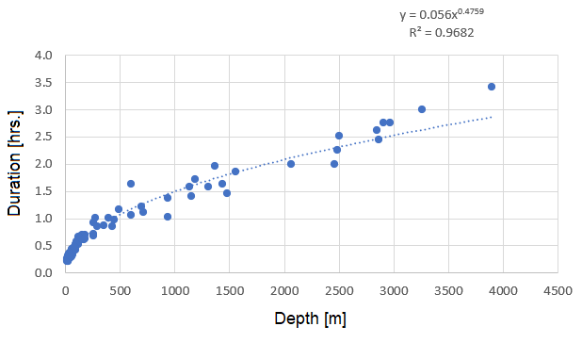

Appendix: Station Timing

Stn.# | Stn. Name | GMT CTD in water | GMT CTD on deck
1 | QC85 | 6/25/2021 02:00 | 6/25/2021 03:40
2 | QC74 | 6/25/2021 13:00 | 6/25/2021 15:01
3 | QC62 | 6/25/2021 16:52 | 6/25/2021 17:38
4 | QC2 | 6/25/2021 22:48 | 6/25/2021 23:05
5 | QC18 | 6/26/2021 00:55 | 6/26/2021 01:36
6 | QC43 | 6/27/2021 04:02 | 6/27/2021 04:39
7 | BS64 | 6/27/2021 11:55 | 6/27/2021 14:10
8 | BS48 | 6/27/2021 16:07 | 6/27/2021 17:45
9 | BS43 | 6/27/2021 18:57 | 6/27/2021 20:01
10 | BS32 | 6/27/2021 21:23 | 6/27/2021 21:55
11 | BS20 | 6/27/2021 23:13 | 6/27/2021 23:33
12 | BS14 | 6/28/2021 01:18 | 6/28/2021 01:55
13 | BS9 | 6/28/2021 04:53 | 6/28/2021 05:30
14 | BS6 | 6/28/2021 09:35 | 6/28/2021
15 | BS4 | 6/28/2021 11:17 | 6/28/2021 11:52
16 | BS2 | 6/28/2021 12:50 | 6/28/2021 13:10
17 | JF20 | 6/28/2021 16:11 | 6/28/2021 16:53
18 | JF9 | 6/28/2021 18:41 | 6/28/2021 19:59
19 | JF2.5 | 6/28/2021 20:27 | 6/28/2021 20:52
20 | JF23 | 6/28/2021 23:07 | 6/28/2021 23:50
21 | JF35 | 6/29/2021 02:24 | 6/29/2021 03:34
22 | ChaBa | 6/29/2021 09:13 | 6/29/2021 09:40
23 | Sokul | 6/29/2021 11:36 | 6/29/2021 11:57
24 | JF54 | 6/29/2021 | 6/29/2021 17:59
25 | Kalaloch | 6/29/2021 21:30 | 6/29/2021 21:47
26 | CR40 | 6/30/2021 09:37 | 6/30/2021 11:12
27 | CR0 | 6/30/2021 18:01 | 6/30/2021
28 | CR-1 | 6/30/2021 19:37 | 6/30/2021 19:53
29 | CR-2 | 6/30/2021 22:10 | 6/30/2021 22:24
30 | CR3 | 7/1/2021 00:35 | 7/1/2021 00:54
31 | CR6 | 7/1/2021 01:43 | 7/1/2021 02:05
32 | CR13 | 7/1/2021 03:10 | 7/1/2021 03:40
33 | CR24 | 7/1/2021 05:01 | 7/1/2021 05:42
34 | CR30 | 7/1/2021 10:15 | 7/1/2021 11:07
35 | CR50 | 7/1/2021 13:31 | 7/1/2021 15:29
36 | C77 | 7/1/2021 22:22 | 7/2/2021 00:53
37 | C41 | 7/2/2021 | 7/2/2021 06:42
38 | C35 | 7/2/2021 10:33 | 7/2/2021 12:08
39 | C32 | 7/2/2021 13:08 | 7/2/2021 14:09
40 | C26 | 7/2/2021 15:15 | 7/2/2021 15:53
41 | C19 | 7/2/2021 17:13 | 7/2/2021 17:45
42 | C8 | 7/2/2021 19:23 | 7/2/2021 19:43
43 | C2.5 | 7/2/2021 | 7/2/2021 20:56
44 | ECOLA | 7/3/2021 04:26 | 7/3/2021 04:53
45 | NH55 | 7/3/2021 | 7/3/2021 17:35
46 | NH45 | 7/3/2021 19:23 | 7/3/2021 20:30
47 | NH35 | 7/3/2021 | 7/3/2021 22:54
48 | NH30 | 7/3/2021 01:05 | 7/3/2021 02:00
49 | NH25 | 7/3/2021 03:20 | 7/3/2021 04:11
50 | NH10 | 7/4/2021 09:34 | 7/4/2021 10:02
51 | NH55 | 7/4/2021 11:07 | 7/4/2021 11:33
52 | NH1 | 7/4/2021 11:34 | 7/4/2021 11:49
53 | HH42 | 7/4/2021 20:40 | 7/4/2021 22:18
54 | HH37 | 7/5/2021 00:33 | 7/5/2021 01:55
55 | HH29 | 7/5/2021 | 7/5/2021 03:55
56 | HH20 | 7/5/2021 05:28 | 7/5/2021
57 | HH10 | 7/5/2021 | 7/5/2021 12:00
58 | HH3 | 7/5/2021 13:16 | 7/5/2021 13:59
59 | CB06 | 7/5/2021 17:30 | 7/5/2021 17:59
60 | B66 | 7/6/2021 03:01 | 7/6/2021 05:46
61 | B38 | 7/6/2021 13:16 | 7/6/2021 14:59
62 | B26 | 7/6/2021 16:20 | 7/6/2021 17:33
63 | B17 | 7/6/2021 18:53 | 7/6/2021 19:52
64 | B15 | 7/6/2021 21:02 | 7/6/2021 21:40
65 | B9 | 7/6/2021 22:52 | 7/6/2021 23:17
66 | B5 | 7/7/2021 | 7/7/2021 00:52
67 | B2.5 | 7/7/2021 01:36 | 7/7/2021
68 | FKC | 7/7/2021 05:05 | 7/7/2021 05:22
69 | CM45 | 7/7/2021 16:57 | 7/7/2021 18:57
70 | CM30 | 7/7/2021 | 7/7/2021 22:30
71 | CM20 | 7/7/2021 23:51 | 7/8/2021 00:53
72 | CM3 | 7/9/2021 08:30 | 7/9/2021 08:55
73 | CM1 | 7/9/2021 10:08 | 7/9/2021 10:29
74 | CM5 | 7/9/2021 12:35 | 7/9/2021 13:12
75 | CM7 | 7/9/2021 14:05 | 7/9/2021 15:06
76 | PA19 | 7/9/2021 22:51 | 7/10/2021 00:51
77 | PA09 | 7/10/2021 02:12 | 7/10/2021 02:53
78 | PA3 | 7/10/2021 04:17 | 7/10/2021 04:48
79 | PR28 | 7/10/2021 19:41 | 7/10/2021 21:06
80 | PR20 | 7/10/2021 22:29 | 7/10/2021 22:55
81 | PR10 | 7/11/2021 01:30 | 7/11/2021 01:54
82 | PR1 | 7/11/2021 03:22 | 7/11/2021 03:39
83 | PR4 | 7/11/2021 04:29 | 7/11/2021 04:49
84 | PR15 | 7/11/2021 11:11 | 7/11/2021 11:38
85 | PR37 | 7/11/2021 14:39 | 7/11/2021 17:16
86 | GGTX7 | 7/12/2021 16:02 | 7/12/2021 16:16
87 | S Sta 18 Pt Blunt | 7/12/2021 17:06 | 7/12/2021 17:27
88 | C Map CO2 Buoy | 7/12/2021 18:43 | 7/12/2021 18:56
89 | GGTX6 | 7/12/2021 20:00 | 7/12/2021 20:16
90 | GGTX5 | 7/12/2021 21:28 | 7/12/2021 21:47
91 | GGTX4 | 7/12/2021 22:35 | 7/12/2021 22:48
92 | GGTX3 | 7/12/2021 23:52 | 7/13/2021 00:05
93 | GGTX2 | 7/13/2021 01:48 | 7/13/2021 02:06
94 | GGTX1 | 7/13/2021 03:33 | 7/13/2021 04:01
95 | ML126 | 7/13/2021 18:06 | 7/13/2021 21:31
96 | ML82 | 7/14/2021 01:43 | 7/14/2021 04:43
97 | ML60 | 7/14/2021 09:37 | 7/14/2021 12:22
98 | ML38 | 7/14/2021 14:37 | 7/14/2021 17:39
99 | ML8 | 7/14/2021 | 7/14/2021 21:16
100 | ML3 | 7/14/2021 22:31 | 7/14/2021 23:13
101 | ML1 | 7/15/2021 00:39 | 7/15/2021 00:55
102 | ML5 | 7/15/2021 02:14 | 7/15/2021 02:50
103 | ML11 | 7/15/2021 03:58 | 7/15/2021 04:30
104 | CC73.3-50 | 7/15/2021 16:38 | 7/15/2021 17:04
105 | CC73.3-55 | 7/15/2021 18:54 | 7/15/2021 20:12
106 | CC73.3-60 | 7/15/2021 22:12 | 7/16/2021 00:37
107 | CC73.3-70 | 7/16/2021 04:30 | 7/16/2021 07:55
108 | CC73.3-80 | 7/16/2021 15:20 | 7/16/2021 19:04
109 | CCE1 | 7/17/2021 | 7/17/2021 05:32
110 | 80-70 | 7/17/2021 13:16 | 7/17/2021 16:26
111 | 80-60 | 7/17/2021 20:16 | 7/17/2021 22:20
112 | 80-57 | 7/17/2021 23:38 | 7/18/2021 00:53
113 | CCE2 | 7/18/2021 02:31 | 7/18/2021 03:48
114 | 80-51 | 7/18/2021 11:01 | 7/18/2021 11:31
115 | 80-54 | 7/18/2021 12:40 | 7/18/2021 13:36
116 | 80-52 | 7/18/2021 14:41 | 7/18/2021 15:35
117 | 80-50.5 | 7/18/2021 17:02 | 7/18/2021 17:16
118 | SB2 | 7/19/2021 00:41 | 7/19/2021 01:19
119 | SB3 | 7/19/2021 02:34 | 7/19/2021 03:50
120 | SB4 | 7/19/2021 05:03 | 7/19/2021 06:21
121 | Scorp | 7/19/2021 11:19 | 7/19/2021 11:47
122 | SB5 | 7/19/2021 13:11 | 7/19/2021 14:11
123 | Anacapa | 7/19/2021 22:22 | 7/19/2021 22:50
124 | CC90-28 | 7/20/2021 07:55 | 7/20/2021 08:18
125 | CC90-27.7 | 7/20/2021 14:38 | 7/20/2021 14:54
126 | CC90-30 | 7/20/2021 16:37 | 7/20/2021 17:49
127 | CC90-35 | 7/21/2021 00:59 | 7/21/2021 01:41
128 | CC90-37 | 7/21/2021 08:04 | 7/21/2021 09:39
129 | CC90-49 | 7/21/2021 18:34 | 7/21/2021 19:51
130 | CC90-53 | 7/22/2021 01:31 | 7/22/2021 03:00
131 | CC90-60 | 7/22/2021 09:38 | 7/22/2021 10:57
132 | CC90-70 | 7/22/2021 22:54 | 7/23/2021 01:59
133 | P02-12 | 7/23/2021 09:33 | 7/23/2021 12:56

WCOA2021 station notes
The following is a subset of notes from the stations occupied on WCOA2021 with a focus on leg 2:
QC85: Stopped at 1334 despite a multibeam depth of ~1400 due to unresponsive altimeter. Vertical net had issues with cod end getting tangled with net. Aborted to adjust. Adjustments were still incomplete when the sun rose, so only did the 200 µm Vertical Net and proceeded to next station.
QC74: Stopped at 879 m despite 907 m bottom depth (and 1020 m wire out). Altimeter again seemed unresponsive, this time stuck at 67 m out. Wind picking up throughout the day.
Sokul: Huge haul of jellyfish from first neuston. Had to dump out most of the catch. Skipped 2nd neuston. Noah got minor sting on face. Tremendous number of crab larvae with octopus (small). Did Rita x2. Had to make water and release waste so went offshore, doing J54 next, then Kalaloch. Steep vertical chemistry gradient (see leg 1 narrative).
CR40: We need to replace the firing mechanism for bottle 5 which has been stuck for the last several stations. We fiddled with the lanyard prior to this station, but the problem remained. One Neuston net overflowed. Similarly, there was excessive catch on the 2nd bongo (100-200 µm) despite our fastest spool-in speed yet (30 m/min). Vibrant purple “stuff” with one shrimp. Much of the catch was deemed too voluminous to preserve and was tossed out. We trained the net squad on the plankton splitter later in the day after the tow was completed.
CM>10: Stopped and measured first three on the CM line on the way south due to bad weather rolling in, which was possible after the captain suggested moving the end-of-leg-1 point to Bodega Bay. Had time for outermost three, only. Got Argo floats deployed. These floats returned signal successfully.
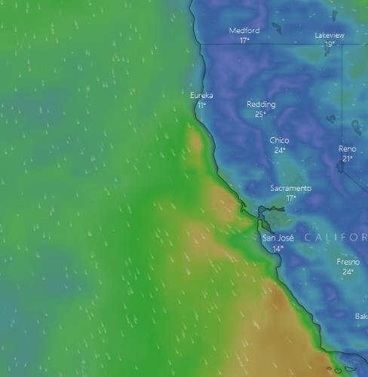
The day we started the Cape Mendocino line on windy.com are shown above (orange winds were our no-go criteria). For comparison, here are the next 8 days of winds projected and waves. (EDIT, the reality matched expectations quite well, unfortunately.)
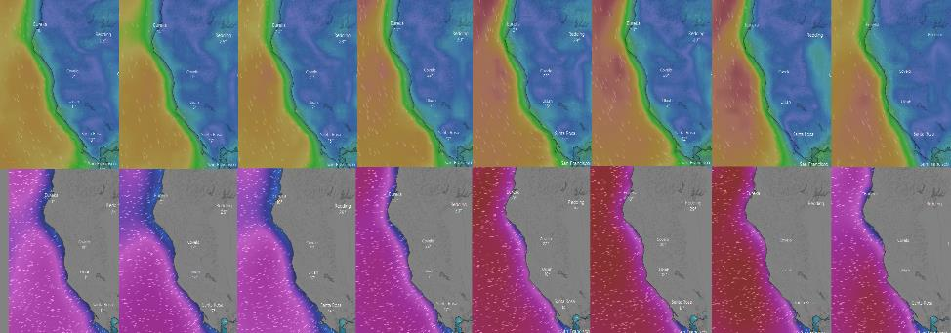

CM3: 30-35 knot winds… little chance of getting better according to forecasts. Doing CTD stations as far inshore as we can get. CM 0.5 and CM1 may be too shallow, CMs5 and 7 might be too exposed.
CM1 then CM7: Happened, winds still strong. Captain wants to wait for sunup to get off station. No nets possible aside from Rita nets. Then went offshore and finished CM7. CM0.5 deemed too shallow/close to rocks and was cancelled.
PALine: Started in the middle of the line and headed to the coast for full bio station at 3. Then heading back out to finish the line. Goopy green stuff in fine mesh tows. Big krill in coarse mesh bongos.
PA30: Transit out to this station was quite rough (and slow) with some tacking to minimize rocking. Upon arrival we learned that a wave had crashed over the side, damaging the fish tote that held the bongo nets. The nets remained in place but were compressed, abraded, and somewhat tangled in securing line. The 335 bongos sustained minor damage with several small tears and abrasions and a partially detached flowmeter. The 100 and 200 nets had still more and larger tears. The frame was also abraded, but did not appear to have lost any functionality, just some than paint. A plan was made to replace all nets on the frame with backups to buy time to carefully repair the damage to the original nets.
Once on station the wave state was rough, with water occasionally reaching the deck while winds varied between 25 and 35 knots. The safety of deploying and recovering a CTD was in question. The forecast called for winds and waves to continue to build over the coming week. As PA30, PA49, and PA75 were not part of the core WCOA timeseries, they were deemed expendable, and Carter requested that the vessel skip these stations and begin to transit to the next line (Point Reyes). Weather forecast showed gradually worsening weather at PR line over next several days so it seemed prudent to start these (core) stations ASAP.
Transit after PA30: The nets were replaced on the frame. A new tote was built about 10-20’ forward of the rosette package landing area and the rails. This area should have less wave action being closer to the middle of the boat (less pitching relative to sea level) and is protected by an area of the frame of the ship that extends to the 01 deck.
PR10: Whales by the CTD!
PR4: Did neustons only due to depth. Large number of jellyfish spotted during 2nd tow. Ended cast at ~1/2 duration and still came up with a mess of jellyfish.
Advised that the sample be dumped except for the cod end. Of that, nothing came through the colander that had been used to separate out salps. Samples collected of “jellyfish mucus” only. No stings, thankfully.
PR15: Got in a full bio despite modest winds and waves.
2021/07/11_PR37: Did CTD in strong waves and modest winds. Winch driver and Survey timed it perfectly.
ML126: 07/13/2021 0300 hrs. Was advised that there is a naval weapons test advisory for the area around this station. I provided an alternative further SW of the advisory area along the Monterey line.
ML60 2021/07/14: Pulling up overflowing heaps of pyrosomes from the neustons and not a lot else (pyrosomes, one krill, and a bit of algae from the verticals). Trying 20 m/min retrievals on the Bongo in the hopes of avoiding overflowing cod ends. 335 bongos came back with cod ends maybe half full of pyrosomes without much else. It seems unlikely that this is related to mesh size so we’ve kept it at 20 m/min for the 100/200. Only a fraction of the pyrosome biomass is being preserved, so it will be difficult to be quantitative.
ML38: Modulo errors 28 and counting with missed commands to trip bottles. Reterminating after CTD.
SB2: Taking our time starting on this station. TA had a large backlog after troubleshooting the semi-automated pipette sample dispensing system for ~6 hours. Allowing them and others to catch up. Skipping SB1 for the same reason.
La Goleta: Oil slick on the water as we got there. Boat did a 360 to remove the oil, but it came back quite quickly. It was deemed unwise to do a CTD profile and risk the sensors so we took surface (bucket) and underway samples instead. Underway pCO₂ and O₂/Ar were shut down after noticing the oil slicks.
90-27.7: Bridge didn’t want to approach this station until sunup. Waited on station ~4 hours.
90-30: Did a second cast to get enough seawater for SCCWRP intercomparison experiment. Had to wait until after drills were complete to put the package in the water as the Brown does not support concurrent drills and deployments.
90-45: Going to move the station a bit further on down the line to deconflict with other vessels. Other vessels insisted on further deconfliction. Going additional distance.
90-53: Brief power outage on the way here. Fixed in quick order, but the underway O2/Ar system never recovered from the power surge. Other systems seem okay.
07/21/2021 1005 to 1110 UTC: Pyrosome clogged underway water intake. Systems suspended.
90-70: Rough waves making for slow transit. Cast got to 1000 meters wire out and then lost connection to the deck unit. Brought back on board immediately and found the termination was sparking (and the hot glue was slightly burned). Decided to reterminate the CTD again. Still difficulty communicating according to error messages on computer. Voltage at sea cable OK. Test cable did not improve situation. Spare deck box did not improve situation. New cable did not improve situation. Spare carousel/pylon with new cable did not help. Backup CTD with new pylon and test cable worked. Same setup with the new retermination seemed good. Reverting to old setup with new termination returned the problem again, also with new pump y cable. Attached new (backup) CTD, old pylon, removed ORP, and everything worked. Deployed with this configuration as Cast 2.
P02-13: Cast go to <100 m out and failed. Cycled power, no luck. Pulled back on deck. Wired up the test cable and got comms immediately. Switched to aft winch and comms and power continued to pass checks. Decided to end station work here rather than risk backup CTD unit with a viable P02 comparison having already been obtained from the previous two stations. Beginning the long process of finishing sample backlogs, submitting data, and packing up for the container offload, which will be the very hour we arrive in port. Using the intervening time to conduct bathymetric hydrography of a few interesting bathymetric features, to lube the wire in preparation for GOMECC, and to test the aft winch with the ship’s CTD in preparation for GOMECC.
07/25/2021 at ~1340 hrs UTC: Vessel entered Mexican EEZ, underway pCO₂ and multibeam systems stopped from collecting environmental data.

