CRUISE REPORT
Cruise Number: DY18-06
FOCI Number: DY18-06
Ship:
NOAA Ship Oscar Dyson
Area of Operations:
Southeastern Bering Sea shelf
Itinerary:
Date depart/port: May 13, 2018/Dutch Harbor, AK
Date arrive/port: June 1, 2018/Dutch Harbor, AK
Participating organizations:
AFSC/Eco-FOCI
AFSC/EMA

Chief Scientist:
Steven Porter M/AFSC
(206) 526-4271
steve.porter@noaa.gov
Personnel:
Alison Deary F/AFSC
Jesse Lamb M/AFSC
Jeanette Gann F/EMA
Melanie Paquin F/AFSC

Cruise Objective:
The primary objective was to conduct an assessment of the abundance and spatial distribution of Walleye Pollock larvae (Gadus chalcogrammus) over the southeastern Bering Sea shelf. The data collected will also be used to investigate interactions between climate and the Bering Sea ecosystem. Two Alaska Fisheries Science Center (AFSC) programs participated on the survey, Ecosystems and Fisheries Oceanography Coordinated Investigations (Eco-FOCI), and Ecosystem Monitoring and Assessment (EMA).

Summary of Operations:
For a complete list of stations and operations see Table 1
Operation Tows
60cm bongo (60BON) 184
20cm bongo (20BON) 184
CalVET 19
CTD with bottle samples (CTDB) 14
Neuston 15

Summary of Cruise:
A sampling grid design consisting of core and adaptive stations was used to better determine the boundaries of Walleye Pollock larvae spatial distribution (Fig. 1). Core stations are always sampled, and an adaptive station is sampled depending on the number of Walleye Pollock larvae caught at the station prior to it.
On 13 May 2018 at 1300 local time Oscar Dyson departed Dutch Harbor and proceeded to the first grid station located in Unimak Pass (southwestern most station, Fig . 1) arriving there on 13 May at 1800. Sampling continued eastward along the peninsula and then station transects were run in a northeast and southwest pattern across the shelf working in a northerly direction toward Nunivak Island. At the northern boundary of the grid a southward transect was run along the shelf break toward Dutch Harbor. At every station, zooplankton and ichthyoplankton were sampled using a paired 20 and 60-cm Bongo array with 153µm and 505µm mesh nets respectively. The final station was completed on 31 May at 1900, and the ship arrived back at Dutch Harbor on 1 June at 0800. The spatial distribution pattern of Walleye Pollock larvae based on the number of larvae caught in the codend of the 60-cm bongo net showed that larvae were abundant in the southeast and northern areas of the grid and in densities similar to 2016 (Fig. 2).

Special Studies
Rapid zooplankton analysis was conducted at selected stations to determine the spatial distribution of the proportions of copepods, euphausiids, chaetognaths, and other zooplankton. Zooplankton were collected for fatty acid and stable isotopes analyses (R. Heintz, NOAA/AFSC). Walleye Pollock larvae were collected throughout the survey area for special projects: condition (S. Porter, NOAA/AFSC), RNA/DNA (R. Heintz, NOAA/AFSC), and lipid (R. Heintz, NOAA/AFSC). Other species of fish larvae were preserved for genetics (A. Deary, NOAA/AFSC).

Days Lost to Weather:
None

Days Lost to Equipment Failure:
0
Acknowledgments:
The scientific party would like to acknowledge the hard work and support of the Officers and Crew of the NOAA Ship Oscar Dyson who helped to make our project a success. We would like to thank the Steward Department for delicious meals, Survey and Deck Departments for their assistance deploying our gear, Engineering Department for a smooth running ship, ET for his quick repair of the FastCat termination, and Officers who made sure that operations were conducted in a safe and time efficient manner.

Table 1. Cruise summary of operations (double click on table to open file)
Figure 1. Station grid
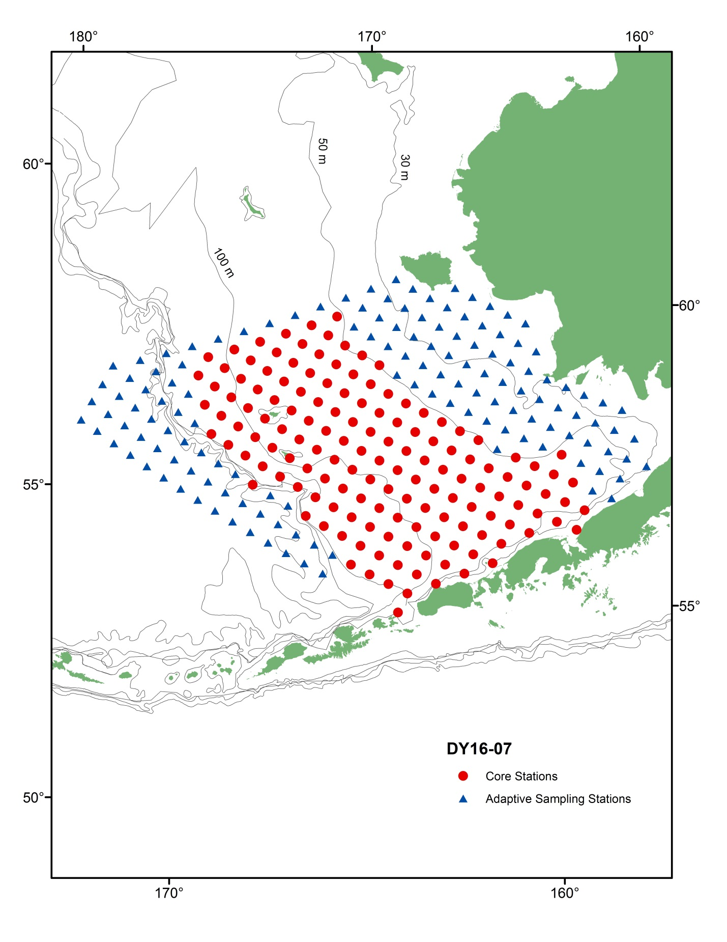
Figure 2. Walleye Pollock larvae abundance based on the number of larvae caught in the codend of the 60-cm bongo net. 