CRUISE REPORT
Cruise Number: DY16-07
FOCI Number: DY16-07
Ship:
NOAA Ship Oscar Dyson
Area of Operations:
Eastern Bering Sea
Itinerary:
Date depart/port: May 17, 2016/Dutch Harbor, AK
Date arrive/port: June 8, 2016/Dutch Harbor, AK
Participating organizations:
AFSC/Eco-FOCI
AFSC/EMA

Chief Scientist:
Steven Porter M/AFSC
(206) 526-4271
steve.porter@noaa.gov
Personnel:
Colleen Harpold F/AFSC
Jesse Lamb M/AFSC
David Nicolls M/EMA
Jessica Randall F/AFSC

Cruise Objective:
The primary objective was to conduct an assessment of the abundance and spatial distribution of Walleye Pollock larvae (Gadus chalcogrammus) over the eastern Bering Sea shelf. The data collected will also be used to investigate interactions between climate and the Bering Sea ecosystem. Two Alaska Fisheries Science Center (AFSC) programs participated on the survey, Ecosystems and Fisheries Oceanography Coordinated Investigations (Eco-FOCI), and Ecosystem Monitoring and Assessment (EMA).

Summary of Operations:
For a complete list of stations and operations see Table 1
Operation Tows
60cm bongo (60BON) 212
20cm bongo (20BON) 212
Seabird FastCAT CTD (CAT) 212
CTD without bottle samples (CTD) 1
CTD with bottles (CTDB) 2

Samples Collected Tows Number
Larval fish for DNA barcode (AMGEN) 211 4356
SeaBird CTD (CTD) 3
Quantitative tow preserved in formalin (QTowF) 424 451
Rough count of pollock larvae (RCountL) 212 28594
Rapid Zooplankton Analysis (RCountZ) 231
Pollock larvae for Condition (SPFCM) 11 175
Zooplankton for lipid analysis 11 30 (vials)

Summary of Cruise:
A new sampling grid design consisting of core and adaptive stations was used to better determine the boundaries of Walleye Pollock larvae spatial distribution (Fig. 1). Transects were run in a northeast and southwest pattern across the shelf. Core stations were always sampled. The number of pollock larvae at an adaptive sampling station determined which station would be sampled next. If no larvae were present at an adaptive sampling station (indicating that the edge of the distribution had been reached) then the station directly across on the next transect line was sampled next, skipping the stations in between them. If the number of larvae was 1 or greater then the next station along the same transect line was sampled. That protocol was continued until the end of the transect line was reached.
The start of the survey was delayed for over a day because scientists were late arriving at Dutch Harbor due to flight cancellations because of fog. On 18 May 2016 at 2000 local time the ship departed and proceeded to the first grid station located in Unimak Pass (southwestern most station) arriving there on 19 May at 0000 (Fig. 1). Zooplankton and ichthyoplankton were sampled using a paired 20 and 60-cm Bongo array with 153µm and 505µm mesh nets respectively. Sampling continued eastward along the peninsula and then in a northerly direction toward Nunivak Island. On 31 May stormy weather stopped operations for about 24 hours. Operations resumed again at 1400 on 1 June beginning at the northern boundary of the grid. From there, northeast and southwest transects were run southward toward Dutch Harbor. The final station was completed on 7 June at 1900, and the ship arrived at Dutch Harbor on 8 June at 0800. The overall pattern of Walleye Pollock larvae abundance based on rough counts showed that larvae were abundant on the eastern side of the grid (Fig. 2). In the north, abundance was greatest between approximately 50 and 100 m depth, and between 30 and 70 m in the south (Fig. 2). In the most general terms, large copepods (> 2 mm) were the dominant zooplankter on the outer shelf, small copepods (< 2 mm) dominated the middle shelf, and the inner shelf had the greatest diversity of species (Fig. 3).

Special Studies
Rapid zooplankton analysis was conducted at selected stations to determine the spatial distribution of the proportions of copepods, euphausiids, chaetognaths, and other zooplankton. Samples were collected throughout the survey for other special projects: Walleye Pollock larvae for condition (S. Porter, NOAA/AFSC), molecular identification of fish larvae (A. Matarese, NOAA/AFSC), and zooplankton for fatty acid analysis (R. Heintz, NOAA/AFSC).

Days Lost to Weather:
2.3 days. Scientists were late arriving at Dutch Harbor for the survey due to flight cancellations because of fog (1.3 days). One day at sea was lost due to stormy weather.

Days Lost to Equipment Failure:
0
Acknowledgments:
The scientific party would like to acknowledge the hard work and support of the Officers and Crew of the NOAA Ship Oscar Dyson who helped to make our project a success. We would like to thank the Steward Department for delicious meals, Survey and Deck Departments for their assistance deploying our gear, Engineering Department for a smooth running ship, and Officers who made sure that operations were conducted in a safe and time efficient manner.

Table 1. Cruise summary (double click on table to open file)
Figure 1. Grid stations
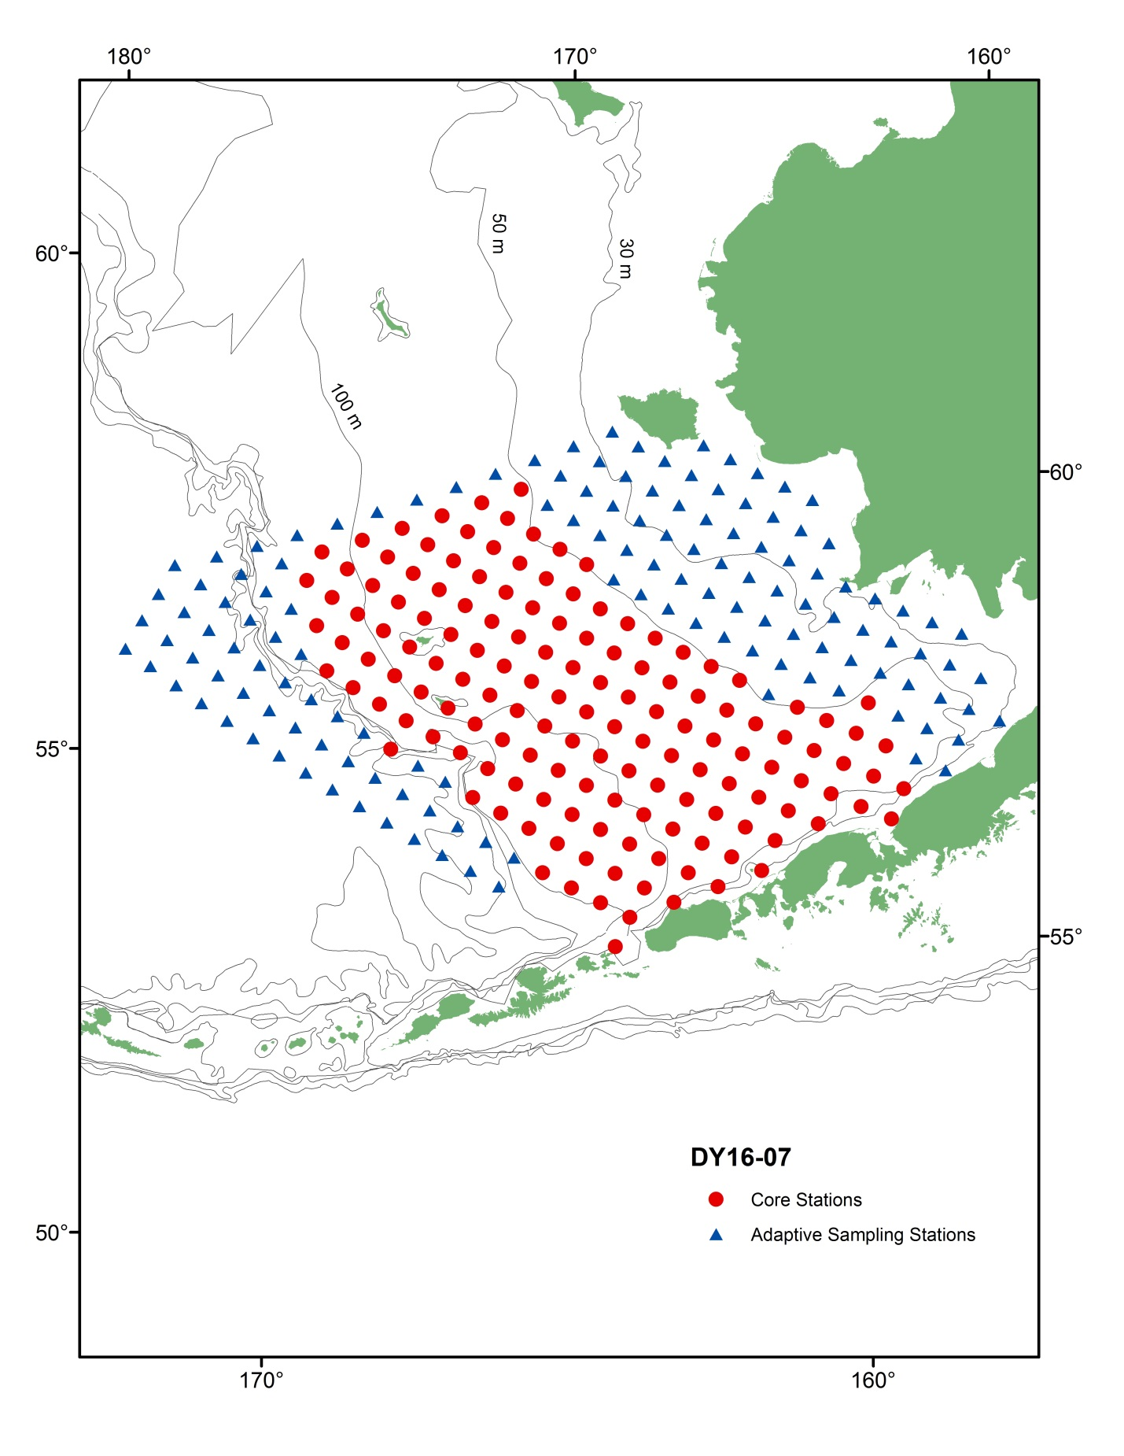
Figure 2. Walleye Pollock larvae abundance based on rough count.
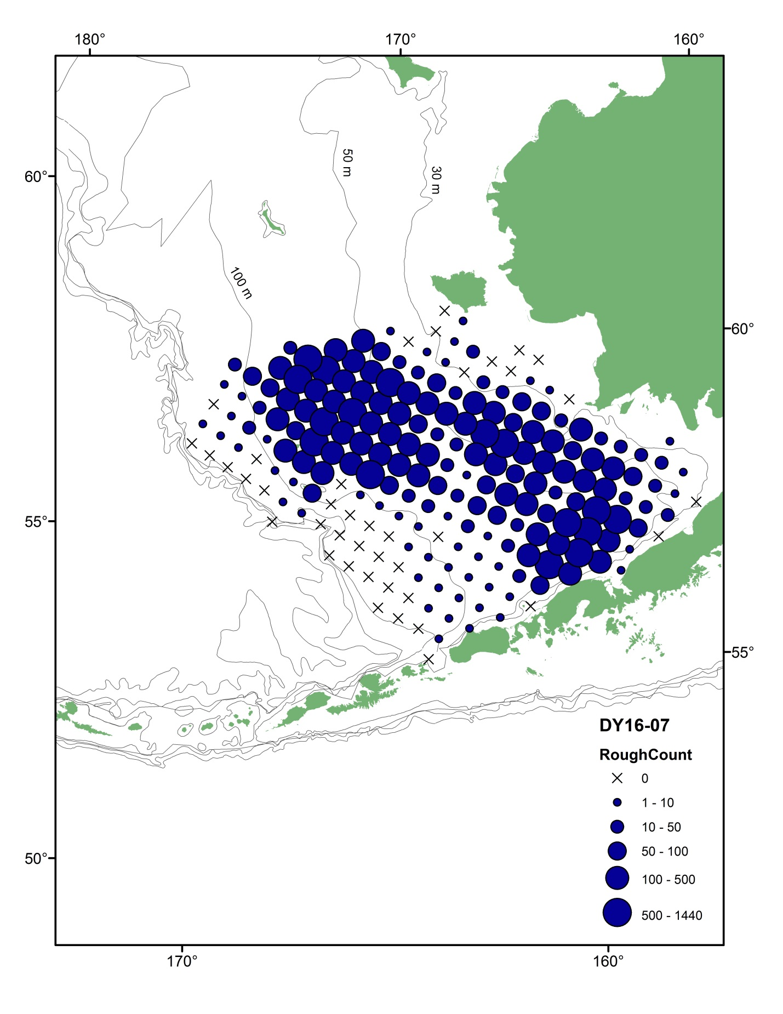
Figure 3. Results from rapid zooplankton analysis. The proportions of various zooplankters collected from the 20 and 60-cm Bongo array.
