CRUISE REPORT
Cruise Number: DY16-10
FOCI Number: DY16-10
Ship:
NOAA Ship Oscar Dyson
Area of Operations:
Eastern Bering Sea sampled from south to north along the 70 m Isobath to 61.06°N and 173.83°W (and from north to south at stations skipped during northward transect) and Unimak Pass region.
Itinerary:
Date depart/port: September 24, 2016/Dutch Harbor, AK
Date arrive/port: October 7, 2016/Kodiak, AK
Participating organizations:
AFSC/Eco-FOCI
PMEL/JISAO
AFSC/EMA

EcoFOCI Field Party Chief & POC:
Colleen Harpold F/AFSC
(206) 526-6716
colleen.harpold@noaa.gov

Chief Scientist:
Lisa Eisner F/EMA
Personnel:
David Kimmel M/AFSC
Jeanette Gann F/EMA
David Strausz M/PMEL/JISAO
Jessica Randall F/AFSC
Melissa Johnson F/EMA
Peter Proctor M/PMEL/JISAO
Martin, Reedy M/USFWS

Cruise Objective:
The primary objective of this survey was to collect oceanography and plankton (zooplankton and ichthyoplankton) along the 70 m isobath (middle shelf) in the eastern Bering Sea. This survey continues the historical time series that has been sampled since the late 1990’s around the Bering Sea moorings, along the 70 m isobath and in the Unimak Pass region. Two Alaska Fisheries Science Center (AFSC) programs participated on the survey, Ecosystems and Fisheries Oceanography Coordinated Investigations (Eco-FOCI), and Ecosystem Monitoring and Assessment (EMA) as well as Pacific Marine Environmental Lab (PMEL), Joint Institute for the Study of Atmosphere and Ocean (JISAO) and U.S. Fish and Wildlife Service (USFWS).

Summary of Operations:
For a complete list of stations and operations see Table 1
Operation Tows
60 cm bongo (60BON) with 505 µm mesh 48
20 cm bongo (20BON) with 153 µm mesh 48
CalVET (CalCOFI vertical egg tow net) with 53 µm mesh 6
Sea-Bird Electronics (SBE) FastCAT CTD (CAT) 54
SBE 911+ CTD with bottles (CTDB) 70

Samples Collected Tows Number
CTDB 70
Quantitative tow preserved in formalin (QTowF) 108 108
Zooplankton Rapid Assessment (RCountZ) 40
Extracted chlorophyll 70 426
Nutrient samples 70 520
Salinity samples 16 16
Oxygen samples 70 75

Summary of Cruise:
The ship departed Dutch Harbor, AK at 16:00 local time on 24 September 2016 and headed to the first sampling station in Unimak Pass (Figure 1). Zooplankton and ichthyoplankton were sampled using a paired 20 and 60-cm Bongo array with 153 µm and 505 µm mesh nets, respectively, along with a Sea-Bird Electronics (SBE) Fastcat collecting temperature, conductivity and depth information (Figure 1). SBE 911+ CTD casts with bottles were performed at all but one station; chlorophyll, nutrient, salinity and oxygen samples were collected as well as electronic data including photosynthetically active radiation (PAR), chlorophyll a fluorescence, light attenuation (beam c), oxygen, temperature, conductivity and depth information (Figure 1). After completing the Unimak Pass South line, the ship transited to mooring 2 (M-2). After completing one station, the ship had to return to Dutch Harbor to retrieve required medical oxygen. Sampling around M-2 resumed 36 hours later, and sampling around M-2, M-4 and M-5 and along the 70 m isobath was completed as far north as 61.06°N (Figure 1). In addition to bongo tows and CTD casts, triplicate CalVET tows fitted with 53 µm mesh was used to sample microzooplankton at M-2 and M-4 center mooring stations (CalVETs were not taken at M-5 due to weather conditions). There were several storms that slowed down and halted operations on two separate occasions, and we hid behind St. Mathew Island until conditions were workable. As a result some of the CTD only stations along the 70 m isobath were dropped while heading northward, but most were able to be sampled on the way back south after the storm had ceased. The Unimak Box South line was sampled a second time, then the North and East lines were sampled, after which the ship completed the transit to Kodiak, AK arriving on 7 Oct 08:00 local time.

Throughout the survey water temperatures were typical of a warm year, with ~11°C surface and ~5°C bottom temperatures in the southern part of the 70 m isobath line. Pycnoclines were around ~30 m indicating wind mixing and the start of fall conditions. There were relatively low volumes of zooplankton and few large copepods in the southern part of the 70 m isobath line, with proportions of large copepods (mostly Calanus marshallae + glacialis) increasing north of ~59.7°N (Figure 2). Small copepods were abundant at all stations. The zooplankton community in the Unimak Pass region was more diverse, with more large copepod species and coastal zooplankton present. There was an unusual seabird observation of 32 mottled petrels sighted 20-30 miles NW of Dutch Harbor. These seabirds are normally only observed as single individuals, in regions SW of the location where they were sighted. In addition, Cassin’s auklets were observed riding the ship at 59°N. These birds are usually only seen south of the Aleutians.

Special Studies
Primary production experiments (11) were conducted to better quantify phytoplankton growth during late summer/fall in a warm year. Zooplankton rapid assessment was conducted at selected stations to determine the spatial distribution of the proportions of copepods, euphausiids, chaetognaths, and other zooplankton, with aliquots saved for future study. A seabird observer from USFWS collected seabird sightings information.

Days Lost to Weather:
~1.5 - 2 days. The ship had to stop operations and hide from stormy weather on two occasions, and there was reduced transit time between stations due to winds and swell.

Days Lost to Equipment Failure:
1.5 days lost due to returning to Dutch Harbor, AK to retrieve required medical oxygen. The survey was extended by 1 day to help account for this time loss.
Acknowledgments:
The scientific party would like to acknowledge the hard work and support of the Officers and Crew of the NOAA Ship Oscar Dyson who helped to make our project a success. We would like to thank the Steward Department for delicious meals, Survey and Deck Departments for their assistance deploying our gear, Engineering Department for a smooth running ship, and Officers who made sure that operations were conducted in a safe and time efficient manner.

Table 1. Cruise summary (double click on table to open file)
Figure 1. DY16-10 Station Locations

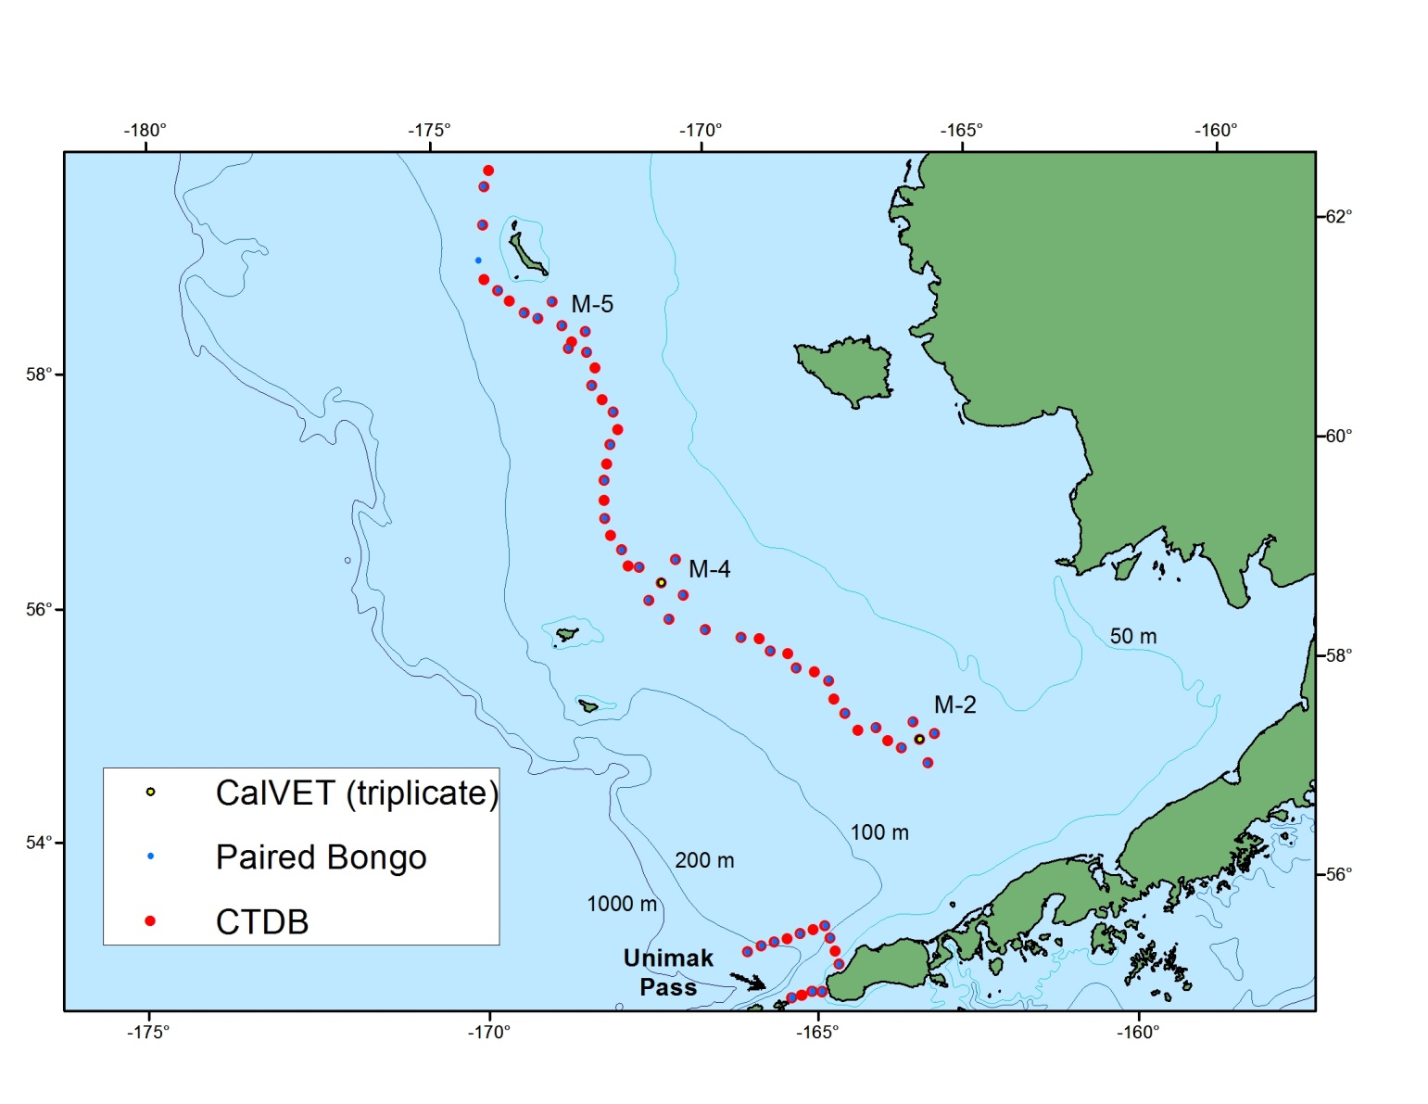
Figure 2. Results from zooplankton rapid assessment. The proportions of various zooplankters collected from the 20 and 60-cm Bongo array.
