CRUISE REPORT

Eco-FOCI’s GOA-IERP/LTL May 2011

**Cruise Number: TN263 / FOCI Number:1TT11**

**Ship: R/V Thomas G. Thompson**

**Area of Operations:** Southeast Alaska

Depart: Seattle, WA April 30, 2011

Return: Seattle, WA May 21, 2011

**Participating Organizations and Principal Investigators:**

Dr. Phyllis Stabeno

NOAA – Pacific Marine Environmental Laboratory (PMEL)

7600 Sand Point Way N.E.

Seattle, Washington 98115-6439

Dr. Jeff Napp

NOAA – Alaska Fisheries Science Center (AFSC)

7600 Sand Point Way N.E.

Seattle, Washington 98115-0070

Dr. Suzanne Strom

Western Washington University

Shannon Point Marine Center

1900 Shannon Point Road

Anacortes, WA 98221

Dr. Calvin W. Mordy

Joint Institute for the Study of Atmosphere and Ocean

University of Washington

7600 Sand Point Way N.E.

Seattle, Washington 98115-6439

Dr. Ana Aguilar-Islas

Institute of Marine Science

335A Irving II

P.O. Box 757220

University of Alaska Fairbanks

Fairbanks, AK 99775-7220

**Chief Scientist:**

Dr. Nancy Kachel, NOAA/PMEL

Joint Institute for the Study of Atmosphere and Ocean

University of Washington

7600 Sand Point Way N.E.

Seattle, Washington 98115-6439

206-526-6780

Nancy.Kachel@noaa.gov

###### Personnel:

|  |  |  |  |  |
| --- | --- | --- | --- | --- |
| Dr. N  Dr. Jeff Napp  Dr. Calvin Mordy  Dr. Suzanne Strom  Dr. Ana Aguillar-Islas  Dr. Peter Proctor  David Kachel  Colleen Harpold  Lisa DeForest  Morgan Busby  Declan Troy  Sophie Webb  Kerri Fredrickson  Kerry Whitaker | M  M  F  F  M  M  F  F  M  M  F  F  F | USA  USA  USA  USA  USA  USA  USA  USA  USA  USA  USA  USA  USA | AFSC  PMEL/UW  WWU  UAF  PMEL/UW  PMEL  PMEL  AFSC  AFSC  AFSC  USFWS  WWU  U. Rhode Island |  |

**Objectives of Cruise:**

Ecosystems & Fisheries-Oceanography Coordinated Investigations (EcoFOCI) is an effort by National Oceanic and Atmospheric Administration (NOAA) and associated academic scientists. Eco-FOCI’s goal is to understand the effects of abiotic and biotic variability on ecosystems of the North Pacific Ocean and Bering Sea. This cruise is in support of research sponsored by NOAA’s North Pacific Climate Regimes & Ecosystem Productivity Program, the North Pacific Research Board (NPRB), and PMEL/AFSC base. The research conducted on this cruise is part of the NPRB’s Gulf of Alaska- Integrated Ecosystem Research Program (GOA-IERP) Lower Trophic Level Project (LTL) component. The Program intends to increase our understanding of how five target fish taxa (walleye pollock, Pacific cod, arrowtooth flounder, sablefish, and Pacific Ocean perch) pass through the larval gauntlet and eventually recruit as adults. The Lower Trophic Level Component is one of four major components to the overall project (Lower Trophic Levels, Middle Trophic Levels, Upper Trophic level, Modeling. An additional major goals of the overall project s to compare and contrast the mechanisms responsible for recruitment of fish species between the eastern and northern portions of the Gulf of Alaska. While many mechanisms controlling on shelf and cross-shelf fluxes in the two regions are likely similar, we expect there are also distinct differences between the narrow shelf of EGOA and the broader down welling dominated shelf of WGOA. Our three primary objectives for each region are to quantify, compare and contrast (1) the timing and magnitude of the different cross-shelf exchange mechanisms, using an extensive suite of oceanographic (i.e. moorings, drifters, cruises) and atmospheric measurements, (2) how these physical mechanisms influence the distribution, timing and magnitude of phytoplankton productivity, and (3) how both transport and primary productivity control the distribution, productivity, and fate of both zooplankton and ichthyoplankton.

**Cruise Itinerary**

The R/V Thompson left Seattle at 08:30 on 30 April 2011 and prodeeded out through the Straits of Juan de Fuca, up the west side of Vancouver I. and the Queen Charlotte Is. to Southeast Alaska. The stations sampled during TN263 are shown in Figure 1. The transects across Chatham Strait (CS, Cross Sound (XS), Cross Sound Trough (XST) and Yakutat Trough (YTX) were not part of the GOA_IERP standard grid. Not all stations were on CTD transects. We began sampling on 3 May with a transect of nets and CTD samplings across the southern end of Chatham Strait We also deployed a pair of drifters there. We circled around the south end of Baranof Island and began the accupation of the GOA-IERP Southeast Alaska grid. At the second station, rough weather caused us to cease operations for 5 hours. Four nets-only nearshore stations were occupied before beginning the SEA line once again as a transect. Thereafter, the weather improved greatly, and was calm for the rest of the cruise. We worked our way northward, not encountering spring bloom conditions until we got to the KIB line southwest of Kayak Island. Upon completion on the three KI lines, we returned to the SEM, SEK, and SEG lines to resample under early bloom conditions on 17 May. After sampling was completed on 18 May four members of the science party disembarked in Sitka, AK. The ship returned to Seattle,WA on 21 May. The summary of operations, sampling, the AFSC cruise summary, and an event log can be found in the Appendix.

**Sampling and Operations**

Operations primarily consisted of hydrographic measurements with samples taken for oxygen, fractionated chlorophyll, nutrients, dissolved inorganic carbon (DIC) and salinity, as well as for phytoplankton productivity and molecular analysis. MARMAP bongo tows, neuston net tows, MOCNESS and CalVET tows were made to collect zooplankton and larval fish. Water was collected for experiments measuring the growth and production of phytoplankton. Trace metal samples were taken by two methods: bottles samples, and a trace metal fish towed away from the side of the ship that collected samples underway. During the course of the cruise five ARGOS satellite-tracked buoys drogued at 40m were deployed. An ancillary project collected water samples for phytoplankton identification, culture and DNA analysis. We were accompanied by two volunteer bird watchers working for the U.S. Fish and Wildlife Service Division of Migratory Bird Management in Anchorage, AK. The goal of that project is to examine seabird and marine mammal distribution relative to oceanographic and biological features of the Southeast Alaska..

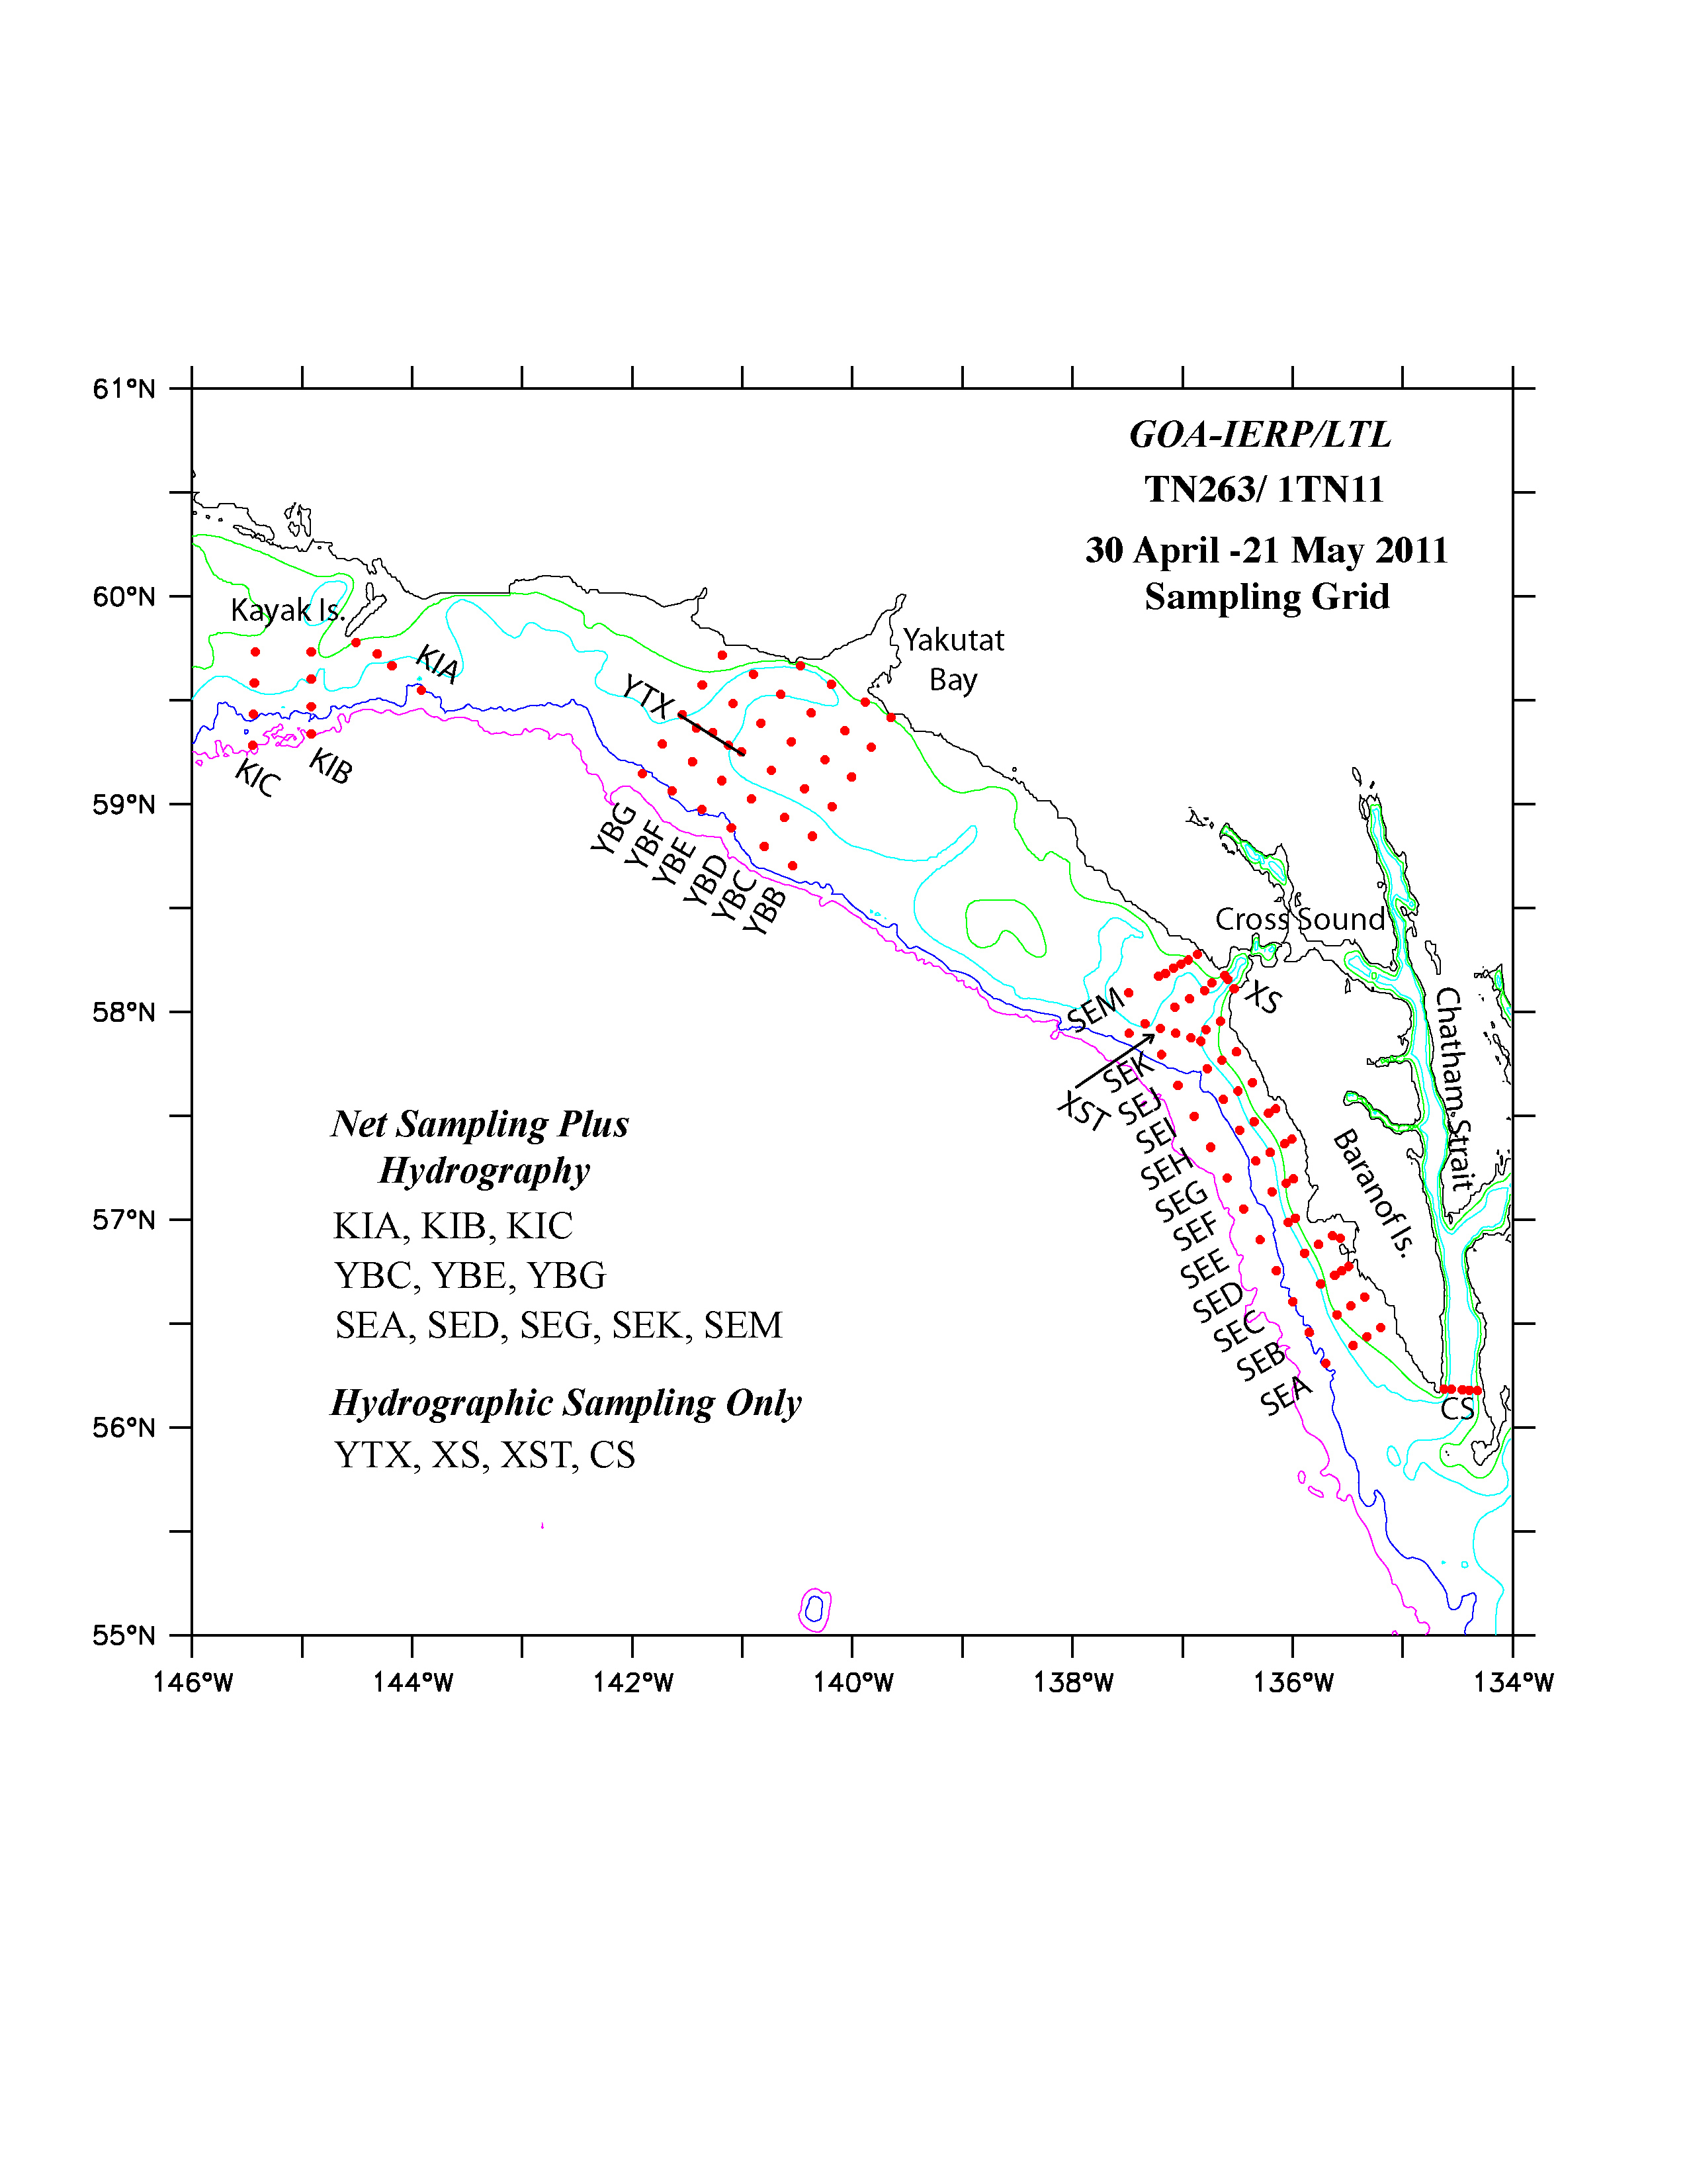

Figure 1. Sampled Stations on TN263. Most

**Hydrographic Measurements- Nancy Kachel, Calvin Mordy, Peter Proctor, David Kachel, and Sigrid Salo**

The conductivity, temperature and depth (CTD) casts were made with the Thompson’s CTD with SeaBird 911 with dual temperature and conductivity sensors. Attached to the CTD were a transmissometer (beam attenuation), a WetLabs ECO chlorophyll fluorometer, a Biospherical Instruments QPC2300-HP Photosynthetically Activated Radiation (PAR) sensor, and two SBE43 oxygen sensors.

**a. Salinity Measurements**

A total of 63 salinity samples were taken and analyzed using a shipboard salinometer as a means of calibrating the conductivity sensors.

**b. Nutrient Measurements**

Nutrient samples were collected from the Niskin bottles in acid-washed 35-ml polyethylene bottles after three complete seawater rinses and frozen in a -80°C freezer for analysis after the cruise at PMEL. Nutrients are to be analyzed with a continuous flow analyzer (CFA) using the standard analysis protocols for the WOCE hydrographic program as set forth in the manual by L.I. Gordon, et al (2000). Approximately 760 samples from CTD casts and another 80 samples from trace metal casts were collected for analysis of phosphate (PO4-), nitrate (NO3-), nitrite (NO2-), orthosilicic acid (H4SiO4), and ammonium (NH4+).

**c. Oxygen Measurements**

Winkler titrations were conducted according to WOCE protocols. On each cast, the number of samples and the depths sampled were dependent on the oxygen profile from the CTD. In deep water, samples were typically collected at every depth below 100m. On the shelf, samples were usually collected in the upper layer, or in the bottom mixed layer. End point determinations of the Winkler titration were determined poteniometrically. Thiosulfate was standardized for each batch of sample titrations, and blanks were measured periodically during the cruise.

**d. Dissolved Inorganic Carbon**

As an ancillary project we collected 400 DIC samples for Dr. Jeremy Matthis’s student, Kristan Shake of the University of Alaska, Fairbanks.

**e. ARGOS Satellite-Tracked Drifters**

On six occasions during the cruise we deployed ARGOS drifters drogued at 40m: Two in Chatham Strait, two at the mouth of Cross Sound, at different times, and one each on the slopes off Baranoff I. and off Yatutat. Movies of the drifter tracks are updated daily at the website:

[http://www.pmel.noaa.gov/foci/visualizations/drifter/movies_2011.html \](http://www.pmel.noaa.gov/foci/visualizations/drifter/movies_2011.html%20\)

At that site click on one of these choices:

[2011 buoy track annimation - Cross Sound Area](http://www.pmel.noaa.gov/foci/visualizations/drifter/csou2011.html)

[2011 buoy track annimation - Yakutat Area](http://www.pmel.noaa.gov/foci/visualizations/drifter/yaku2011.html)

**Ichthyoplnkton and Zooplankton Sampling- Jeff Napp, Morgan Busby, Colleen Harpold and Lisa DeForest**

**a. Neuston Net Tows**

    Neuston net tows (0.500 mm mesh) were made at all GOA_IERP grid stations.  The contents were preserved in 5% Formalin and will be examined for ichthyoplankton.  Larvae of one of the five target species (sablefish) are found in the neuston.

**b. MARMAP Bongo Tows**

Zooplankton and ichthyoplankton were collected at all grid stations and at some of the stations on transects across troughs (Figure 1). We used 20-cm (0.150 mm mesh) and 60-cm (0.500 mm mesh) bongo frames.  A SeaCat19+ was attached to wire, just above the 20 cm bongo frames to allow the depth of the tow, temperature, and salinity to be measured. In water deeper than 200m, tows were made to 200m.  Samples were preserved with 5% buffered Formalin.  Prior to preservation, one side of the 60 cm bongo frame was examined for presence of fish larvae.  They were preserved in 95% ethanol; all rockfish larvae will be sent to the TSMRI laboratory for identification using genetic barcoding methods.  The remaining fish will be used for special studies by the Recruitment Processes Program of the AFSC.  The unexamined side of the 60 cm bongo will be sent to the Polish Plankton Sorting and Identification Center in Szczecin Poland for identification of all fish eggs and larvae.  The other side of the 60 cm (the one where fish larvae were removed) plus one side of the 20 cm frame will be sent to R. Hopcroft (University of Alaska, Fairbanks) for identification and quantification of all zooplankton.

**c. Other Tows**

Four MOCNESS tows were accomplished to determine the vertical distribution of fish larvae.  These data are necessary for proper construction of the GOA IERP larval transport models being developed by the Modeling Component (Gibson and Hinckley). To supplement that effort several MARMAP bongo tows were made to 600m depth.

**Phyto- and microzooplankton sampling – Suzanne Strom and Kerri Fredrickson**

Chlorophyll: Samples from 6 depths for extracted chlorophyll analysis were taken from stations on the following transect lines: CST, SEA, SED, SEG, SEK, XS, SEM, YBC, YBE, YBG, KIA, KIC. Profiles were also taken on the re-occupation of southeast lines SEM, SEK, SEG, and at additional stations sampled for productivity experiments. All chlorophyll samples were size-fractionated in a sequential (cascade) filtration system so that chlorophyll in the >20 µm and <20 µm size fractions (as well as total chlorophyll) were determined. Chlorophyll samples were analyzed on-board using fluorimetry (acidification method). A total of 68 vertical profiles were analyzed overall.

**a. Phyto- and microzooplankton**

Preserved samples of 3 types were taken for later analysis of the taxonomic composition and biomass of the phyto- and microzooplankton communities. Samples preserved in acid Lugol’s will be analyzed for microzooplankton; these samples were collected from 4 depths at each sampled station. Samples preserved in buffered formalin will be analyzed for diatom and other large phytoplankton by inverted light microscopy, while samples preserved in glutaraldehyde will be analyzed for small phytoplankton by epifluorescence microscopy. Phytoplankton samples were collected only from 10 m depth at sampled stations. Transect lines sampled for phyto- and microzooplankton were: SEA, SEG, SEK, YBC, YBG, and the re-occupation of line SEG. Line KIA was sampled for phytoplankton only. Additional stations were sampled for phytoplankton when productivity experiments were conducted there.

**b. Photosynthesis Rates**

Experiments to determine the relationship between photosynthesis and irradiance (P-E experiments) were conducted on most days of the cruise. Water from the target depth was divided into 12 subsamples, which were inoculated with tracer amounts of 14C-bicarbonate and incubated for ~1.5 hr in an artificial light gradient at ambient water temperatures. To terminate the experiment, samples were filtered onto 2 different filter types so that photosynthetic properties of the large (>20 µm) and small (<20 µm) phytoplankton size fractions can be determined. Water from 10 m was always used; typically water from a second depth near the base of the mixed layer or euphotic zone was also assayed. Overall we conducted 27 P-E experiments from a range of shelf habitats (nearshore versus offshore) and ambient chlorophyll levels. 15 of these were conducted in the southeast grid region, 8 in the Yakutat region, and 4 in the Kayak Island region. Ultimate products from these experiments will be estimates of the photosynthetic parameters (maximum photosynthesis rate, photosynthetic efficiency) of large and small phytoplankton, and estimates of the daily primary production rate of the phytoplankton community.

**Effects of Iron Size Classes on Productivity and Community Structure –**

**Ana M. Aguilar-Islas**

**Trace Metal Sampling**

Seawater and suspended particulate samples were collected using trace metal clean techniques. Samples will be analyzed onshore for the determination of several size fractions and chemical species of iron. The overarching goal of this work is to better understand how oceanographic processes in the Gulf of Alaska affect the distribution of different forms of iron. Because different species of iron vary in their biological reactivity, this work will contribute towards an improved understanding of the factors that affect the primary productivity of this important region. Collaboration with other GOA-IERP lower trophic level (LTL) components will serve to place the Fe work into an ecosystem context.

**a. Vertical Profiles**

Seawater and suspended particles were collected at 9 stations from various depths (20 - 1000 m). The stations sampled were SEA-05, SEA-20, SEG-00, SEG-20, YBC-50a, YBC-40, YBC-10, SEG-00a, and SEG-20a. YCB-50a was chosen further offshore at a water depth of ~1700 m because the water depth at YCB-50 was only ~400 m. SEG-00a and SEG-20a were occupied 10 days after SEG-00 and SEG-20. A total of 161 samples were collected; 38 for suspended particles; 38 for total dissolvable iron; 38 for dissolved iron; 38 for soluble iron; 9 samples for organic iron speciation.

**b. Surface Transects**

Surface seawater samples were collected during 7 transects from Chatham Strait to an area north of Kayak Island (Figure 2). A total of 115 samples were collected; 52 for total dissolvable iron; 52 for dissolved iron; 5 samples for soluble iron; 6 samples for organic iron speciation.

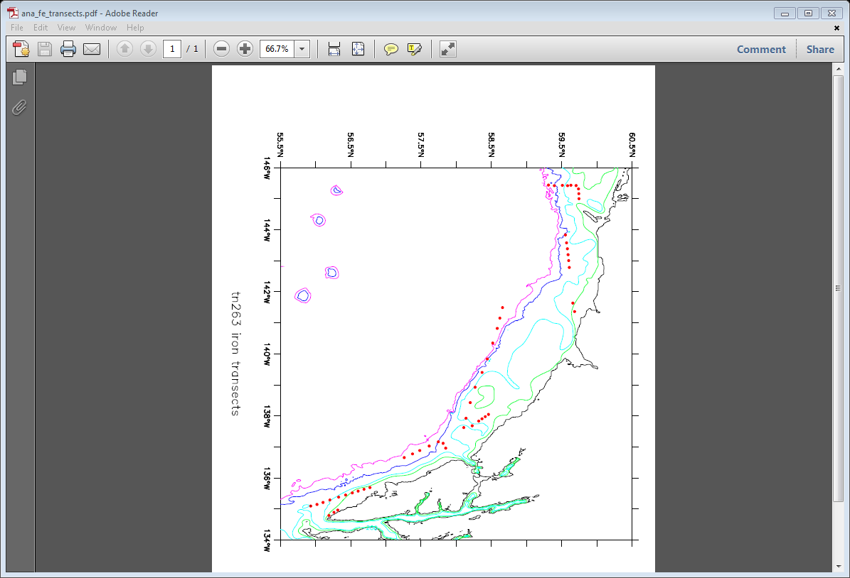

T1

T2

T3

T4

T5

T6

T7

Figure 2. Surface seawater collected from the trace metal sampler during transects.

# Seabird and Marine Mammal Surveys- Declan Troy and Sophie Webb

Standardized marine bird/mammal surveys were conducted during daylight hours whenever the ship was transitting between study grids and between stations permitting ≥ 30 minutes of run time. During 20 days of arroximately 2225 km of transects were surveyed (see Figure 3). Over 16,500 birds and marine mammals were recorded.

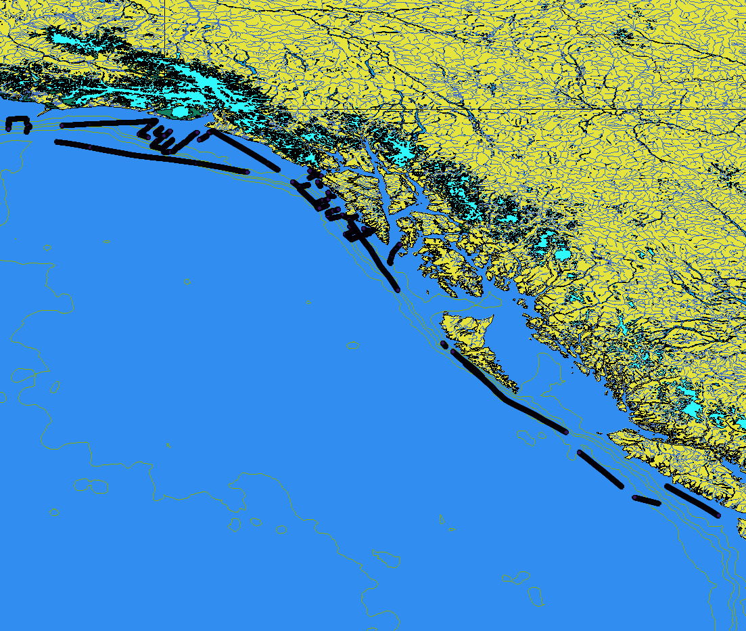

Figure 3. Tracklines for bird and mammals transect.

The birds were represented by 13 families of diverse taxa. Dominant seabirds in our 300 meter strip transect were Red-necked Phalaropes, Black-legged Kittiwakes and Northern Fulmars, species returning to Alaska to breed and Short-tailed Shearwaters, an austral breeder that visits the region to feed during the austral winter. Of the 9 species of alcids recorded Common murres were the by far the most abundant, on the inshore transects particularly those near or across the entrance of bays Marbled Murrelets were common, Ancient Murrelets were scattered from near shore to off shore and in general Rhinoceros Auklets were encountered closer to the shelf break. Of the three species of visiting North Pacific Albatross encountered Black-footed Albatross was by far the most numerous, 378, followed by Laysan Alabatross, 8 and a chance encounter while on station near Kayak Island of a single juvenile Short-tailed Albatross was a highlight.

Marine mammals were recorded whenever seen forward of the beam to the horizon. Close to shore humpback whales were the dominant species, offshore and along the shelf break fin whales were the most common. We had seven sigthigngs of 70 killer whales, both nearshore and offshore representing two ecotypes: resident and transient. When possible we took photos for photo identification of groups or individuals In deep water beyond the shelf break we recorded two species of beaked whale, a group of 35 Baird’s Beaked Whales and a probable group of four Stejneger’s beaked whales. Dall’s porpoise were seen throughout, both on the shelf and off.

# Molecular Analysis of Diatoms- Kerry Whittaker

This project involves the molecular analysis of diatom population connectivity and gene flow throughout the Gulf of Alaska. This work focused mainly on the intraspecific diversity of the diatom *Thalassiosira rotula. Thalassiosira rotula* is a globally-distributed, ecologically important centric diatom, and a persistent resident of the phytoplankton community in the Gulf of Alaska. The fine-scale sampling undertaken during TN263 accompanies ongoing work examining global-scale intraspecific biogeography of this species. In addition, live cultures collected during TN263 will be used to assess physiological differences amongst genetically different strains, thus contributing to our understanding of the links between molecular and functional diversity in diatoms. This is important for understanding the evolutionary trajectory of these organisms, as well as their relative contributions to important marine ecosystems, such as the Gulf of Alaska.

**a. Monoclonal Diatom Cultures**

To study diatom diversity, 1,043 monoclonal diatom cultures were generated using single-cell isolation and microscopy. The dominant species cultured was *Thalassiosira rotula*. As another species of interest for the Rynearson lab, *Ditylum brightwellii* was additionally isolated whenever present in the phytoplankton community. The monoclonal cultures were then filtered at a concentration of ~1000cells/ml, providing enough biomass for efficient DNA extraction and downstream molecular analysis. For the molecular analysis, rDNA and microsatellite markers will be used to quantify diversity patterns across cruise stations. Environmental and hydrographic data collected during TN263 will be used in the analysis of molecular and biological connectivity between diatom populations.

**b. Diatom Community Diversity Sampling**

In addition to single-cell isolations, samples were collected to capture the entire phytoplankton community. Whole seawater from the chlorophyll maximum (identified through the CTD fluorescent sensor) or surface was filtered using duplicate 0.2 and 5um polyester filters. In the future, DNA can be extracted from this library of filters and used to analyze the dynamics whole-community diversity alongside intraspecific diversity within *T.rotula* alone. In addition, samples were concentrated and fixed with Lugol’s solution, providing an additional source from which phytoplankton can be identified, or DNA extracted.

The following map includes stations for which the diatom community was analyzed, and molecular analysis will take place. The number of isolates collected at each station can be found in the Table 3 of the Appendix. In addition, duplicate 0.5 and 20um community filters were collected at the stations listed, and concentrated samples were fixed with Lugols’ solution.

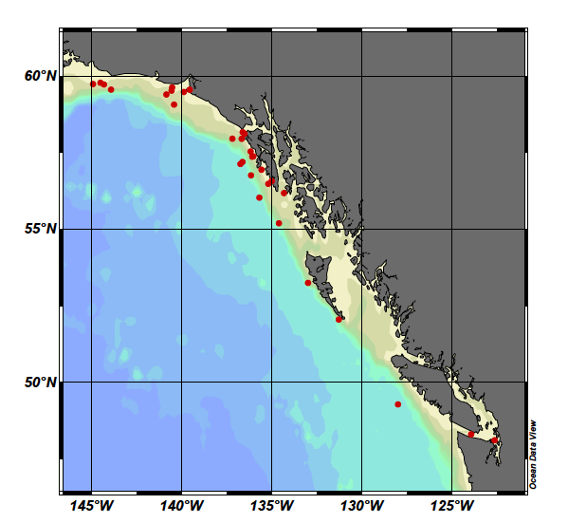

Figure 4. Stations at which diatom community was analyzed and molecular analysis will occur.

## APPENDIX

Table 1. Summary of Gear Deployed

**Operation** **Tows**

20cm bongo (20BON) 102

60cm bongo (60BON) 105

Seabird SeaCAT CTD (CAT) 103

1m² MOCNESS (MOC1) 4

CTD casts 101

Trace Metal/CTD casts 101

Trace Metal transects 101

Bird/Mammal Transects 101

**Table 2. Summary of Samples Collected**

**Samples Collected** **Tows** **Number**

larval fish for DNA barcode (AMGEN) 79 921

SeaBird SeaCat CTD (CAT) 103

Larval pollock collected for muscle tissue DNA analysis (L-Musc) 1 1

Fluorescence data collected during net tow (NetFluor) 29

Quantitative tow preserved in formalin (QTowF) 428 463

Quantitative tow preserved in Stockard's (QTowS) 2 3

Rough count of pollock juveniles (RCountJ) 1 0

Rouch count of pollock larvae (RCountL) 98 2

MOCNESS salinity (SAL) 29

MOCNESS temperature (TEMP) 29

Nutrrient Samples 764

Chlorophyll Samples ~1100

Phytoplankton Samples for Molecular analyses 29

Water for Phytoplankton for growth experiments 27

**Table 3. Diatom isolates collected at each station.**

|  |  |  |
| --- | --- | --- |
| **STN** | **T.Rotula isolated**  **(single cells, grown into culture)** | **D.Brightwellii isolated**  **(single cells, grown into culture)** |

Puget Sound 96 48

Straight of Juan de Fuca 48 0

Vancouver Island 48 0

Queen Charlottes North 0 0

Queen Charlottes South 0 0

CST1 48 0

CST5 24 0

SEA0 20 0

Whale Bay 96 3

Sea20 0 0

SED20 14 0

SED0 36 2

SEHA 48 48

SEG0a 0 0

SEG0 48 0

SEG 20 0 0

SEK0 48 0

SEK20 48 0

SEL0 00

YBB0 48 0

YBC20 48 0

YBC0 0 0

YBE20 0 0

YBE10 0 0

YBE0 0 0

KIA4 48 0

KIA2 48 0

KIA1 0 0

KIB1 48 0

XS1 48 0

**Table 4. AFSC Cruise Summary For FOCI Cruise 1TT11**

**Table 5. Event Log for TN263/FOCi Cruise 1TT11**