Global Ocean Acidification Observing Network:
Requirements and Governance Plan
First Edition

JA Newton, RA Feely, EB Jewett, P Williamson, D Gledhill, A Dickson

EXECUTIVE SUMMARY:
The need for coordinated, worldwide information-gathering on ocean acidification and its ecological impacts is now widely recognized. The Global Ocean Acidification Observing Network (GOA-ON) fills that need. Its design and foundation comes from two international workshops to focus on this issue, held at the University of Washington, Seattle, USA, in June 2012 and at the University of St. Andrews, UK, in July 2013 involving over a hundred participants and over 30 nations.

The GOA-ON has three high level goals:
Goal 1: Provide an understanding of global ocean acidification conditions
- Determine status of and spatial and temporal patterns in carbon chemistry, assessing the generality of response to ocean acidification;
- Document and evaluate variation in carbon chemistry to infer mechanisms (including biological mechanisms) driving ocean acidification;
- Quantify rates of change, trends, and identify areas of heightened vulnerability or resilience.

Goal 2: Provide an understanding of ecosystem response to ocean acidification
- Track biological responses in concert with physical/chemical changes;
- Quantify rates of change and identify locations as well as species of heightened vulnerability or resilience.

Goal 3: Acquire and exchange data necessary to optimize modeling for ocean acidification
- Provide spatially and temporally-resolved chemical and biological data to be used in developing models for societally-relevant analyses and projections;
- Use improved model outputs to guide Goals 1 and 2 in an iterative fashion.

This GOA-ON Requirements and Governance Plan provides both broad concepts and key critical details on how to meet the Network’s goals. This includes defining the Network design strategy, ecosystem and goal-specific variables, spatial and temporal coverage needs, observing platform-specific recommendations, and Network support requirements.
Additionally, the GOA-ON Plan defines:
- Data quality objectives and requirements;
- GOA-ON’s proposed governance structure;
- International OA data sharing arrangements based on defined data and metadata standards and open access to observing data. While the ocean carbon community has a relatively mature data-sharing process, it is recognized that the addition of coastal and nearshore sites as well as biological and ecological data to this framework will take time and effort to structure; and
- GOA-ON products, outcomes, and applications.

The effort of GOA-ON to develop the optimal observing system to detect ecosystem impacts of OA in various large scale ecosystem types, including Tropical, Temperate, and Polar Regional Seas; Warm and Cold-water Corals; and Nearshore, Intertidal and Estuarine Habitats, is a developing effort only recently started. Further workshops will be needed to refine detailed protocols for relevant biological observing on a habitat- or regionally-specific basis. The potential scope for such biological observing is extremely wide, and it is therefore essential that GOA-ON builds on and works in close liaison with the Global Ocean Observing System and the International Ocean Carbon Coordination Project through their “Framework for Ocean Observation” (Lindstrom et al., 2012) and associated biogeochemical, biological and coastal panels.

A GOA-ON website, http://www.pmel.noaa.gov/co2/GOA-ON/, has been developed to include the latest version of the interactive map of global OA-related observing activities. The map represents the best information available on the current inventory of global OA observing, and provides a tangible means for increasing awareness and coordination between network partners and others with interests as well as access to OA data being collected around the globe.

1. Background and Introduction
The need for coordinated, worldwide information-gathering on ocean acidification and its ecological impacts is widely recognized. It is necessary to develop a coordinated multidisciplinary multinational approach for observations and modeling in order to coordinate international efforts to document the status and progress of ocean acidification in open-ocean and coastal environments, and to understand both its drivers and its impacts on marine ecosystems. Global and regional observation networks will provide the necessary data required to firmly establish impacts attributable to ocean acidification. Regional and global networks of observations collected in concert with process studies, manipulative experiments, field studies, and modeling will facilitate the development of our capability to assess present-day and predict future biogeochemistry, and climate change feedbacks and the responses of marine biota, ecosystem processes, and socioeconomic consequences.

This report provides the consensus vision and strategy for the Global Ocean Acidification Observing Network (GOA-ON) based on input from two international workshops. The first international workshop was held at the University of Washington in Seattle, Washington, USA during June 26-28, 2012, to define the goals and requirements of a global observing network for both carbon and ocean acidification in the context of an overall framework for ocean observing responding to societal needs. This workshop was supported by the NOAA Ocean Acidification Program, the International Ocean Carbon Coordination Project (IOCCP), the Global Ocean Observing System, including the U.S. Integrated Ocean Observing System (IOOS), and the University of Washington. Building on that effort, a second workshop to define the GOA-ON was held at the University of St. Andrews, in St. Andrews, UK, during 24-26 July 2013. The overarching goal of the second meeting was to refine the vision for the structure of GOA-ON, with emphasis on standardizing the monitoring of ecosystem impacts of OA in shelf and coastal seas. Support for this workshop was provided by the UK Ocean Acidification research programme (UKOA, co-funded by Natural Environment Research Council, Defra and DECC); the International Ocean Carbon Coordination Project; the Ocean Acidification International Coordination Centre of the International Atomic Energy Agency; the UK Science & Innovation Network (co-funded by BIS and FCO); the NOAA Ocean Acidification Program, the Global Ocean Observing System, the Intergovernmental Oceanographic Commission of UNESCO, and the University of Washington.

Participants in both workshops designed the GOA-ON to monitor biogeochemical changes at sufficient detail to discern trends in acidification and determine relative attribution of the primary physical-chemical processes governing such changes. Consensus was that the GOA-ON must also include a means of tracking changes in large-scale biological processes (changes in productivity, species distributions, etc.) which can be impacted by ocean acidification. The GOA-ON will incorporate the existing global oceanic carbon observatory network of repeat hydrographic surveys, time-series stations, floats and glider observations, and volunteer observing ships in the Atlantic, Pacific, Arctic, Southern, and Indian Oceans; assuring the continuity and quality of these foundational observations affords us an opportunity to build from them a more comprehensive network capable of meeting the multidisciplinary observational requirements of an ocean acidification network. A more fully developed GOA-ON requires the adoption of advanced new technologies that will reliably provide the community with the requisite biogeochemical measures necessary to track ocean acidification synoptically (e.g. new carbon chemistry sensors developed and adapted for moorings, volunteer observing ships, floats and gliders). Such technologies provide critically important information on the changing conditions in both open-ocean and coastal environments that are presently under-sampled.
A fully realized GOA-ON would have the capability to track changes in CaCO₃ saturation states, biological production rates, and species functional groups. These additional measurements are needed to predict the rates and magnitude of ocean acidification and better discern ecosystem responses. New technologies for monitoring dissolved inorganic carbon and total alkalinity would be beneficial for tracking changes in the marine inorganic carbon system, including inputs of non-CO₂ sources of acidification. The biological measurements are admittedly more difficult and complex to measure repeatedly or remotely. However, measurements of net primary production and community metabolism, either directly or from nutrient or oxygen inventories, along with an understanding of hydrodynamics are important in order to identify biological impacts and adaptations to ocean acidification, especially in coastal zones where secular changes in ocean acidification are augmented by local processes.
Full implementation of the GOA-ON requires a coordinated and integrated international research effort that is closely linked with other international carbon research programs. Where appropriate, leveraging existing infrastructure and monitoring programs (both carbon and ecological) will improve efficiency although it is envisioned that new infrastructure will also be necessary given that considerable observational gaps remain. We must both assure that the existing infrastructure is adequately sustained and fully capable, and identify and prioritize new time series stations, repeat surveys and underway measurements that are urgently needed in under sampled open-ocean and coastal regions. The GOA-ON must be developed as a collaborative international enterprise whereby international coordination is sought when advancing ocean acidification infrastructure development.
2. Workshop Goals
The goals of the international workshops were to:
- Provide the rationale and design of the components and locations of a GOA-ON that includes repeat hydrographic surveys, underway measurements on volunteer observing ships, moorings, floats and gliders and leverages existing networks and programs wherever possible;
- Identify a minimum suite of measurement parameters and performance metrics, with guidance on measurement quality goals, for each major component of the observing network;
- Develop a strategy for data quality assurance and data distribution; and
- Discuss requirements for international program integration and governance.

3. Workshop Participation and Community Input
At both workshops, participant expertise included ocean carbon chemists, oceanographers, biologists, data managers, and numerical modelers. See Appendix 1 for participant lists and Appendix 2 for the workshop agendas.

At the Seattle workshop there were 62 participants from 22 countries and 1 international body. Countries represented were: Australia, Bermuda, Canada, Chile, China, France, Germany, Iceland, India, Israel, Italy, Japan, Korea, Mexico, New Zealand, Norway, South Africa, Sweden, Taiwan, United States, United Kingdom, and Venezuela.

At the St. Andrews workshop there were 87 participants from 26 countries and 4 international bodies. Countries represented were: Australia, Bermuda, Brazil, Canada, Chile, China PR, France, Germany, Iceland, India, Ireland, Israel, Italy, Japan, Rep Korea, Malaysia, New Zealand, Norway, Philippines, South Africa, Spain, Sweden, Taiwan, Thailand, United States, and United Kingdom.

Prior to each workshop, participants and their colleagues were requested to identify existing (red) and planned (green) OA observing assets, as shown in Figure 1, which is the basis for the GOA-ON.

4. Paths to Creation of the Global OA Observing Network
The international OA observing efforts which led to the first international (Seattle) workshop are pictured in Figure 2. The Surface Ocean Lower Atmosphere Study/Integrated Marine Biogeochemistry and Ecosystem Research (SOLAS/IMBER) Working Group on Ocean Acidification (with broad international representation) was established in 2009. The subcommittee produced the initial plans and proposal for the Ocean Acidification International Coordination Centre (OA-ICC) project, which was announced at the Rio +20 United Nations Conference on Sustainable Development held in Rio de Janeiro, Brazil, in June 2012. The OA-ICC
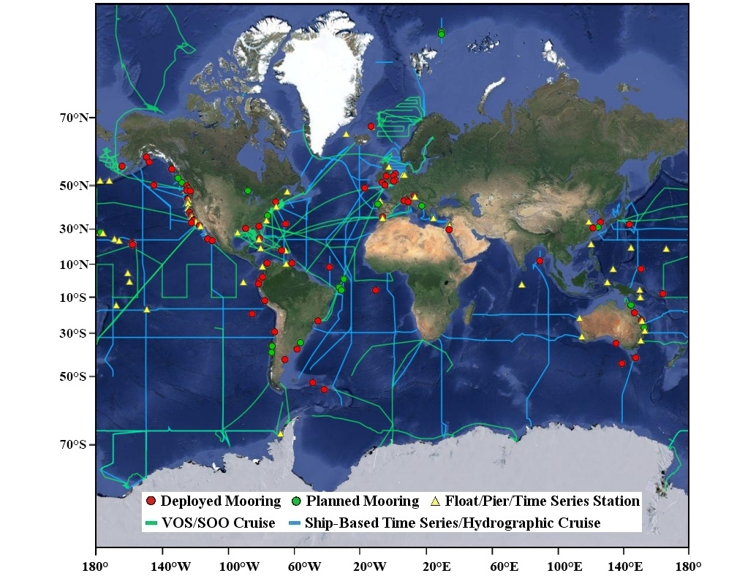Figure 1. Map of current and planned Global Ocean Acidification Observing Network (GOA-ON) components (weekly updated; last updated December 2013;
http://www.pmel.noaa.gov/co2/GOA-ON/ ).

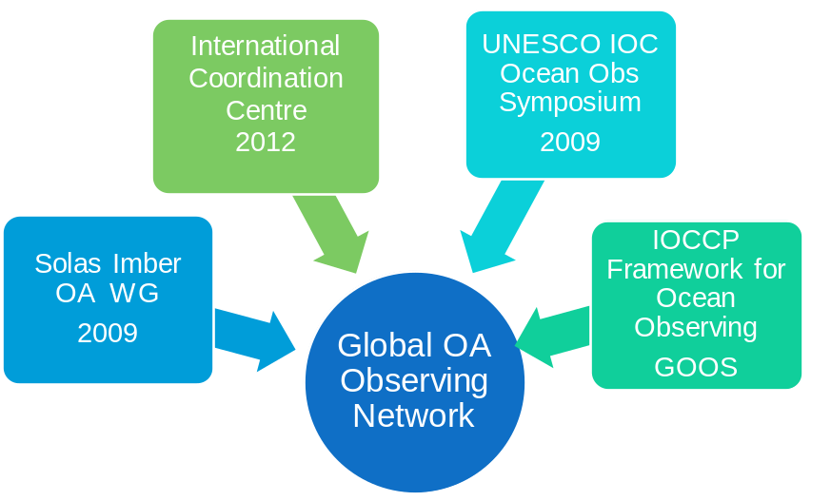
Figure 2. Schematic diagram of the international ocean acidification (OA) governance that led to the first GOA-ON workshop.
began its work in early 2013. A Global OA Observing initiative was included as one of the core activities for the OA-ICC. In addition, a number of white papers on observing requirements for ocean acidification were published as part of the OceanObs’09 Conference. These white papers (Feely et al., 2010; Iglesias-Rodriguez et al. 2010) provide a solid structural framework for the GOA-ON described in this document. The IOCCP developed a cooperative agreement with GOOS and released the Framework for Ocean Observing (Lindstrom et al., 2012). All of the entities referenced above continue to provide the basic foundation for the network.

5. Global OA Observing Network Justification and Goals
There was strong consensus in both workshops on why an OA observing system was needed, why it must be global in scale, why it should be integrated across physical, chemical, and biological observations and the goals of the GOA-ON.
a. Why is a Global OA Observing Network needed?
- We need information and data products that can inform policy and the public with respect to OA and implications for the overall ecosystem health (status) of the planet.
- Processes are occurring at global scales; therefore, we need to go beyond local measurements and observe on global scales in order to understand OA and its drivers correctly.
- There exist insufficient observations and understanding to develop robust predictive skills regarding OA and impacts. While we need enhanced coverage at finer-scales, successful international coordination of these observations will allow for nesting of these local observations within a global context.

b. What does the Global OA Observing Network need to provide?
The goals of the GOA-ON are established to:
- Goal 1: Provide an understanding of global OA conditions.
  - Determine status of and spatial and temporal patterns in carbon chemistry, assessing the generality of response to OA;
  - Document and evaluate variation in carbon chemistry to infer mechanisms (including biological mechanisms) driving OA conditions;
  - Quantify rates of change, trends, and identify areas of heightened vulnerability or resilience.

- Goal 2: Provide an understanding of ecosystem response to OA.
  - Track biological responses in concert with physical/chemical changes;
  - Quantify rates of change and identify locations as well as species of heighted vulnerability or resilience.
- Goal 3: Acquire and exchange data necessary to optimize modeling for OA.
  - Provide spatially and temporally-resolved chemical and biological data to be used in developing models for societally-relevant analyses and projections;
  - Use improved model outputs to guide Goals 1 and 2 in an iterative fashion.

6. System Design of the Global OA Observing Network: Conceptual
Conceptually, the GOA-ON addresses each of the three goals identified through the use of a nested design encompassing observations from open ocean and coastal waters (to include estuaries and coral reefs) using a variety of integrated and interdisciplinary observing strategies appropriate to the environment of interest.
a. Global OA Observing Network Nested System Design
To address the goals, a nested design is proposed for measurements at stations:
- Level 1: critical minimum measurements; measurements applied to document OA dynamics.
- Level 2: an enhanced suite of measurements that further promote understanding of the primary mechanisms (including biologically mediated mechanisms) governing control of ocean acidification dynamics; measurements applied towards understanding OA dynamics).
- Level 3: Opportunistic or experimental measurements that may offer enhanced insights into OA dynamics and impacts; measurements under development that may be later adapted to Level 2.
The system design of the Network is further nested because observing investments designed to address Goal 2 should be implemented at a subset of the Goal 1 stations.
b. Global OA Observing Network Design Attributes
- The GOA-ON will be comprised of observing assets within multiple ecosystem domains, specifically, the open ocean, coasts (including the nearshore and estuaries), and coral reef waters. The open ocean and coasts can also be subcategorized into polar, temperate and tropical regions with their associated ecosystem types.
- The Network will utilize a variety of observing platforms, classified here into three categories that share similar capabilities. These are: 1) ship-based sampling including survey cruises, the Ship of Opportunity Program (SOOP), which has alternatively been called the Voluntary Observing Ship (VOS) program and; 2) fixed platforms, including moorings and piers; and 3) mobile platforms, including gliders (both profiling and wave) and floats (possibly others, such as animals).
- Existing platforms will be leveraged wherever possible and appropriate.
- The Network will be interdisciplinary in approach, including these fundamental disciplines: carbon chemistry, oceanography, biogeochemistry, and biology. These disciplines will be much more effective if integrated, from a system design standpoint, a priori. For instance, while typically ocean chemistry is measured to assess effects on biology, an equally critical question to assess is “How is biology affecting ocean chemistry?” and the design of the Network must reflect such needs.

7. System Design of the Global OA Observing Network: Data Quality
The measurement quality goals of the GOA-ON may differ from site to site depending on the intended use of the observations, with differing intended uses requiring different measurement uncertainties.

MEASUREMENT UNCERTAINTY AND GOA-ON
A key goal for any observing network is to ensure that the measurements made are of appropriate quality for their intended purpose, and that they are comparable one with another; though made at different times, in different places, and in many cases by different instruments, maintained by different groups. It is thus as important to communicate the uncertainty related to a specific measurement, as it is to report the measurement itself. Without knowing the uncertainty, it is impossible for the users of the result to know what confidence can be placed in it; it is also impossible to assess the comparability of different measurements of the same parameter.⁽⁾
The term uncertainty (of measurement) has a particular technical meaning.^{(,)} It is a parameter associated with the result of a measurement that permits a statement of the dispersion (interval) of reasonable values of the quantity measured, together with a statement of the confidence that the (true) value lies within the stated interval. It is important not to confuse the terms error and uncertainty. Error refers to the difference between a measured value and the true value of a physical quantity being measured. Whenever possible we try to correct for any known errors; for example, by applying calibration corrections. But any error whose value we do not know is a source of uncertainty.
It is therefore essential to ascertain (and report) the uncertainty of measurements made as part of the GOA-ON, and to characterize the GOA-ON measurement quality goals in terms of such uncertainties. Hence the GOA-ON must establish clear guidelines for estimating this uncertainty for each of the separate measurement procedures to be used in the Network, and ultimately must also emphasize the need for formal quality assurance procedures in the various participating laboratories responsible for the instruments comprising GOA-ON to ensure that the various measurements quality goals are met.
Throughout this document, the term “uncertainty” should be taken to mean the standard uncertainty of measurement; that is with the associated confidence interval equivalent to that for a standard deviation.
a. Data Quality Objectives
Conventionally, long-term sustained carbon observations have been the purview of carbon inventory studies focused on documenting small changes within blue water, offshore, oligotrophic oceanographic settings. Such measurements demand an exacting quality necessary for identifying small changes over decadal time-scales. However, participants recognized that differing measurement quality goals are appropriate for the observations proposed here for observing ocean acidification depending on the intended application, the relative ‘signal-to-noise’ with respect to the environment and the processes being examined. For example, the uncertainty of measurement required for observations intended to track multi-decadal changes at a long-term time-series open ocean station is inherently different from the needs of data collected for determining the relative contributions of the acidification components within an estuary or to inform assessments of biological response. Each of these applications has associated measurement quality goals that need to be met. Analogous to terminology adopted in atmospheric sciences, participants proposed that the Network provide differing measurement quality goals specific to “climate” and “weather.” Accordingly, the goals proposed for the Network are defined here, in general and in the context of OA.

MEASUREMENT QUALITY GOALS FOR GOA-ON
“Climate”
- Defined as measurements of quality sufficient to assess long term trends with a defined level of confidence
- With respect to OA, this is to support detection of the long-term anthropogenically-driven changes in hydrographic conditions and carbon chemistry over multi-decadal timescales
versus
“Weather”
- Defined as measurements of quality sufficient to identify relative spatial patterns and short-term variation
- With respect to OA, this is to support mechanistic interpretation of the ecosystem response to and impact on local, immediate OA dynamics

b. Data Quality Requirements
For GOA-ON to succeed at delivering its goals, observations must be of a verifiable quality and consistency. Participants identified three critical data quality requirements that must be followed in order to implement the Network:
- Observations provided to the Network (whether measured, estimated, or calculated) will be accompanied by a statement of their uncertainty,.
- Observations will be calibrated to a community-accepted set of reference materials.
- All constants applied in the derivation of calculated parameters will be documented and reported. The uncertainties of such constants will need to be incorporated into the estimate of the uncertainty of each derived parameter.

8. System Design of the Global OA Observing Network: Measurements
a. Measurements for GOAL 1: An understanding of global OA conditions
Contributors to the GOA-ON will provide the hydrographic conditions and carbon chemistry data necessary to provide for:
- At a minimum, mechanistic interpretation of the ecosystem response to and impact on local, immediate OA dynamics (Weather).
- Optimally, detection of the long-term anthropogenically-driven changes in hydrographic conditions and carbon chemistry over multi-decadal timescales (Climate).

The workshop participants agreed it would be necessary for the GOA-ON to provide a complete description of the seawater carbonate system at each measuring site. Insofar as such a description can be achieved in a variety of ways, involving alternate combinations of measurable parameters together with values for various equilibrium constants, etc., participants agreed that it would be useful to consider measurement quality goals in terms of calculating the saturation state of aragonite (a form of calcium carbonate) so as to constrain the uncertainty of measurement that would be required of the observed parameters used for this calculation.

GOAL 1 Level 1 Measurements for Oceans and Coasts:
- Temperature, Salinity, Pressure, Oxygen concentration, and Carbonate-system constraint*
* Carbonate-system constraint can be achieved in a number of ways, including combinations of direct measurements and estimates of other parameters.
- Fluorescence⁺ and Irradiance⁺
⁺Except where platform is not appropriate or available for this measurement

The weather objective requires the carbonate ion concentration (used to calculate saturation state) to have a relative standard uncertainty of 10%.
- Implies an uncertainty of approximately 0.02 in pH; of 10 µmol kg^{–1} in measurements of total alkalinity and total dissolved inorganic carbon; and a relative uncertainty of about 2.5% in the partial pressure of carbon dioxide.
- Achievable in good (but not reference) labs.
- Achievable with the best autonomous sensors.

The climate objective requires that a change in the carbonate ion concentration be estimated at a particular site with a relative standard uncertainty of 1% (note this is not the uncertainty in the carbonate ion concentration itself, it is significantly smaller as uncertainties in the various equilibrium constants largely cancel out when estimating the uncertainty of the difference between two values).
- Implies an uncertainty of approximately 0.003 in pH; of 2 µmol kg^{–1} in measurements of total alkalinity and total dissolved inorganic carbon; and a relative uncertainty of about 0.5% in the partial pressure of carbon dioxide.
- Barely achievable by the best laboratories currently
- Not currently achievable even with the best autonomous sensors.
As noted above, observations provided by the Network will report estimated values for the uncertainty in measured, estimated, and calculated parameters, regardless of quality objective. Observations will be calibrated using a community-accepted set of reference materials.
The addition of fluorescence and irradiance is because biological processes, e.g., respiration, photosynthesis, may affect the chemical status of OA and its attribution to underlying mechanism. However, it was noted that not all platforms or efforts could accommodate these measurements. Thus, while these remain desired Level 1 measurements, it is understood that in some cases, they will not be made.

GOAL 1 Level 2 Measurements for Oceans and Coasts:
There was no consensus as to which measurements would be broadly relevant at a global scale. That is, the optimal set of Level 2 measurements is condition- (locale, season, hydrographic) and question-dependent. Measurements recommended included:
- Nutrients, Bio-optical parameters (beam C, backscatter, turbidity, absorption), Transport, Meteorology, Net Community Metabolism (NCM), Trace metals, ¹⁸O, ¹³C, Export production, PIC, POC, Atmospheric pCO₂, and Phytoplankton species
In reality, some of these measurements are currently more likely Level 3 measurements, and that distinction may actually vary in different systems.

GOAL 1 Level 1 Measurements for Coral Reefs:
In addition to the Goal 1 Level 1 measurements for Oceans and Coasts, measurements for assessing the effect of biology on OA in Coral Reefs are:
- Biota biomass
  - Corals, Photosynthesizers (algae, seagrasses), Coralline Algae
- Changes in Net Ecosystem Processes
  - Calcification/Dissolution (NEC: Net Ecosystem Calcification)
  - Production/Respiration (NPP: Net Primary Production)
GOAL 1 Level 2 Measurements for Coral Reefs:
These measurements were specified as necessary in some areas or instances:
- Processes
  - Freshwater input
  - Nutrification (especially for inshore reefs)
- Wind (for oxygen-derived NPP)

b. Measurements for GOAL 2: An understanding of ecosystem response to OA
There are two aspects when considering the interface of biology and OA:
- What effect does biology have on OA (i.e. how do species, communities and ecosystems affect OA)?
- What are biological responses to OA (i.e. how will ecosystems respond to OA vis-à-vis metabolic rates, morphology, and community composition)?
The first question needs to be considered in the context of both Goals 1 and 2. This question notes the biological contribution to OA chemical status. As reflected in the Goal 1 sections above, biologically relevant measurements are required. Thus, for oceans and coasts, fluorescence and light are defined as Goal 1 Level 1 measurements to help assess photosynthesis and respiration, along with the other Goal 1 Level 1 measures, including oxygen (for hypoxia) and salinity (for freshwater input). While the remainder of the discussion in this section is focused on the second question only (Goal 2: the biological/ecosystem responses to OA), an inherent coupling of these two questions is noted.

In the context of Goal 2, a conceptual structure for the effects of OA on ecosystems is depicted in Figure 3 that illustrates direct effects of CO₂ and pH on organisms, as well as indirect effects of OA on ecosystems and ecosystem services.

The GOA-ON will focus on specific measurements within this conceptual structure to resolve thresholds of response to OA in relation to site-specific baselines. There is also synergy between experimental work on biology and Goal 2 observations. While experiments are not part of GOA-ON directly, the Network will help inform independent experimental site selection and results from experimental work will be used to inform and update observational emphasis.
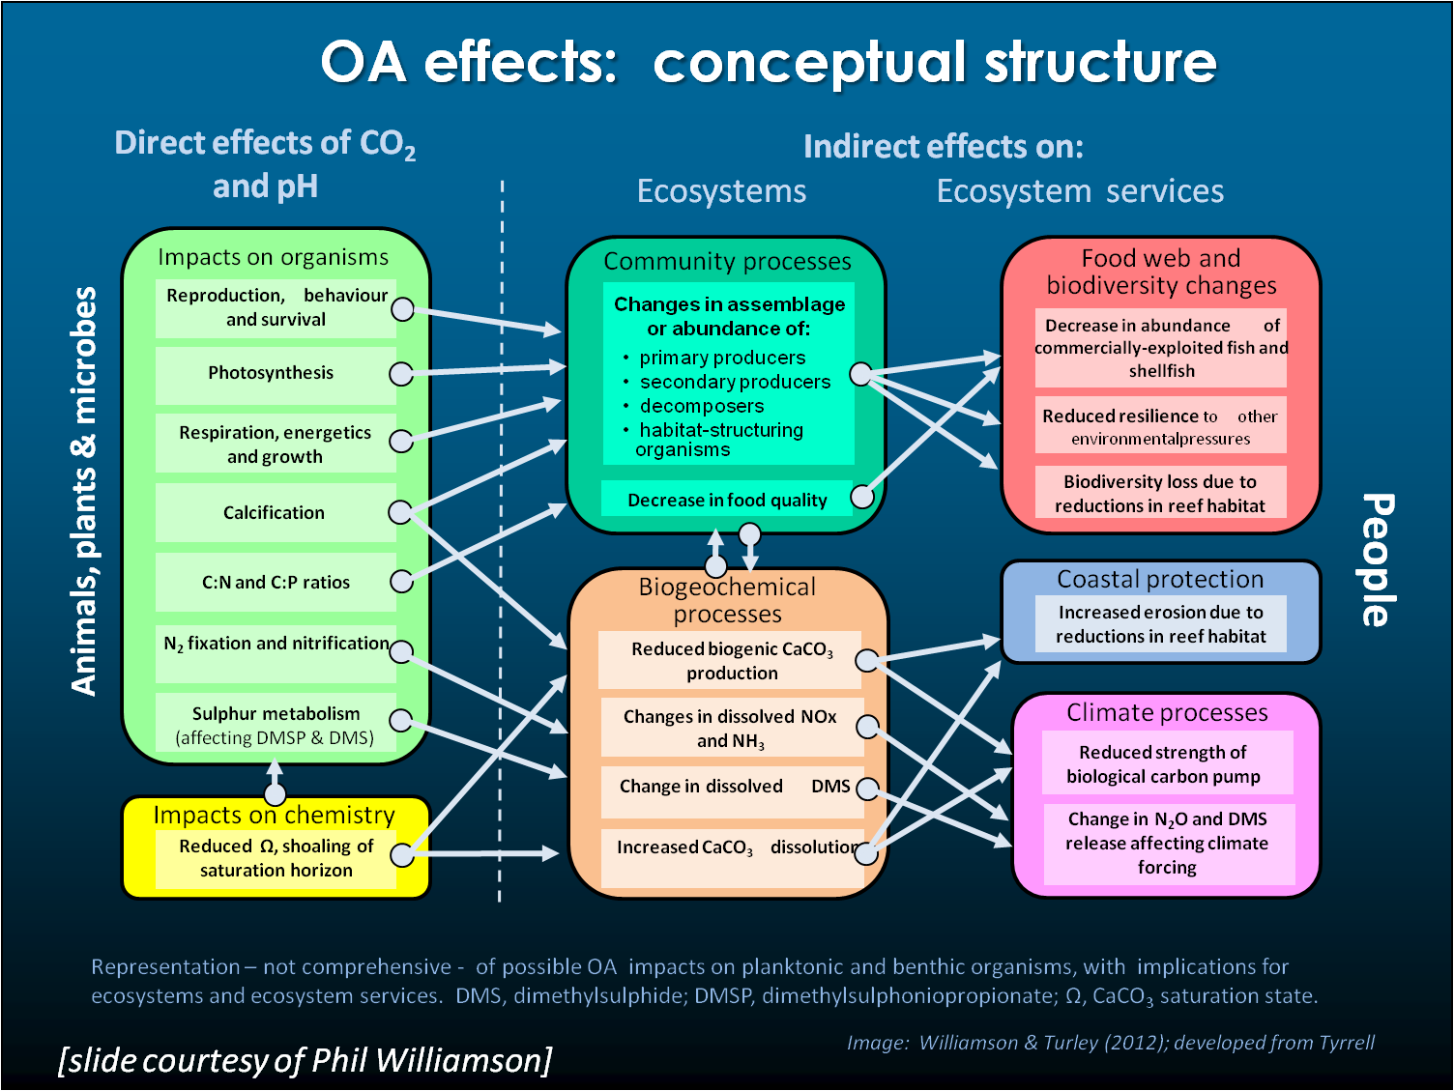
Figure 3. Conceptual model of the effects of OA on ecosystems illustrating direct effects of CO₂ and pH on organisms, as well as indirect effects of OA on ecosystems and ecosystem services (adapted from Williamson & Turley, 2012).

To address the complexity of biological response to OA, the St Andrews workshop focused on five ecosystem types: polar, temperate, and tropical waters, coral reefs, and the nearshore (including estuaries and coasts). While not exhaustive, these sub-categories offer capacity for GOA-ON participants to consider key variables and adapt further as required by the environment. For inter-site comparisons, it is recommended to use anomalies from long-term means as a basis, where absolute values are difficult to compare. Network design and site selection should consider the utility of the resultant information to management and mitigation.

GOAL 2 Level 1 measurements for Oceans and Coasts:
Addressing Goal 2 at the broadest scale requires the measurement of biomass or abundance of functional groups, listed below, contemporaneous with the physical and chemical measurements for Goal 1 using at least ‘weather’ data quality methods.
- Biomass/abundance of:
  - Phytoplankton
  - Zooplankton
  - Benthic producers and consumers (primarily Nearshore)

Biomass of calcified versus non-calcified species is desired, as is measuring the timing of changes in abundance, e.g., blooms, community shifts, pigment changes. Zooplankton should include both micro- (e.g., protists) and meso- (i.e., multicellular) plankton as well as meroplankton, where applicable.

At the finer scale of addressing Goal 2 in specific ecosystem types, Goal 2 Level 1 recommendations follow.
Polar: Phytoplankton and zooplankton biomass/abundance; phytoplankton functional types; particulate inorganic carbon (PIC)

Temperate: Phytoplankton and zooplankton biomass/abundance; calcified to non-calcified plankton abundance; phytoplankton functional types; PIC

Tropical: Phytoplankton and zooplankton biomass/abundance; size fractionated chlorophyll; sunlight (PAR); turbidity; colored dissolved organic material (CDOM)

Nearshore: Phytoplankton, zooplankton, and benthic producers and consumers abundance/biomass; calcified to non-calcified plankton and benthos abundance; chlorophyll; TSS/turbidity; CDOM (remote sensing); nutrients

GOAL 2 Level 2 measurements for Oceans and Coasts:
Goal 2 Level 2 measurements primarily add measurements to help elucidate more information about the biota functional groups and responses to OA including:
- Processes & Rates (e.g., production and export)
- Chemical speciation (e.g., C, N, P and phase)
- Species (e.g., key species or groups)

For specific ecosystem types, Goal 2 Level 2 recommendations are:
Polar: Primary production; export flux rate; net community production (NCP); net community calcification (NCC); nutrient uptake rates; taxonomy; sea algae

Temperate: Primary production; export flux rate; NCP; calcification rates; remineralization; dissolution; POC/DOC (size fractionated); PON/DON (size fractionated); TEP; POP; fatty acid measurements; benthic processes: burial deposition, benthic respiration, calcification, and production

Tropical: Primary production; export flux rate; NCP; DOC; DOM; N/P ratios; Nitrate/Phosphate; satellite imagery; algal pigments (HPLC); currents (ADCP); zooplankton vertical/spatial and temporal variation; zooplankton grazing rates

Nearshore: Phytoplankton primary production; pelagic and benthic NCP; community structure; trophic interactions/del O18; disease; phytoplankton species (for HABS include species and toxicity)

GOAL 2 Level 1 Measurements for Coral Reefs:
Goal 2 level 2 measurements are those needed to constrain Goal 1 level 1 measurements.
- Biota biomass and distribution
  - Corals, photosynthesizers (macroalgae, turf algae), coralline algae

This includes population structure of corals; population structure of algae; biomass, population and trophic structure of cryptobiota; population structure of urchins; architectural complexity

- Processes
  - Calcification (NEC: net ecosystem calcification) and dissolution rates
  - Production (NEP: net ecosystem production) and respiration rates
  - Growth rates of calcifiers and non-calcifiers

Additionally, calculate the NEP:NEC ratio and measure food supply rate and quality and bioerosion rates at specific sites.
- Chemical habitat
  - Sediment mineralogy/composition
  - Organism mineral content
  - Alkalinity anomalies
  - Vertical profiles of Ω over time in direct proximity to deep sea corals

c. Measurements for GOAL 3: Input data to optimize modeling for OA
i. Global/Basin and Climate Scales
To improve the capacity of existing models to yield widespread information on global/basin scale OA status and trends, the following recommendations are made.
- Large scale surveys – a snapshot of OA conditions is important in order to constrain models; need to coordinate information at basin-scale, repeat hydrography, VOS, historical sections.
- Better spatial coverage of moorings with OA physical/chemical/optics measurements; targeted process studies (rate measurements, budget, community structure) at time series stations and key locations to improve biogeochemical model structures and parameters.
- More Argo floats with bio-optical sensors (NPZD-O2 floats) with proper temporal sampling frequencies, which establish interconnections of the same water masses.
- Extended spatial coverage of gliders, based on modeling simulations and experiments (OSSE) to establish new glider and survey sections.
- Connect global/basin OA conditions with marginal seas/coastal processes; use coastal extensive OA observing networks and modeling capabilities to examine impact of coastal seas on the open ocean.
ii. Marginal Seas/Coastal – Weather and Climate Scales
To improve our capability to use coastal models for physical, chemical, and biological applications relevant to OA and to optimize a coupled monitoring-modeling network for the coastal/marginal seas, the following recommendations are made.
- Make better use of regional/coastal physical modeling capabilities, especially near-real time and short-term (weather) forecasting information; coastal OA observations provide necessary information to establish and improve physical-biogeochemical models.
- Evaluate and constrain model performance at OA observing locations (moorings, glider and survey sections); produce near-real time and short-term forecasts of OA conditions; extract and simplify model results to develop a set of usable OA indicators for the key locations.
- Based on physical-biogeochemical model results and numerical experiments (OSSE), identify new OA observing locations and modify existing OA monitoring networks.
- Integrate OA measurements with water quality information (oxygen, nutrients/loading, turbidity, etc.) and plankton community structures (survey data, bio-optical and remote sensing measurements); incorporate this information into physical-biogeochemical models to produce 3D distribution on dominated temporal scales.
- Develop models for pelagic and benthic organisms (vulnerable to OA) with connections to the habitat and OA conditions; establish ecosystem models to link with living marine resource management (integrated ecosystem assessment).
iii. Coral Reef Systems – Weather and Climate Scales
To provide for the capability to assess OA impacts on coral reef systems the following recommendations are made.
- Very high spatial resolution (100 meters scale) circulation models for coral reef ecosystems need to be developed; these models will need to address connectivity related issues, linking with basin/regional models.
- Wave models should be incorporated into circulation models, which will address impact of extreme weather events.
- OA observing information is needed that constrains initial and boundary conditions for targeted reef systems (smaller spatial domain and shorter temporal simulations).
- There will need to be multiple model simulations and future projections of OA conditions and key physical processes (temperature, sea level, light, frequency and intensity of extreme events) for coral reef systems.
- Models must capture habitat conditions and ecosystems connections.

9. Global OA Observing Network Design: Spatial and Temporal Coverage
For spatial and temporal coverage, considerations are the current status of GOA-ON relevant to the three broad ecosystem domains, oceans, coasts, and coral reefs, the desired spatial and temporal resolution of the measurements, identification of gaps and high vulnerability areas, and priorities for filling gaps or building capacity for new measurements.
a. Current status
- OCEANS: On a global scale, for assessment of OA in the oceans, the significant building blocks of a network are well established and vetted by the ocean community (e.g., CLIVAR/CO₂ Repeat Hydrography Program, GO-SHIP, OceanSITES, SOOP), but it needs filling in for certain areas, some components lack sustained funds, and some components need enhancements.
- COASTS: On a global scale, for assessment of OA in the coastal ocean, seas, and estuaries, a coastal network needs construction. On regional scale, there are some systems in place, some ability to leverage OA observations on existing infrastructure (e.g., World Association of Marine Stations, International Long-Term Ecological Research Network), but there are many gaps. The coastal element needs a globally consistent design which must be coordinated & implemented on a regional scale also. In some areas, there is a need for significant infusion of resources and infrastructure to build the necessary capacity.
- CORAL REEFS: For assessment of OA and its impacts on coral reefs, a globally consistent coral reef OA observing network needs construction. There is some observing capacity in some regions but observing assets may not cover the extent of variability that organisms observe and should be supplemented by site-specific studies. The National Coral Reef Monitoring Program being built out by the US for Atlantic and Pacific coral reefs can serve as a model.

b. Recommendations for Spatial-Temporal Network Design: OCEANS
A framework for a Global OA Observing Network in the open oceans largely exists but components need critical attention in order to bring this to realization.
- Utilize the GO-SHIP global plan (Figure 4) and similar research cruises for critical OA components of the Network. The existing repeat hydrography program provides essential foundation to establish OA conditions at global scale. Expansions include a sampling density sufficient to map aragonite saturation horizon and addition of bio-optical measurements for calibrating Argo floats.
- Participate in VOS/SoOP global plan (Figure 5; bimonthly temporal resolution at roughly 10-15° latitude spacing at some locations) and enhance its coverage, especially to the southern hemisphere, Indian Ocean, Arctic, and other locations to be scoped.
- Contribute to OceanSITES deepwater reference stations (Figure 6; roughly half have OA sensors now) and enhance this plan to address gaps (e.g., high latitudes, Labrador Sea, South Pacific gyre, BATS, etc.) or keep operational (e.g., Japanese site at 60° S). High vulnerability sites with insufficient coverage include the Arctic, Southern Ocean, Coral Triangle, off Peru.
  - To optimize this for the GOA-ON, the OA community could add/share funding, operational effort/cost/ship time/people, sensors, data processing/management, or in a few cases take ownership of complete moorings.
- Participate in ongoing developments to collect OA relevant data with sufficient quality from floats, such as Argo floats (Figure 7).
  - Comparison with ship-based measurements is essential to the success of this effort. Utilize a smaller number of additional biogeochemistry-ecosystem Argo floats (Figure 8) that would have shorter profile intervals (e.g. 6 hours) more relevant to biological processes (e.g. NPZD floats)
- Contribute to development of glider technology for deployment, especially to target high vulnerability areas. Will need attention to address biofouling.

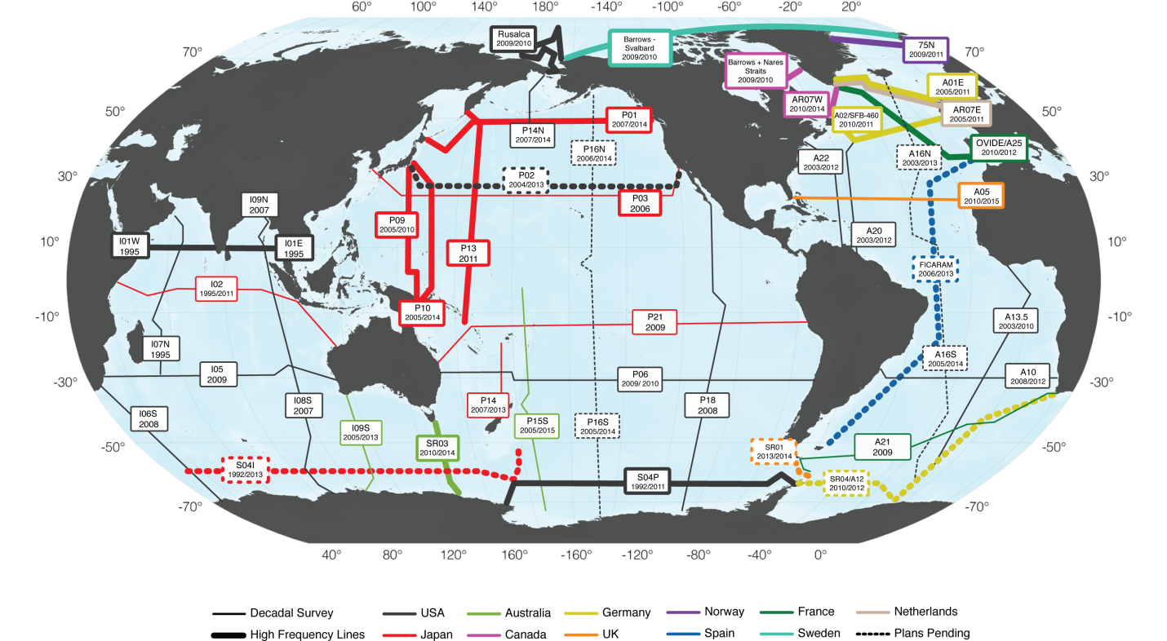
Figure 4. Map of Go-Ship Repeat Hydrographic Surveys in the global oceans as of 2013.

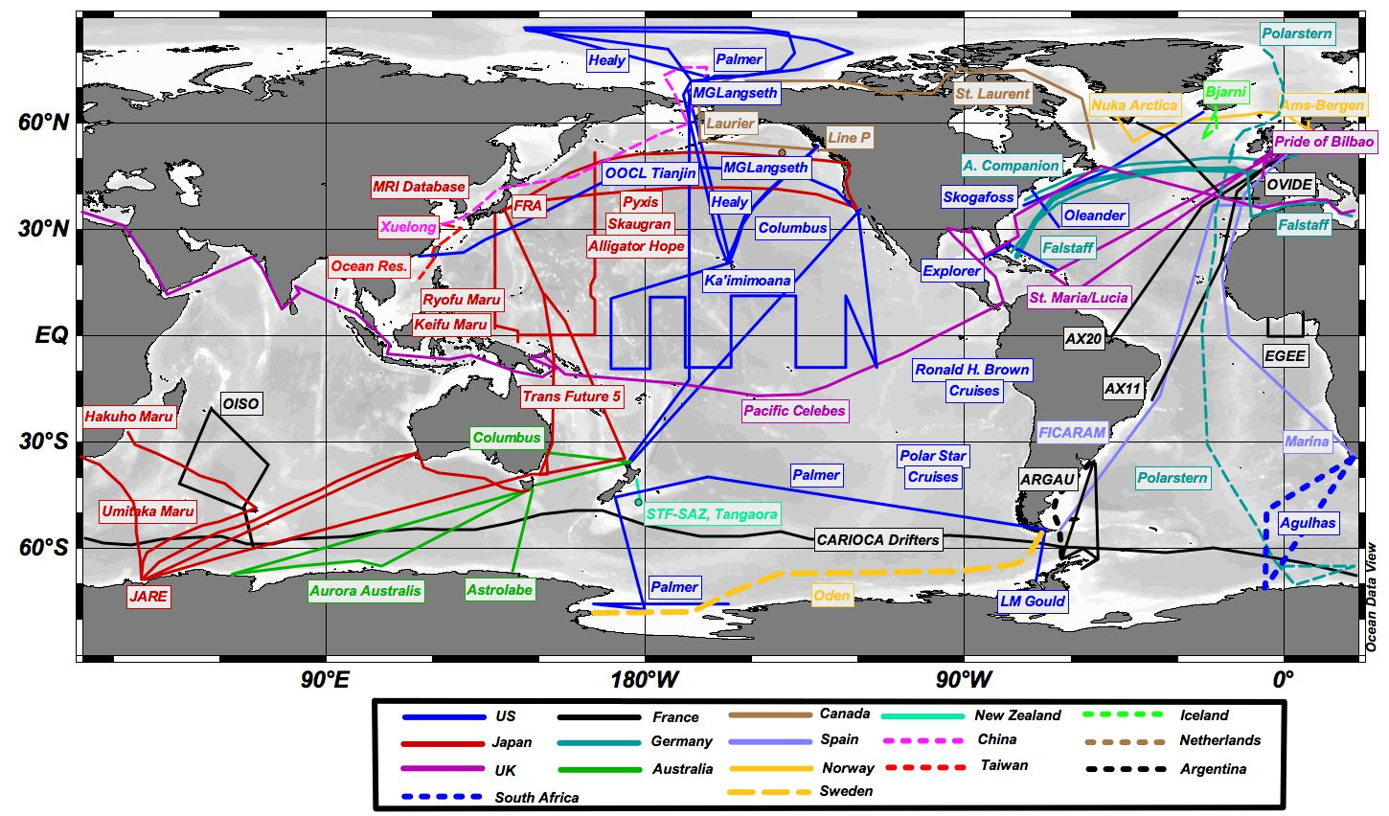
Figure 5. Map of global Volunteer Observing Ships (VOS) cruise tracks for underway measurements as of 2013.

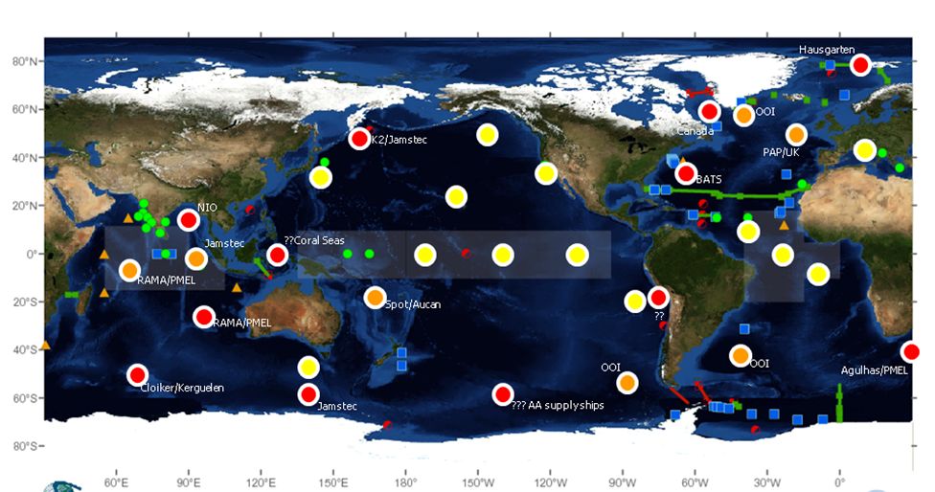
Figure 6. Map of OceanSites mooring locations for time-series measurements.
Color coding: Yellow = collecting some OA parameters in 2012; Orange = likely to happen in next year; Red = unlikely to happen without strong push from OA community.

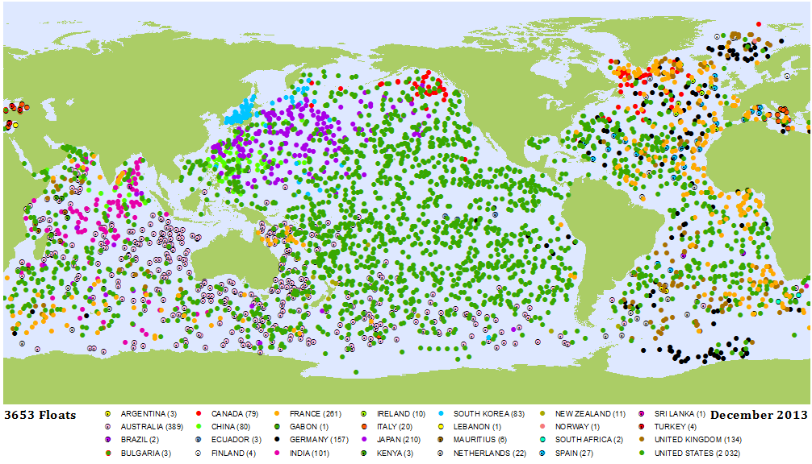

Figure 7. Map of ARGO Float locations as of December 2013. Some of the floats are equipped with biogeochemical sensors, as shown in Figure 8.

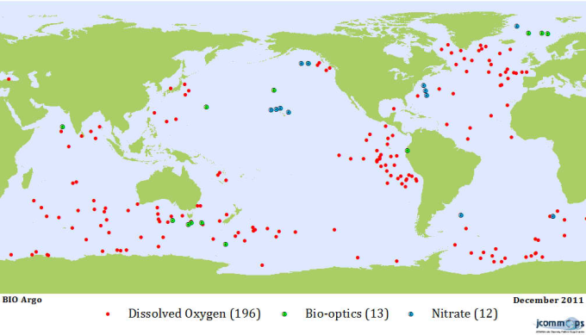
Figure 8. Map of ARGO floats with biogeochemical sensors.

c. Recommendations for Spatial-Temporal Network Design: COASTS
The status of a Global OA Observing Network in the coastal area is much less developed than that for the open ocean. There is no existing framework for most regions and no global framework for coastal areas, so the Network’s design needs a more fundamental approach.

- Create OA capacity:
- Incorporate existing OA observing, where available
- Inventory current observing capacity and expand subset to include OA observations*
- Be proactive in treatment of gaps (e.g., Africa, etc).*
*Use statistical/quantitative analyses to: a) target new assets to optimal locations and b) provide a means of filling gaps (data extrapolation in a resource-limited world)
- Aim for balanced representation:
Represent the full range of natural variability (and presumably ecosystem resilience); include high vulnerability areas and areas with important economic resources. For example, upwelling zones versus stable water column areas should both be captured. While the former may see lower pH in surface waters, organisms may be better adapted to variation, thus more resilient.
- Work within regions to optimize capacity and relevance.
  - Encourage use of coastal observational nodes as ideal locations to conduct explanatory process studies
  - Improve upwelling indices for nearshore areas (useful in creating proxy methods for extrapolating sparse observations across complex coastal zones)

d. Recommendations for Spatial-Temporal Network Design: CORAL REEFS
Capacity is adequate in some areas, but non-existent in others; a balance is needed for a truly Global OA Observing Network.
- Utilize current observing assets including moorings/buoys in:
Hawaii (Kaneohe Bay and S. Shore), Bermuda (Hog Reef, Crescent), GBR (Heron Island) and Ningaloo (W Australia), Chuuk, Florida Keys (Cheeca Rocks), Puerto Rico (La Parguera).
However, these may not cover the extent of variability that organisms observe and should be supplemented.
- Aim for balanced representation, monitoring across gradients of latitude, biodiversity, warm vs. deep coldwater systems, pristine vs. impacted.
- The observing system should also give us insight as to what reefs will look like in 50-60 yrs., so include natural-CO₂ seeps.
e. Recommendations for Spatial-Temporal Network Design: SYSTEM-WIDE
There are several items that the Network system design needs to address that are not specific to any one of the above ecosystem types:
- Data coverage gaps – a global network cannot be global if not adequately distributed to all sectors of the globe. The current status is not acceptable.
- ‘Threatened’ ecosystems – either due to proximity to perceived thresholds, rate of change in carbonate chemistry conditions, or vulnerability of ecosystem, these systems should be observed via the Network. It is likely that we, as a global community and perhaps through the auspices of the IOCCP and the OA-ICC, can focus attention on identifying those hot spots through a dedicated research effort.
- Ecosystem function – because OA is an environmental condition with implications for biota, the ecosystem function must be a focal point for observations. This calls for integration of physical, chemical, and biological sensing.
- Operational benefits – data from the Network should be available to and linked with those sectors of society that benefit from the data in making business and management decisions. The Reference User Group of the International Coordination Centre will become a focal point for bringing messages to industry, governments and the public.

10. Data Quality Objectives in the context of Goals and Sampling Platforms
The various sampling platforms currently available to the community are differentially suited to the two GOA-ON goals and its two data quality levels.
- Data satisfying Goal 1 ‘climate’ data quality criteria currently can only be obtained from direct analysis of water samples, typically necessitating sampling from cruises or VOS. Thus, cruise and VOS sampling, analyzed appropriately, more likely assures ‘climate’ quality data as well as offers sporadic validation of ‘weather’ quality measurements.
- Data of Goal 1 ‘weather’ quality are often collected on moorings or fixed platforms, but must be calibrated, as noted above, by validation samples of ‘climate’ quality. The added benefit of mooring/fixed platforms is that these platforms can be used to obtain high temporal resolution data that is useful for elucidating mechanisms of variation. Such high temporal resolution measurements are also valuable in the ‘climate’ context to verify means in highly dynamic systems i.e. to increase knowledge on representativeness of spot sampling from cruises.
- Goal 1 is also aided by ‘weather’ quality data obtained from gliders or floats yielding high spatial resolution data that is useful for assessing vertical variation (shoaling of saturation horizons) and elucidating mechanisms. The same caveats as for moorings/fixed platforms apply, that these should be calibrated.
- Data for Goal 2 currently requires cruise-based sampling for all variables, except for some indicators relevant to phytoplankton and production, e.g., fluorescence and PAR.
Needs: In order to accurately satisfy goals in all environmental regimes, the applicability of method to environment is key and having documentation thereof. Important examples mentioned are the:
- Need to prepare CRMs for other environments (low salinity).
- Need to establish alkalinity dissociation constants for lower salinity waters.
- Need for SOPs for autonomous sensors and to standardize those.
- Need for detailed honest documentation of what people are doing, including validation, SOPs, metadata. It is the intent of GOA-ON to build access to these items via the GOA-ON map server.

11. Global OA Observing Network Products
An important output of the GOA-ON is informational products on OA status that can inform scientists, managers, policy makers, educators and the public at large.

i. GOAL 1 priority products:
- Open Ocean
  - Seasonally resolved global and regional surface maps of pH, alkalinity, saturation states, pCO₂
  - Time series stations (e.g. interactive maps)
  - Decadal changes in pH, alkalinity, saturation states, and pCO₂ from repeat hydrography
  - Export production (PIC, POC)
  - Subsurface saturation maps
- Coastal
  - Seasonally resolved surface maps of pH, alkalinity, saturation states, pCO₂
  - Time series stations (e.g. interactive maps)
  - Near-Real-Time data access
  - Alkalinity anomaly
  - Subsurface maps of pH, alkalinity, saturation states, pCO2
- Coral Reefs
  - DIC/Alkalinity relationships for different sites
  - Biogeochemical model output at coral reef sites
  - Time series of delta Alkalinity (deviation from salinity)

ii. GOAL 2 priority products:
These are desired ecosystem products from the GOA-ON, but recognizing that not all will be possible with Level 1 measurements only. Products would to be spatially resolved and analyzed in relation to carbonate system variability.
- Benthic recruitment and recruitment variability
- Planktonic calcifiers (phyto- and zooplankton) abundance and variability
- PIC:POC (calcifiers:non-calcifiers) in planktonic and benthic organisms
- Phytoplankton biomass, primary production, and assemblage shifts
- Habitat compression/expansion of pelagic & benthic organisms
- Comparative resilience of managed vs. unmanaged ecosystems
- Susceptibility to phase shifts

12. Global OA Observing Network Data Management
a. Data Sharing: Consensus vision and solutions to roadblocks
Members of the GOA-ON agree that data sharing is essential to achieving the payoff of the Network. The consensus statement regarding sharing of ocean domain GOA-ON data approved by participants of both GOA-ON workshops is:
“The participants in the Global OA Observing Network agree to support in principal the construction of a web portal that
  - builds on current capacity and capabilities,
  - accepts data streams from relevant data centers,
  - provides visual and data link capabilities, and
  - exhibits synthesis products for the ocean scale.”

Recommended metrics for data sharing for ocean data from the GOA-ON were to:
- Provide the QC’ed data for synthesis products
  - 6 mo (desired) – 2 yr (longest possible) after collection
  - Work to accelerate the QC process
- Post the near-real-time (NRT) data
  - Picture of data (realistically possible)
  - Download of data (desired)
  - Work to accelerate the QC process
- Provide the data via public web portal
It is recognized this is sometimes problematic in coastal waters, due to national policies. Additional roadblocks to data sharing identified by workshop participants each have solutions that the community offered. The five most common roadblocks and solutions are shown below.
- Data QA/QC: it takes time; there are no standardized procedures; capacity lacking
- Solution: On the Global OA Network portal
  - Advertise Data Managers, e.g., CDIAC, better
  - Create standardized procedures for the Network
  - Engender trusting relationship between data providers and data managers
  - Post info on benefits of data sharing

- Institutional boundaries or national regulations
- Solution:
- Develop terms of reference for Global OA Network
- Network provides contacts for EEZ paperwork
- There is no consistent data portal
- Solution:
- Develop a data portal for the OA Network
- Scientists’ reluctance
- Solution:
- Publication, acknowledgement
- Highlight examples of benefits on portal
- Provide version control
- Funding insufficient
- Solution:
- Outreach to scientists regarding data expectations
- Provide relevant products to users that are highly valued

b. Data Management Plan
The Data Management Plan for the GOA-ON can largely build upon an existing data management plan for OA that NOAA spearheaded in cooperation with other U.S. agencies. Seeing a critical need for data coordination and as lead for the United States Interagency Working Group on Ocean Acidification, the NOAA Ocean Acidification Program took lead to integrate ocean acidification-related data across the U.S. federal government, recognizing the paramount importance for data sharing both nationally and internationally. As a result, an OA Data Management Workshop was convened in March 2012 at the University of Washington, in coordination with IOOS and its Pacific Northwest regional association, NANOOS. Thirty representatives, both scientists and data managers, from across NOAA, from other ocean-related science federal agencies (DOE, NASA, NSF, USGS, etc.) and from academia attended. While this was a U.S.-only workshop, a vision to guide an OA Data Management Plan was established and titled “Interagency Ocean Acidification Data Management Plan: Draft One,” now located on the U.S. National Oceanographic Data Center website (NODC, 2012). The essence of that plan, which shapes the vision for OA data management, dubbed the “Declaration of Interdependence” was shared with the GOA-ON workshop participants, who supported it. The declaration is appended to this report in Appendix 3. There is ongoing activity led by NODC to begin implementing that plan.
A data management vision for GOA-ON, building on recommendations of the first GOA-ON workshop, proposed and adopted at the second GOA-ON workshop, provides for effective long-term scientific data management using interoperable online data services allowing for human- and machine-to-machine data discovery and access. This vision includes specific considerations for
- Providing data sharing time limits for coastal and open ocean data.
- Deployment of a web data portal allowing optimal data discovery, access, integration, and data visualization from collection- to granular- level OA data and data products using common inter-operable web data services. This web portal would build on current capacity and capabilities, accepts data streams from relevant data centers, provides visual and data link capabilities, and synthesis data products for the ocean scale.
- A coordinated scientific data management and data flow framework that builds on existing infra-structure and scientific requirements over the long-term in coordination with the OA-ICC.
- Adoption of best practice metadata procedures/protocols following international standards like ISO to facilitate data discovery, use of DOIs or similar identifiers to provide clear data provenance and attribution.
- Adopt international OA long-term archival centers for OA observational, biological, model data, and data products. This centers would provide data integration where possible using interoperable online data services consistent with the proposed web data portal.
13. Global OA Observing Network International Governance

A preliminary governance structure was established at the close of the St Andrews meeting (Figure 9). It was decided that, until a more formal arrangement is made, the organizing committee of the 2nd workshop would provide the basis for the GOA-ON Executive Council (see Appendix 4 for members). The main national and international entities directly represented on the Executive Council are expected to continue to provide both in-kind and direct support for GOA-ON organizational activities, including future meetings and staff involvement, with additional support potentially available for training, technological infrastructure and other forms of capacity building.

The roles for the core entities of the GOA-ON included in the diagram below and as outlined in the St Andrews meeting include:

- OA observing activities, data, expertise & assets of global research community: represents the central and most important piece of the network which encompasses all the actual assets in the water, the data collected and, most importantly, the scientists who oversee their operation, and interpretation of the data.
- National and Regional Funders: will provide the human, technical and financial resources for the actual implementation of the observing assets around the globe. Several, such as US/NOAA and University of Washington, Aus/CSIRO and UK/NERC, are represented on the Executive Council. Staffing for the GOA-ON website and for management of the network will likely be provided by national funders but may also be supported by the ICC.
- OA- International Coordination Centre: will coordinate across international scientific efforts from sharing of scientists and expertise across national observing efforts, development of standardized data management approaches and capacity building for developing countries. The global observing network is a primary task in the ICC project.
- International Atomic Energy Agency: will support the OA-ICC project as its parent body but will also support development of new scientific observing capacity in under-observed regions through its global capacity building networks.
- Blue Planet task of the Group on Earth Observations: includes an activity focused on the GOA-ON and provides access to: 1) novel international audiences (Departments of Environment, for instance) and 2) their scientific networks in developing regions.
- Global Ocean Observing System: is current developing the Framework on Ocean Observing which will also guide the GOA-ON requirements. GOA-ON scientists are participating in the biogeochemical panels for the FOO.
- Intergovernmental Oceanographic Commission: will support the GOOS as its parent body but also has its own Ocean Acidification project which will, in near term, work on organizing the next GOA-ON scientific meeting.
- International Ocean Carbon Coordination Projects: will, through its Ocean Acidification task, coordinate: the development of the requirements for the biogeochemical essential ocean variables for GOOS (see above) and with other international carbon observing efforts.

The Executive Council is charged with ensuring the core functioning of the network including to:
- Finish the Plan including soliciting input from the broader membership (by March 2014)
- Oversee process for further refinement of Plan
- Maintain of the Membership
- Network with other International Bodies
- Develop resources for certain geographic areas of high concern
- Ensure international data management which provides centralized access to distributed data centers
- Keep the map (currently supported by NOAA PMEL) of OA observing assets robust, current, and useful
- Encourage development of synthesis products based on data from GOA-ON
- Provide transboundary scientific sharing to ensure high quality observing

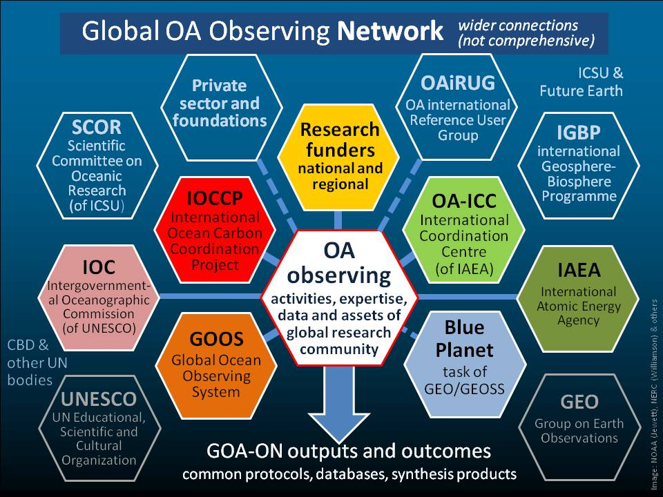

Figure 9. Representation of the basic matrix constituting the GOA-ON and the primary entities responsible. The entities represented by colored shapes constitute the Executive Council and have committed to providing either direct or in-kind support to core organizing activities. The outlined shapes are parent bodies.

14. Global OA Observing Network Support Requirements
The GOA-ON must be regarded in terms of the need to support a functional network in its entirety. A network is not just sensors in water; a network requires support for the following capacities:
- Physical infrastructure, i.e., the platforms and sensors;
- Operations and maintenance, i.e., the humans to run the network and keep it functioning;
- Data QA/QC, i.e., the standards and application thereof to keep the data quality suitable to the application;
- Analytical and synthesis activities, i.e., the humans and models to analyze the data, synthesize it into useful data products, and interpret and publish its significance to a variety of audiences;
- Capacity, i.e., the new infrastructure and job force that will have to be built and provided for in order to bring GOA-ON to a global reality.

It is recognized that individual countries are likely most interested in what is happening within their respective national waters and may provide financial resources to support the network when systems are located locally. However, deployment of observing assets needs to be preceded by identification of local or regional scientific expertise to support the deployment.

15. Global OA Observing Network Web Portal
Participants in the Network have agreed to support the construction of a web portal, currently maintained by US NOAA PMEL, which provides:
  - a detailed overview of the GOA-ON goals, elements, governance, and network members, with relevant links to each of the components
  - a visual and interactive map representation of the platforms in the network, building upon current capacity and capabilities; the interactive component for each platform will include:
    - a detailed summary of the project
    - a direct link to the project website(s)
    - a list of the parameters being measured
    - direct links to original data at data centers and/or project websites
    - direct links to data synthesis products
  - visual and data link capabilities to process studies, manipulative experiments, field studies, and modeling activities
  - clear links to existing data centers and data management plans
  - access to graphics, data, and GOA-ON data synthesis products for a variety of users with specific OA information needs
  - links to workshops, references, and other relevant GOA-ON activities
  - a means for new participants to join the GOA-ON

Forthcoming links from the web portal will provide information on agreed upon data QC protocols, and access to future GOA-ON data synthesis products

16. Global OA Observing Network Outcomes and Applications
The outcomes from GOA-ON are globally distributed quality-assured data, near-real-time data, and data synthesis products that:
  - Facilitate research (new knowledge) on OA and its drivers
  - Communicate status of OA and biological response
  - Enable forecasting/prediction of OA conditions

These OA data can be used to provide relevant products to variety of users. Specific applications with information needs relevant to OA are:
  - Scientific inquiries;
  - International policy especially carbon emission policies;
  - Education and outreach as related to forecasts;
  - Socio-economic impact forecasts;
  - Potential fisheries impacts;
  - Cultural impacts
  - Insurance on fisheries yields
  - Coral reefs and livelihood, especially developing countries
  - Regulatory needs
  - International food and economic security
  - Shellfish aquaculture (widespread globally) adaptation strategies;
  - Shore protection, tsunami protection as related to implications for coral reefs
  - Tourism as related to coral reef and marine habitat degradation

References cited:

Feely, R. & Co-Authors (2010). "An International Observational Network for Ocean Acidification" in Proceedings of OceanObs’09: Sustained Ocean Observations and Information for Society (Vol. 2), Venice, Italy, 21-25 September 2009, Hall, J., Harrison, D.E. & Stammer, D., Eds., ESA Publication WPP-306, doi:10.5270/OceanObs09.cwp.29

Iglesias-Rodriguez, M. & Co-Authors (2010). "Developing a Global Ocean Acidification Observation Network" in Proceedings of OceanObs’09: Sustained Ocean Observations and Information for Society (Vol. 1), Venice, Italy, 21-25 September 2009, Hall, J., Harrison, D.E. & Stammer, D., Eds., ESA Publication WPP-306, doi:10.5270/OceanObs09.pp.24

Lindstrom, E., A. Fisher, & J. Gunn (2012). “GOOS and a Framework for Ocean Observing” http://www.iooc.us/wp-content/uploads/2012/12/15-GOOS-Lindstrom-13Nov2012.pdf

NODC (National Oceanographic Data Center) (2012). “Interagency Ocean Acidification Data Management Plan” http://www.nodc.noaa.gov/media/pdf/oceanacidification/InteragencyOADataMgmtPlan_June2012-2.pdf
Appendix 1. Global OA Observing Network workshop participants
¹Seattle, WA; ² St Andrews, UK; ªOrganizing Committee; ^{b}Steering Committee
Rebecca Albright¹ - Australian Institute of Marine Science
Simone Alin¹ - NOAA Pacific Marine Environmental Laboratory, USA
Leif Anderson¹ - University of Gothenburg, Sweden
Andreas Andersson^{1, 2} - Scripps Institution of Oceanography, USA
Yrene Astor¹ - Estacion de Investigaciones Marinas de Margarita, Venezuela
Kumiko Azetsu-Scott^{1b, 2} - Bedford Institute of Oceanography, Canada
Dorothee Bakker² - University of East Anglia, UK
Nick Bates^{1, 2} - Bermuda Institute of Ocean Sciences
John Baxter² - Scottish Natural Heritage, UK
Richard Bellerby² - NIVA, Bergen, Norway
Liesbeth Bouwhuis² - UK Science & Innovation Network, The Netherlands
Rusty Brainard² - NOAA-CRED, USA
Paul Bunje² - X-PRIZE Foundation, USA
Darius Campbell² - Oslo-Paris Commission (OSPAR)
Louis Celliers¹ - Council for Scientific and Industrial Research, South Africa
Carolina Cantoni² - CNR-ISMAR, Trieste, Italy
Fei Chai^{1, 2} - University of Maine, USA
Suchana Apple Chavanich² - Chulalongkorn University, Thailand
Arthur Chen^{1, 2a} - National Sun Yat-sen University, Taiwan
Liqi Chen^{1, 2} - State Oceanic Administration, Xiamen, China
Melissa Chierici^{1, 2} - Institute of Marine Research, Norway
Jim Christian¹ - Institute of Ocean Sciences, Canada
Cathy Cosca^{1, 2} - NOAA Pacific Marine Environmental Laboratory, USA
Sarah Cooley¹ - Woods Hole Oceanographic Institute, USA
Julia Crocker² - Plymouth Marine Laboratory, UK
Kim Currie^{1,2} - National Institute of Water and Atmospheric Research, New Zealand
Eric de Carlo² - University of Hawaii, USA
Andrew Dickson^{1, 2} - Scripps Institution of Oceanography, USA
Sam Dupont^{1, 2} - University of Gothenburg, Sweden
Vicky Fabry² - California State University, San Marcos, USA
Richard Feely^{1a,b, 2a,b} - NOAA Pacific Marine Environmental Laboratory, USA
Helen Findlay^{1, 2} - Plymouth Marine Laboratory, UK
Albert Fischer^{1a,b, 2a} - UNESCO - Intergovernmental Oceanographic Commission, France
Agneta Fransson² - Norwegian Polar Institute, Norway
Gernot Friederich¹ - Monterey Bay Aquarium Research Institute, USA
Hernan Garcia^{1, 2} - National Oceanographic Data Center, USA
Michele Giani² - OGS Trieste, Italy
Dwight Gledhill^{1, 2} - NOAA Ocean Acidification Program, USA
Lina Hansson^{2a} – OA-ICC International Atomic Energy Agency, Monaco
Burke Hales^{1, 2} - Oregon State University, USA
Naomi Harada² - JAMSTEC, Japan
Claudine Hauri² - University of Alaska, USA
J. Martin Hernandez Ayon^{1,2} - University Autonoma de Baja California, Mexico
Kirsten Isensee^{2a} - Intergovernmental Oceanographic Commission - UNESCO
Masao Ishii² - Meteorological Research Institute, Japan
Libby Jewett^{1a,b, 2a,b} - NOAA Ocean Acidification Program, USA
Truls Johannessen¹ - University of Bergen, Norway
Se-Jong Ju² - KIOST, Ansan, Rep Korea
Rodrigo Kerr² - University Federal do Rio Grande, Brazil
Robert Key¹ - Princeton University, USA
Caroline Kivimae² - NOC Southampton, UK
Terrie Klinger² - University of Washington, USA
Alexander Kozyr^{1,2} - Carbon Dioxide Information Analysis Center, USA
Nelson Lagos^{1,2} - Universidad Santo Tomas Santiago de Chile
Kitack Lee^{1b} - Pohang University, Korea
Choon Weng Lee² - University of Malaya, Malaysia
Nathalie Lefèvre² - L’Ocean-IPSL, IRD, France
Jane Lubchenco² - Oregon State University, USA
Jian Ma^{1,2} - State Key Laboratory of Marine Environmental Science, Xiamen University, China
Derek Manzello² - NOAA-AOML, USA
Jeremy Mathis^{1, 2a,b} - University of Alaska during workshop 1; NOAA PMEL during 2, USA
Emilio Mayorga¹ - University of Washington/APL/NANOOS, USA
Evin McGovern² - Marine Institute, Ireland
Bruce Menge^{1,2} - Oregon State University, USA
Colin Moffat² - Marine Scotland Science, UK
Pedro Monteiro^{2a} - Council for Scientific and Industrial Research, South Africa
Enrique Montes-Herrara² - University of South Florida, USA
Akihiko Murata^{1, 2} - Japan Agency for Marine-Earth Science and Technology, Japan
Jan Newton^{1a,b, 2a,b} - University of Washington/APL/NANOOS, USA
Mai Valentin Nielsen² - UK Science & Innovation Network (Denmark)
Yukihiro Nojiri^{1b, 2a} - National Institute for Environmental Studies (NIES), Japan
Marit Norli² - NIVA, Norway
Mark Ohman^{1,2} - Scripps Institution of Oceanography, USA
Jon Olafsson^{1, 2} - Marine Research Institute, Iceland
Are Olsen¹ - University of Bergen, Norway
Erica Ombres²- NOAA Ocean Acidification Program, USA
James Orr^{2a} - CEA-CNRS-UVSQ, France
Geun-Ha Park² - KIOST, Ulgin, Rep Korea
David Paterson² - University of St Andrews, UK
David Pearce^{1, 2} - Centre for Environment, Fisheries & Aquaculture Science, Lowestof, UK
Benjamin Pfeil¹ - University of Bergen, Norway
Ulf Riebesell² - GEOMAR Kiel, Germany
Aida F. Rios² - CSIC-Instituto de Investigaciones Marinas, Spain
Lisa Robbins¹ - U.S. Geological Survey, USA
Murray Roberts² - Heriot-Watt University, UK
Chris Sabine¹ - NOAA Pacific Marine Environmental Laboratory, USA
Joe Salisbury^{1b, 2} - University of New Hampshire, USA
Eduardo Santamaria del Angel¹ - Universidad Autonoma de Baja California, Mexico
Ute Schuster^{1, 2} - University of East Anglia, UK
Uwe Send^{1, 2} - Scripps Institution of Oceanography, USA
Jacob Silverman^{1, 2} - Israel Oceanographic and Limnological Research, Israel
Stefania Sparnocchia¹ - Istituto di Scienze Marine, Italy
Adrienne Sutton^{1b, 2} - NOAA Pacific Marine Environmental Laboratory, USA
Colm Sweeney¹ - NOAA Earth System Research Laboratory, USA
Toste Tanhua¹ - Leibniz Institute of Marine Sciences (IFM-GEOMAR), Germany
Kathy Tedesco^{1a,b, 2} - International Ocean Carbon Coordination Project, France
Maciej Telszewski^{1, 2a} - International Ocean Carbon Coordination Project, France
Rob Thomas² - British Oceanographic Data Centre, UK
Bronte Tilbrook^{1b, 2a} - Commonwealth Scientific and Industrial Research Organisation, Australia
Rodrigo Torres^{1, 2} - Centro de Investigacian en Ecosistemas de la Patagonia, Chile
Carol Turley² - Plymouth Marine Laboratory, UK
Jorges Luis Valdes^{2a} - UNESCO
Cristian Vargas^{1b, 2} - Universidad de Concepcion, Chile
VSS Sarma Vedula ^{1, 2} - National Institute of Oceanography, India
Pamela Walsham² - Marine Scotland Science, UK
Aleck Wang² - WHOI, USA
Rik Wanninkhof^{1, 2} - NOAA Atlantic Oceanographic and Meteorological Laboratory, USA
Andrew Watson² - University of Exeter, UK
Wendy Watson-Wright² - Intergovernmental Oceanographic Commission - UNESCO
Sieglinde Weigelt-Krenz² - BSH Hamburg, Germany
Steve Weisberg^{1b} - Seattle Workshop Facilitator
Steve Widdicombe^{1, 2} - Plymouth Marine Lab, UK
Phil Williamson^{1, 2a,b} - University of East Anglia, Norwich Research Park, UK
Alette Yniguez² - University of the Philippines, The Philipines
Appendix 2. Agenda of the Seattle and St. Andrews GOA-ON workshops

a. Global OA Observing Network Seattle Workshop Agenda

Day 1: 26 June 2012
08:15 - 09:00: Workshop Introduction: Welcome, Logistics, and Opening Remarks:
Jan Newton (UW-NANOOS, Workshop Leader) and Steve Weisberg (SCCWRP, Workshop Facilitator); Dean Lisa Graumlich, College of the Environment, University of Washington; Clark Mather on behalf of Congressman Norm Dicks, U.S. House of Representatives

09:00 - 10:15: Session A: What is a Global Ocean Acidification Observing Network and why do we need one?
The purpose of this session is to address and discuss the following questions:
- What has been the activity to date regarding a global ocean acidification observing network and why is one needed?
- What are the likely benefits to the various stakeholders (academic, governmental, and commercial) that could be provided by global ocean acidification observing network?
- What kind of ocean acidification observing network is needed to provide such benefits?
- How can it be coordinated at the international level?

Overview talk: “What are the benefits of a Global Ocean Acidification Observing Network?” by Libby Jewett, NOAA OA Program Director, (9:00 – 9:20) followed by Plenary Discussion (9:20 – 10:15).

10:30 - 12:00 Session B: Network Design: Building from existing programs and assessing strategic needs for new locations
The purpose of this session is to address and discuss the following questions:
- What are the existing global carbon observing efforts?
- How do we define Tier 1 and Tier 2 measurements?
- What are the obvious gaps in existing efforts when viewed as a global ocean acidification observing network?
- What should a global ocean acidification observing network consist of (survey cruises, moorings, floats, gliders, etc) and where should assets be located?

Overview talk: “What are the possible components of an ocean acidification network based on existing resources?” by Richard Feely, NOAA PMEL, (10:30 – 11:15) followed by Plenary Discussion (11:15 – 12:00).

13:00 - 17:00 Session C: Global Ocean Acidification Observing Network System Design: 1. Definition
The purpose of this session is to define attributes of the observing network system design.
13:00 Charge to Breakout Groups – Jan Newton/Steve Weisberg
13:30 - 15:00 Breakout Session I: Defining the Global Ocean Acidification Observing Network’s System Design
Breakout Group 1: Time Series Measurements and Platform Location Network Design: This group will focus from a temporal and spatial perspective, what scales need to be accounted for in the system design. They will focus on questions 2 & 3. They will also focus on the rationale for the observations in various regions.
Uwe Send, Simone Alin, Maciej Telszewski

Breakout Group 2: Physical/Chemical Measurements Network Design:
This group will focus from a physical/chemical disciplinary perspective, what measurements need to be accounted for in the system design. They will focus on question 1, but also 2 and 3.
Andrew Dickson, Burke Hales, Kitack Lee

Breakout Group 3: Biological Measurements Network Design:
This group will focus from a physical/chemical disciplinary perspective, what measurements need to be accounted for in the system design. They will focus on question 1, but also 2 and 3.
Bruce Menge, Rebecca Albright, Joe Salisbury
Questions to be addressed by each group:
- What minimum physical, chemical and biological parameters (Tier 1 and Tier 2) should be measured for each platform? Where? At what depths?
- What is the desired spatial and temporal resolution of these measurements?
- Where are the gaps in present observing systems? Where are the areas of high vulnerability? Where do we need new measurements?
15:30 - 17:00 Continue Breakout Session C

Day 2: 27 June 2012
08:30 - 11:30 Session C: Global Ocean Acidification Observing Network System Design: 2. Group Consensus - Steve Weisberg, Facilitator
The purpose of this session is to hear back from breakout groups re the observing network system design and to reach consensus and/or identify unresolved issues.
08:30 - 10:00 Breakout Group Reports (30 min per group)
10:30 - 11:30 Plenary Discussion to reach consensus on Observing System Design and/or identify unresolved issues

11:30 - 12:00 Session D: Data Quality Control and Validation for the Global OA Observing Network in the context of International Coordination: 1. Current International Network Coordination
The purpose of this session is to introduce the current level of international OA network coordination.
Presentation by Richard Feely for Jean-Pierre Gattuso, Chair, SOLAS-IMBER Ocean Acidification Working Group

13:30 - 17:00 Session D: Data Quality Control and Validation for the Global OA Observing Network in the context of International Coordination: 2. Data Quality Control and Validation
The purpose of this session is to address and discuss the following questions:
- What are appropriate data quality goals for the proposed measurements?
- What activities are required to achieve these goals?
- What should be the network system requirements for data availability and data management? (e.g., data delivery schedule, metadata, data archival centers)
- What data synthesis efforts are essential to achieve the benefits of the observing system?
Overview talk: “What are the possible guidelines for data quality control and validation?” by Hernan Garcia, NODC, and Emilio Mayorga, NANOOS-IOOS, (13:30 – 14:00) followed by Plenary Discussion (14:00 – 14:30).

14:30 - 15:30 Breakout Session II. Defining Data Quality Control and Validation for the Global OA Observing Network in the Context of International Coordination
The purpose of this session is to define data QC and validation attributes of the observing network system design.

14:30 Charge to Breakout Groups – Jan Newton/Steve Weisberg
Breakout Group 1: Cruises and Ships of Opportunity
Benjamin Pfeil, Hernan Garcia, Cathy Cosca

Breakout Group 2: Fixed Platforms (e.g., Moorings & Piers)
Mark Ohman, Adrienne Sutton, Simone Alin

Breakout Group 3: Floats and Gliders
Jeremy Mathis, Libby Jewett, Jenn Bennett

Questions to be addressed by each platform-defined group:
- What are appropriate data quality goals for the proposed Tier 1 and Tier 2 measurements on each platform?
- What data quality requirement system is needed to achieve goal?
- What should be the network system requirements for data availability and data management? (e.g., data delivery schedule, metadata, data archival centers)
- What are potential data products and strategies for the required data synthesis needed to make the products?

16:00 - 17:00 Continue Breakout Group Discussions

Day 3: 28 June 2012

08:00 - 10:15 Session D: Data Quality Control and Validation in context of International Coordination: 3. Group Consensus
The purpose of this session is to hear back from breakout groups re the data QC and validation needs for the network and to reach consensus and/or identify unresolved issues.
08:00 - 09:30 Breakout Group Reports (30 min per group)
09:30 - 10:15 Plenary Discussion to reach consensus on Data QC/V in context of International Coordination and/or identify unresolved issues

10:45 - 12:00 Session E: International Data Integration and Network Coordination
Plenary Discussion on the International Coordination for Data and Network Integration – Steve Weisberg, Facilitator
The purpose of this session is to identify if we have consensus on data sharing and what roadblocks inhibit data integration and network coordination.
Presentation by Jan Newton of the “Declaration of Interdependence” from the Consortium for the Integrated Management of Ocean Acidification Data (CIMOAD)
Group poll: Do we have consensus to share data?
Identify roadblocks inhibiting data integration and network coordination on an international scale (take individual participant contributions)
- What are ideas to overcome identified roadblocks?
- How will we ensure that the discrete observing efforts become a network?
- Should there be an official structure or a more organic collective?
- What actions are needed to better integrate and coordinate the observation network?
- What actions are needed to better integrate and coordinate data access?

13:00 - 15:30 Session F. Future Planning
The purpose of this session is to identify if we have consensus on vision for network and what next steps are.
- Looking at the current/planned observing system vs. the vision for the system we have identified here to address gaps, do we a consensus view?
- What tasks should be done first to move this effort forward?
- What infrastructure will be needed to achieve this?
- What has not been resolved and how shall this be addressed?
- What is an appropriate timeline, with milestone steps, for implementation of the network?
- How should we define the network association and what is the most efficient way to integrate efforts in the future? (e.g., regular meetings, website, steering committee, etc.)

16:00 - 17:00 Workshop Summary: Recap Action Items and Identify Points of Contact for follow-up
b. Global OA Observing Network St. Andrews Workshop Agenda

Day 1: 24 July, 2013 Joint session of UKOA ASM and GOA-ON workshop
13.30 | Ocean acidification research in a wider context  Chair: Carol Turley  1. From national to international, from science to policy (Phil Williamson)  2. Awareness and action on ocean acidification (Jane Lubchenco)  3. Environmental protection in the North Atlantic (Darius Campbell, Executive Secretary, OSPAR Commission)  4. Framework for ocean observing and ship-based time series aiding the design of a global OA observing network (Maciej Telszewski)  5. Update on the OA International Coordination Center (Lina Hansson)  6. Promoting technological advances: the X-Prize (Paul Bunge)  Discussion
15.20 | The development of a global ocean acidification observing network  Chair: Bronte Tilbrook  - Why we need a global OA network (Wendy Watson-Wright, Executive Secretary IOC/UNESCO)  - Where we are now: outcomes from Seattle 2012 (Jan Newton)  - An introduction to the global OA observing asset map (Cathy Cosca)  Discussion: where we want to be
16.30 | Global observing of ocean acidification and ecological response  Chair: Arthur Chen  1. Observing OA in regional seas: a modeller’s perspective (Jerry Blackford)  2. OA processes and impacts in US coastal waters (Richard Feely)  3. Observing OA in upwelling regions off South America (Rodrigo Torres & Nelson Lagos)  4. Observing OA and its impacts in the Pacific-Arctic (Jeremy Mathis)  5. Observing OA and its impacts in the Southern Ocean (Pedro Monteiro)  Discussion
18.00 | Session ends
 | Day 2: 25 July 2013 GOA-ON Workshop
08.40 | Aims and objectives of the workshop – and the network  Chair: Libby Jewett  - Goals for the meeting (Jeremy Mathis and Phil Williamson)  Discussion: Defining how the network will operate – and what it will deliver
09.30 | Best practice for analytical chemistry (Goal 1, Level 1)  - Review best practices for OA chemistry (‘weather’ v ‘climate’) as decided at Seattle (Andrew Dickson)  - Comparison of carbonate chemistry software packages – and implications for GOA-ON (Jim Orr)  Discussion
10.00 | Short presentations on physico-chemical variability (and how it may be affected by biology) in specific environments  Chair: Maciej Telszewski  What are the key science issues relevant to establishing long-term observing programmes?  - Shelf seas: from sea surface to sediment (Kim Currie)  - Riverine influences on coastal systems (Joe Salisbury)  - Polar-specific issues (Liqi Chen)  - Tropical-specific issues (Moacyr Araujo)  Discussion
11.15 | Short presentations on ecosystem response to OA in specific habitats and environments  Chair: Mark Ohman  What are the key science issues relevant to establishing long-term observing programmes?  - Pelagic ecosystems in shelf seas (Ulf Riebesell)  - Warm water corals (Rusty Brainard)  - Cold water corals (Murray Roberts)  - Other coastal benthic and intertidal habitats (Steve Widdicombe)  Discussion
12:15 | Charge to the breakout groups (Libby Jewett)
12.20 | Breakout session #1  Discussion on how to observe relevant variability for different ecosystems and habitats, distinguishing signal from noise and including under- observed oceanic and coastal regions. Overall goal: to fine-tune the recommendations for the Ecosystem Response part of the network, taking account of regionally-specific considerations. Issues to include:  - How can we best match chemical, biogeochemical and biological observing to track/predict quantifiable OA impacts of ecological and socio-economic importance?  - What are the (regionally-specific) “essential ocean variables” for biogeochemistry and biology?  - Are there ‘indicator species’ that may be especially vulnerable to OA impacts?
12.20 | Tropical regional seas (excl coral reef habitats)  Leaders:  Eric de Carlo  Rodrigo Kerr |  | Temperate regional seas (excl cold-water coral habitats)  Leaders:  Bruce Menge  Kirsten Isensee |  | Polar regional seas  Leaders:  Richard Bellerby  Jeremy Mathis | Warm and cold -water corals  Leaders:  Dwight Gledhill Andreas Andersson | Nearshore, intertidal & estuarine habitats  Leaders:  Sam Dupont  Terrie Klinger
14.00 | Breakout session #2  Discussion on how to observe relevant variability – continued, with same breakout groups (but opportunity for some individuals to change groups). Overall goal: to fine-tune the recommendations for the Ecosystem Response part of the network, developing the optimal observing system for the various ecosystem types, with variables appropriate for model testing and development. Issues requiring attention include:  - What suite of chemical and biological measurements comprise the essential (Level 1) and desirable (Level 2) at the regional level (maximising congruence with Seattle report)?  - What spatial and temporal coverage is essential/desirable for these measurements?  - Are there regionally-specific ‘hot spots’ (high rate of change or potential for high impacts) for prioritising national and international effort?  Break-out leaders as identified above
14.00 | Tropical regional seas (excl coral reef habitats) |  | Temperate regional seas (excl cold-water coral habitats) |  | Polar regional seas | Warm and cold -water corals | Nearshore, intertidal & estuarine habitats
15.15 | Time for breakout leaders to put together their reports. Opportunity for poster-viewing and other informal discussions.
15.45 | Data sharing and management  Chair: Jim Orr  Introductory presentation: “The vision for GOA-ON data management” (Hernan Garcia & Alex Kozyr). Discussions on:  - Specific issues for shelf seas/coastal regions, and integrating chemistry and biology – building on decisions at Seattle  - Use of the GOA-ON map as a starting point – scope for including links to databases and datasets  - Importance of metadata  - Lessons learnt from SOCAT, ICES and EPOCA (to include inputs from Dorothee Bakker, Evin McGovern and Lina Hansson)  - Linkages to other relevant data management activities , via IOCCP and GOOS
17:30 – | POSTER SESSION
 | Day 3: 26 July, 2013 GOA-ON workshop
 |  | 09:00 |  | Summary of workshop progress and outcomes. Consensus on how to observe chemistry and biology in shelf seas and coastal regions, across  full climatic range  Chair: Jan Newton  Two slides from each of yesterday’s break out groups (summarizing main outcomes), presented by breakout leaders.  Discussion
 |  | 10.45 |  | Consensus on how to observe chemistry and biology in shelf seas and coastal regions – continued  Chair: Jeremy Mathis  1. What measurements  2. How frequently  3. Spatial distribution  4. How precise do we need the data to be, given the high level of variability  5. What technology advancements need to be made? For example, how can gliders contribute and how can we promote that?
 |  | 13.00 |  | Discussion on what do we mean by a “network”? Are there examples of observing networks that we can use as a model? What are the optimal governance arrangements?  Chair: Libby Jewett  Contributions by Maciej Telszewski and Phil Williamson – plus wide input from participants
 |  | 13.45 |  | Regional coverage and capacity building. Can we identify specific regions (currently under-observed but potentially subject to rapid change) which this global OA community will target for improved coverage in the next  2-3 years? How will additional partnerships be created, expertise  developed and national funding secured to help fill gaps in the map?  Chair: Phil Williamson  Contributions by Jim Orr (re role of OA-ICC and iOA-RUG), plus wide input from participants
 |  | 14.30 |  | Next steps/ synthesis products: Jeremy Mathis and Phil Williamson
 |  | 15.15- ~16.40 |  | Workshop Organizing Committee meeting: implementing the agreed actions

Appendix 3. An excerpt from the “Interagency Ocean Acidification Data Management Plan” produced by NOAA, US IOOS, and NODC.

“Declaration of Interdependence of Ocean Acidification Data Management Activities in the U.S.”
Whereas Ocean Acidification (OA) is one of the most significant threats to the ocean ecosystem with strong implications for economic, cultural, and natural resources of the world;
Whereas our understanding of OA and our ability to: 1. inform decision makers of status, trends, and impacts, and 2. research mitigation/adaptation strategies, requires access to data from observations, experiments, and model results spanning physical, chemical and biological research;
Whereas the various agencies, research programs and Principal Investigators that collect the data essential to understanding OA often pursue disparate, uncoordinated data management strategies that collectively impede effective use of this data for synthesis maps and other data products;
Whereas an easily accessible and sustainable data management framework is required that:
i) provides unified access to OA data for humans and machines; ii) ensures data are version-controlled and citable through globally unique identifiers; iii) documents and communicates understood measures of data and metadata quality; iv) is easy to use for submission, discovery, retrieval, and access to the data through a small number of standardized programming interfaces;
Whereas urgency requires that short-term actions be taken to improve data integration, while building towards higher levels of success, and noting that immediate value can be found in the creation of a cross-agency data discovery catalog of past and present OA-related data sets of a defined quality, including lists of parameters, access to detailed documentation, and access to data via file transfer services and programming interfaces;
Whereas this integration will also benefit other users of data for a diverse array of investigations;
Therefore, be it resolved that the 31 participants of an OA Data Management workshop in Seattle, WA on 13-15 March 2012 established themselves as the Consortium for the Integrated Management of Ocean Acidification Data (CIMOAD) and identified three necessary steps forward to achieve this vision:
1. The endorsement of agency program directors and managers for collective use of machine-to-machine cataloging and data retrieval protocols (including THREDDS/OPeNDAP) by each agency data center to provide synergistic, consolidated mechanisms for scientists to locate and acquire oceanographic data;
2. The commitment of the scientific community to establish best practices for OA data collection and metadata production, and the leadership to provide a means of gaining this consensus; and
3. The endorsement of agency program directors and managers to direct data managers to collaborate to develop the system articulated above and contribute to a single national web portal to provide an access point and visualization products for OA.
We, the undersigned, request your attention to this matter and commitment to bringing this vision to reality in the next five years for the benefit of our nation and contribution to the global understanding.

Signatories to the Declaration of Interdependence of Ocean Acidification Data Management Activities:
- Alexander Kozyr, Oak Ridge National Lab, CDIAC
- Burke Hales, Oregon State U
- Chris Sabine, NOAA PMEL
- Cyndy Chandler, WHOI & NSF BCO-DMO
- David Kline, UCSD
- Emilio Mayorga, UW & NANOOS-IOOS
- Hernan Garcia, NOAA NODC
- Jan Newton, UW & NANOOS-IOOS
- Jon Hare, NOAA NMFS NEFSC
- Kevin O’Brien, NOAA PMEL
- Kimberly Yates, USGS
- Krisa Arzayus, NOAA OAR NODC
- Libby Jewett, NOAA OAP
- Libe Washburn, UCSB
- Liqing Jiang, NOAA OAP
- Michael Vardaro, OSU & OOI
- Mike McCann, MBARI
- Paul McElhany, NOAA NMFS NWFSC
- Peter Griffith, NASA
- Philip Goldstein, OBIS-USA
- Richard Feely, NOAA PMEL
- Roy Mendelssohn, NOAA SWFSC
- Samantha Siedlecki, UW & JISAO
- Sean Place, U South Carolina
- Simone Alin, NOAA PMEL
- Steve Hankin, NOAA PMEL
- Tom Hurst, NOAA NMFS AFSC
- Uwe Send, UCSD SIO
- Sarah Cooley (via phone), WHOI and OCB
- Derrick Snowden (via phone), NOAA IOOS
- Jean-Pierre Gattuso (via phone) OAICC

Appendix 4.

Global OA Observing Network Executive Council (as of September 2013):

Co-chairs:
Phillip Williamson (UK – UKOA/NERC)
Libby Jewett (US - NOAA)

Members:
Richard Bellerby (Norway - NIVA)
Chen-Tung Arthur Chen (Taiwan – National Sun Yet-Sen University)
Richard Feely (US – NOAA)
Albert Fischer (Global Ocean Observing System)
David Osborn (IAEA/OA International Coordination Centre)
Jeremy Mathis (US – NOAA)
Pedro Monteiro (South Africa - CSIR)
Jan Newton (US – University of Washington/IOOS)
Yukihiro Nojiri (Japan – NIES)
Maciej Telszewski (IOCCP)
Bronte Tilbrook (Australia – CSIRO)
Jorge Luis Valdes (IOC)

Technical Architect:
Cathy Cosca (NOAA PMEL)

The International Panel on Climate Change (IPCC) Workshop on Impacts of Ocean Acidification on Marine Biology and Ecosystems (2011, p. 37) defines Ocean Acidification (OA) as “a reduction in the pH of the ocean over an extended period, typically decades or longer, which is caused primarily by uptake of carbon dioxide from the atmosphere, but can also be caused by other chemical additions or subtractions from the ocean.”
Measurement uncertainty in chemical analysis, P de Bièvre and H Günzler (Eds), Springer 256 pp. (2003)
Guide To The Expression Of Uncertainty In Measurement. ISO, Geneva (1993). (ISBN 92-67-10188-9) (Reprinted 1995: Reissued as ISO Guide 98-3 (2008), also available from http://www.bipm.org as JCGM 100:2008)
S L R Ellison and A Williams (Eds). Eurachem/CITAC guide: Quantifying Uncertainty in Analytical Measurement, Third edition, (2012) ISBN 978-0-948926-30-3. Available from www.eurachem.org.

